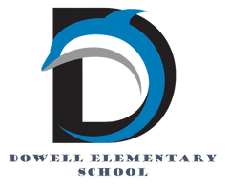
Dolphin Weekly
Sunday, May 3, 2026


Save the Date!
❤️May 4-May 8, Teacher/Staff Appreciation Week❤️

May 4
- Milestone Assessment for 4th grade (ELA)
- 5:30 pm: 5th grade parent meeting to view Human Growth & Development materials
May 5th
- Milestone Assessment for 4th grade (ELA)
- Deadline for Optional Parent Input form: Dowell Elementary 26-27 OPTIONAL Student Placement Form – Fill out form
May 6
- Milestone Assessment for 4th grade (ELA)
May 8
- Terrific Kids: Accomplishment
- 5th Grade: Human Growth & Development lessons
May 11th
- 1st - 4th Grade Classroom Awards
May 12th
- DLI Picnic *Parents must bring ID and Sign-In*
- SNPK Mother's Day Tea and End of Year *Parents must bring ID and Sign-In*Ceremony
- 5th Grade Milestone MATH Re-test
May 13th
- Kindergarten End of the Year Ceremony & Classroom Awards, 8:30 *Parents must bring ID and sign-in*
- 5th Grade Milestone MATH Re-test
May 14th
- 5th Grade Award Ceremony at Smith MS, 6:00 PM
May 15th:
- Senior Walk at Dowell, 8:30 am
- 5th Grade Picnic, 9 - 1pm *Parents must bring ID and sign-in*
May 18, 19, & 20:
- Early Release Days (students dismissed 2 hours early)
May 19th
- 5th Grade Walk 8:30 am *Parents must bring ID and sign-in*
- No Student Backpacks
May 20th:
- No Student Backpacks
- Last Day of School ✌🏻

July 30th: Meet & Greet your 2026-27 Teacher

12:00-1:00, PreK & Kindergarten
1:00-2:00, Last Names A - L
2:00-3:00, Last Names M - Z

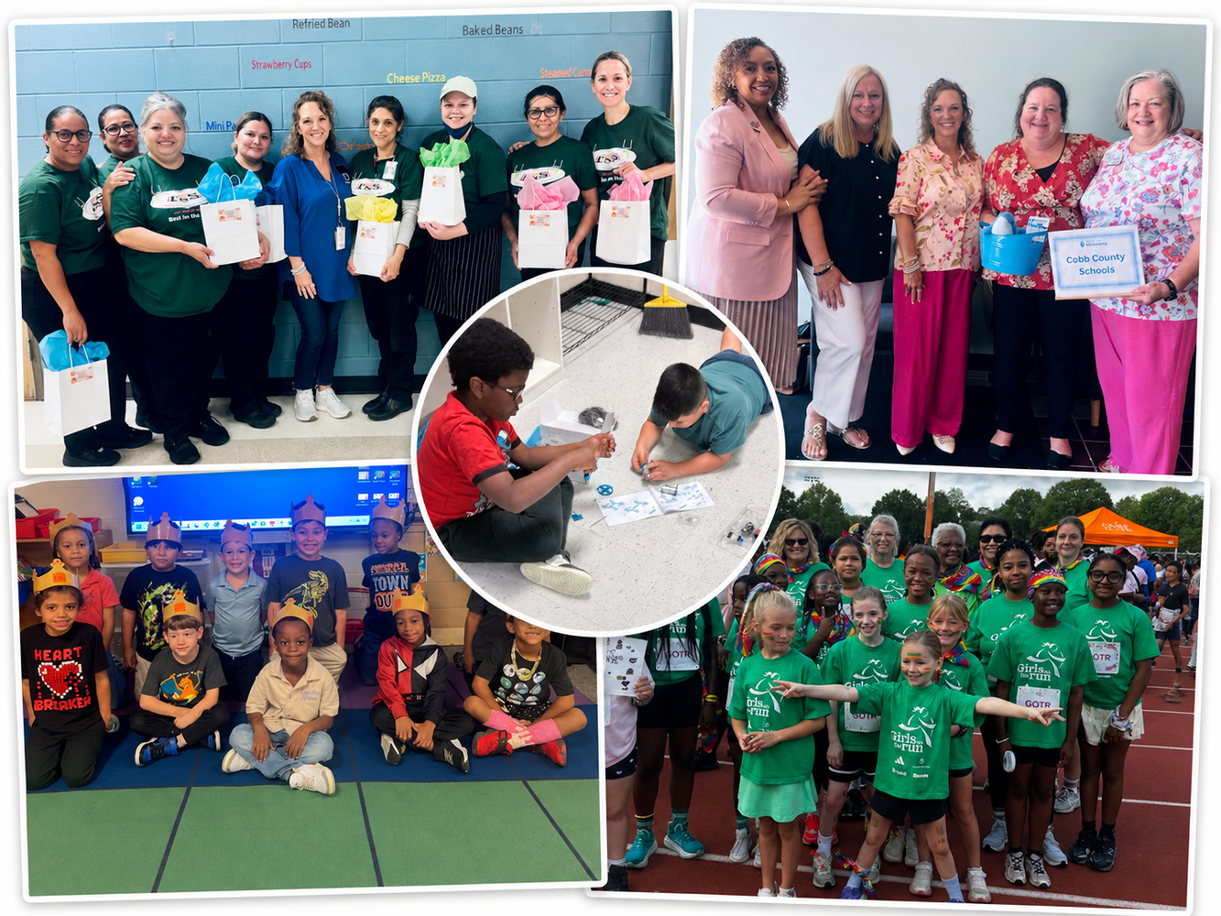

Message from the Principal
Hello Dowell Families,

We had another wonderful week at Dowell, and there is so much to celebrate as we move closer to the end of the school year!

We are almost finished with the Milestone Assessment, and we are so proud of our 3rd, 4th, and 5th grade students for their hard work, focus, and perseverance. They have shown what it means to shine like Dowell Dolphins! As testing wraps up, we are excited to move into our end-of-year activities, including picnics, parties, awards celebrations, and many other fun memory-making moments.

Friday was School Lunch Hero Day! 🎉 We are sending a huge thank you to our amazing cafeteria team for nourishing our students’ bodies and minds each day. They serve with smiles, care, and dedication, and they truly are the real MVPs!

We also want to give a BIG thank you to Macland Community Church for their ongoing support of the staff and students of Dowell. Thank you for choosing us as part of your local missions. Your partnership makes a meaningful difference in the lives of our students, and we are grateful to have you as part of our school family.

Our students wrapped up the year in the STEAM Lab with Mrs. Belcher on a high note! 🤖✨ Students used creativity, innovation, teamwork, and problem-solving as they built and coded their very own maker bots. It was exciting to see their confidence grow as their ideas came to life one line of code at a time. What a wonderful year of curiosity, challenges, and incredible growth!

Dowell’s Girls on the Run also had their season-ending 5K last weekend. Way to finish strong! 💪 We are so proud of our girls and thankful for the coaches who poured time, encouragement, and support into them this season: Mrs. Brake, Ms. Milton, Ms. Mathis, Mrs. Sanchez, Ms. King, and Mrs. Arnold. Thank you for making a difference in the lives of our young ladies!

As an important summer FYI, our building will be closed for construction this summer as we receive new flooring in the hallways, every office, and every classroom, along with new windows. Because of this work, the school building will be closed to visitors until late July. We are excited for these improvements and look forward to welcoming everyone back into a refreshed building!

Thank you, families, for your continued support as we finish the year strong. We are looking forward to celebrating our students and making the final weeks of school special for our Dowell Dolphins! 🐬

Dr. Cain

Classroom Celebrations Request Form
Dear Teachers/Parents/Staff,
Do you want to celebrate with your students but don’t have the time for all the planning and details? Return this request form to the Cafeteria Manager and leave the party to us! Upon receipt of the request form, we will provide you with a price quote for your party within 48 hours. On the celebration day, we take care of everything for you!

Please see attached form for pricing items and pricing.

Also if you plan on bringing in a treat for your child's birthday please fill out the attached cupcake form at least 24 hours in advance for the teacher and front office staff to be aware. This helps with planning and any allergies in the classroom.

Community News

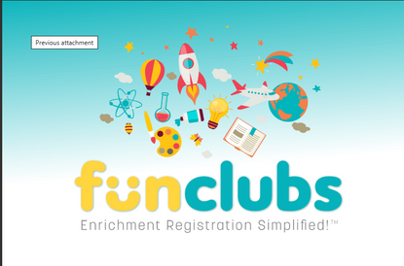
Fun Clubs Summer Camps
FunClubs are offering Summer Camps, sign up here: https://www.funclubs.com/camps

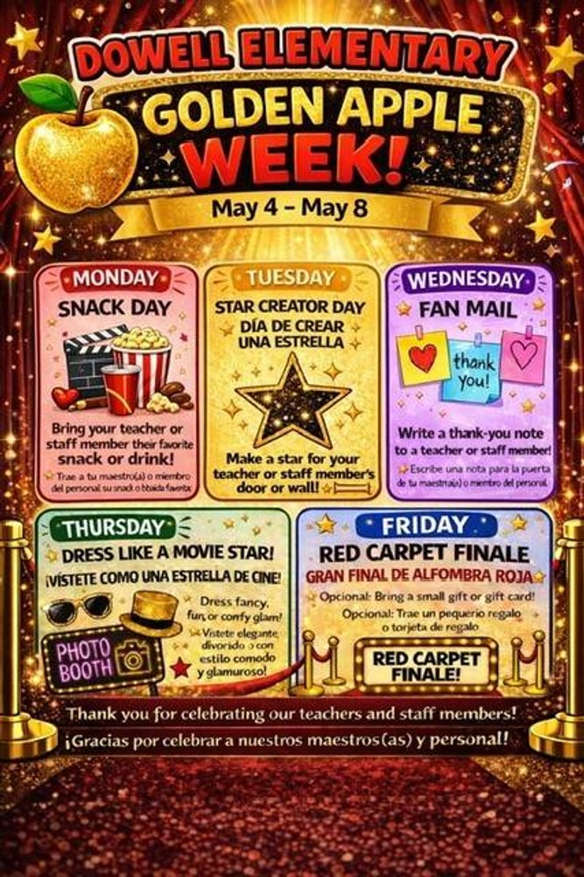



Evan Engram Registration

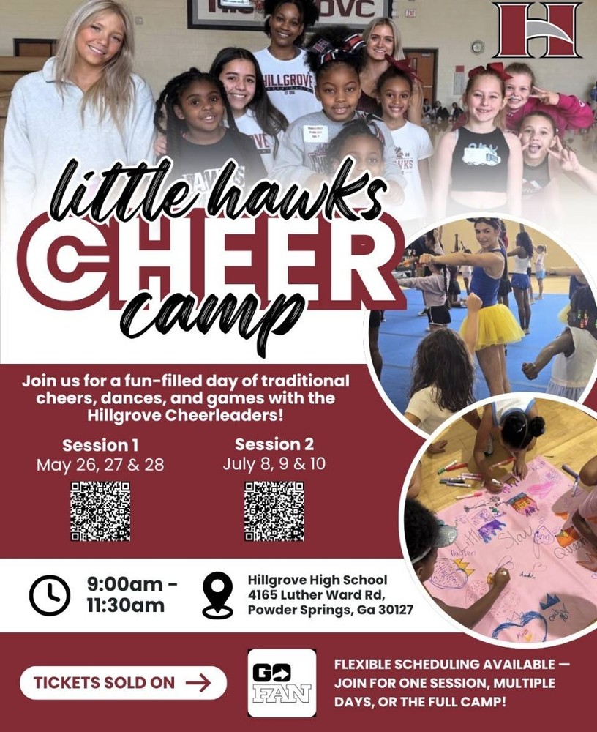



Register for Hillgrove SB Here

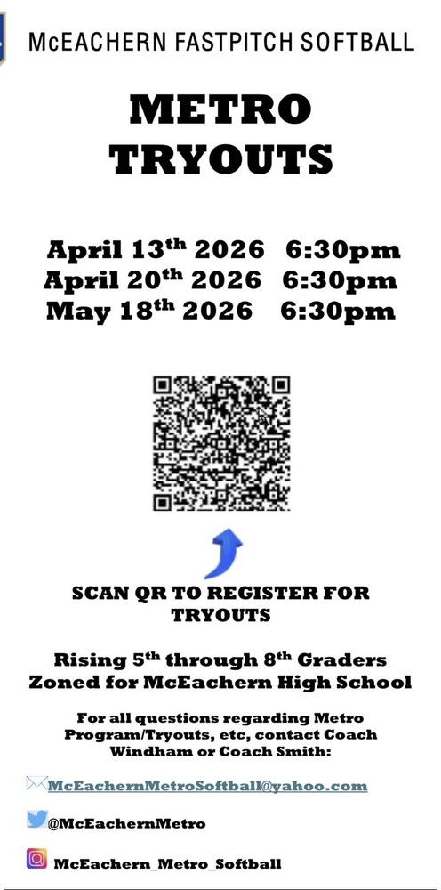

Register for McEachern SB Here



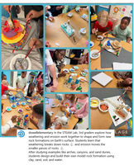
Follow us on social media.
https://www.instagram.com/dowellelementary

