Dolphin Weekly

Sunday, October 12, 2025

Save the Date!

October 13
- Digital Learning Day: No School/No ASP
October 14-17
- Conference Week
- Early Dismissal 12:30
October 16
- District Honor Chorus
October 20
- 50th Day of School
October 21-24
- IOWA Assessment for 3rd & 5th grade students
- Bus Safety Appreciation Week- Thank your bus driver!

From the Principal's Desk

Dear Dowell Families,

We’re wrapping up another great week at Dowell, and I couldn’t be prouder of our students and staff! 🌟

Our 1st and 3rd grade students did an amazing job during COGAT Testing this week—way to go, Dolphins! Thank you to our 1st grade teachers for celebrating with a cool popsicle treat—it was the perfect way to end the day!

Learning is happening everywhere at Dowell—even outside! Check out our 3rd grade students hard at work in the Gazebo, turning fresh air into fresh ideas.

As we continue to make learning and safety our top priorities, please help us maintain a safe and secure carpool process by following all procedures and the directions of our staff each morning and afternoon. Your cooperation helps keep every Dolphin safe and on time.

Next week is Conference Week (October 13–17), and we are so excited to meet with you! These conferences are a wonderful opportunity to celebrate your child’s progress and plan ahead together. Please remember that dismissal will be two hours early each day, and there will be no after-school clubs during Conference Week; however, ASP will be open until 6:00 pm each day.
.
Thank you for your continued partnership and support. Together, we’re creating tomorrow—today!

Dr. Cain
principal
----------------------------------------------------------------

Reminders:
- ID Requirement: A picture ID is required every time you visit the school. Please show it to the camera at the right front door and press the button (door bell). A staff member will confirm your reason for visiting and verify your child’s information before buzzing you in. Upon entry, always go straight to the front office.
- Visiting for Lunch? You’re welcome to sit with your child in the cafeteria during their lunch time. We kindly ask that you not bring fast food or restaurant meals, as it’s not fair to other students. Please check out at the front office after your visit.
- Do NOT Enter: For student and staff safety, please do not use the DO NOT ENTER/Buses Only entrance during AM or PM carpool.

Join the Dowell Foundation
Are you looking for a meaningful way to make a difference at Dowell? We’re seeking parent volunteers to help lead and maintain the Dowell Foundation—an organization dedicated to raising funds for student enrichment and school improvement.

If you have an interest in fundraising, marketing, or enhancing our school environment through Arts Integration and campus projects, we’d love to have you join our Foundation Board. Your ideas and talents can help us continue creating inspiring opportunities for all Dowell Dolphins! 💙

If you’re interested or would like to learn more, please reach out to Chad Itnyre at chad.itnyre@cobbk12.org.

Safety & Security Reminder
Thank you, parents, for always showing your Drivers License when visiting the school. Please remember we can only accept the actual ID (not a photo on your phone). This applies during the school day and for ASP. We appreciate your support in keeping our students safe!

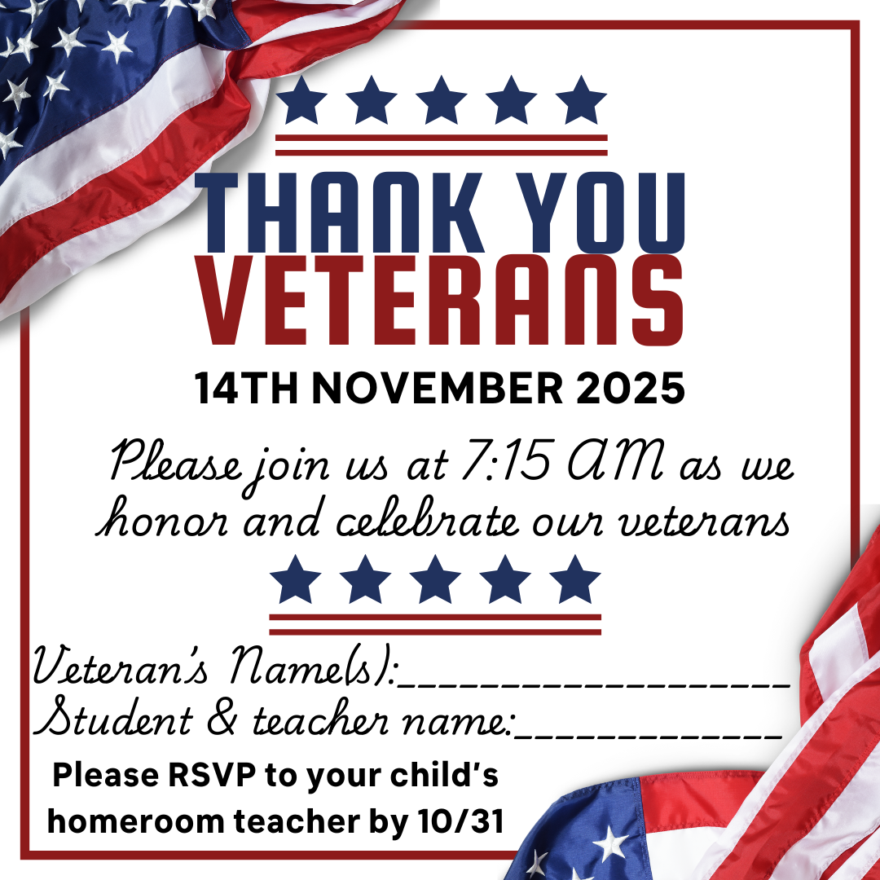

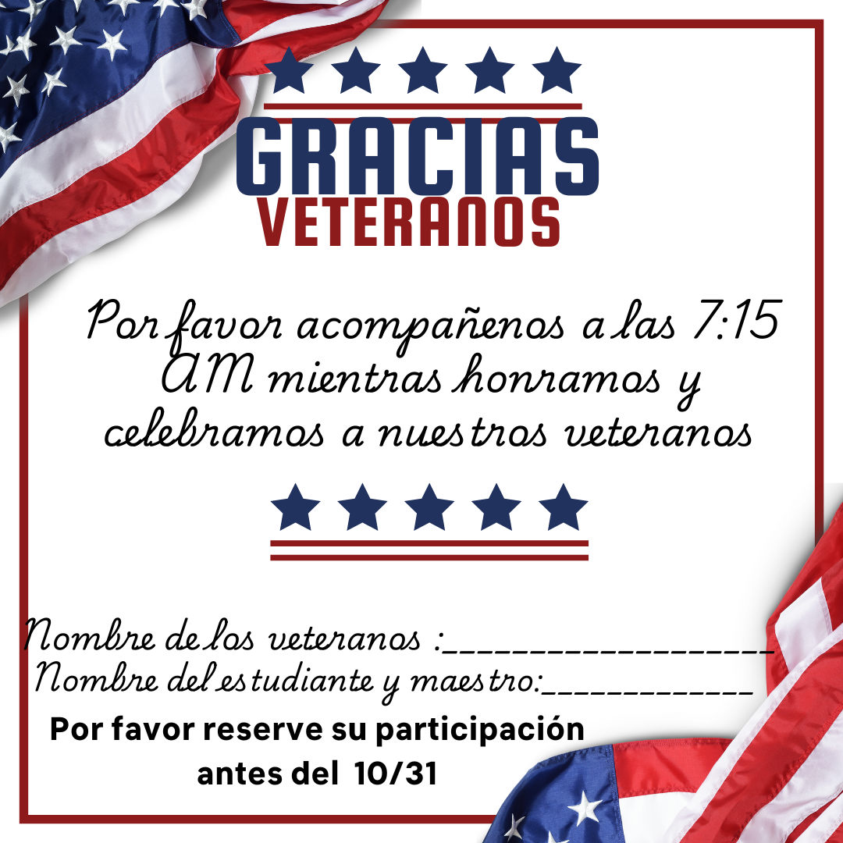

Bookkeeper Notes
When sending cash to the school for activities, events, or items, please ensure that you provide exact change, as the school is unable to give change.

Classroom Celebrations Request Form
Dear Teachers/Parents/Staff,
Do you want to celebrate with your students but don’t have the time for all the planning and details? Return this request form to the Cafeteria Manager and leave the party to us! Upon receipt of the request form, we will provide you with a price quote for your party within 48 hours. On the celebration day, we take care of everything for you!

Please see attached form for pricing items and pricing.

Book Character Parade
Join us for our Book Character Parade on October 31st. Please no mask, makeup or scary characters.

Annual Book Character Pumpkin Contest
Decorate a pumpkin to represent your favorite book character. Open to students and staff.

National PTA Reflections
ll paperwork needed is online on the PTA Reflections website https://www.pta.org/home/programs/reflections
Email Dowell PTA @dowellpta@gmail.com if you have any questions
Due Date to submit entries to Mr. Itnyre - October 17th- PTSA Reflections submissions
All paperwork needed is online on the PTA Reflections website https://www.pta.org/home/programs/reflections

See attachments for guidelines and a application.

PTA News
Cookie Dough Orders will be delivered Wednesday October 22nd from 2:30-6 PM

Volunteer Opportunities
The school is looking for parents to join the Foundation Board (5) and the Principal Advisory Committee (6-8 parents or business partners). If you are interested, please reach out to dowellpta@gmail.com.

Black History Month – if you or anyone you know is/was in a Divine Nine sorority or fraternity and interested in helping the school please reach out to Dr. Clark or dowellpta@gmail.com. The school is also interested in parents to help decorate the school.

Follow us on social media.

https://www.instagram.com/dowellelementary

Community Events

