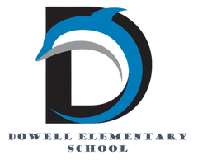

Dolphin Weekly

Sunday, May 17, 2026



Save the Date!
May 18, 19, & 20:
- Early Release Days (students dismissed 2 hours early)
May 19th
- 5th Grade Walk 8:30 am *Parents must bring ID and sign-in* (Overflow parking available at Macland Church of Christ)
- No Student Backpacks
May 20th:
- No Student Backpacks
- Last Day of School ✌🏻

July 30th: Meet & Greet your 2026-27 Teacher

12:00-1:00, PreK & Kindergarten
1:00-2:00, Last Names A - L
2:00-3:00, Last Names M - Z

August 3, 2026
- First Day of School

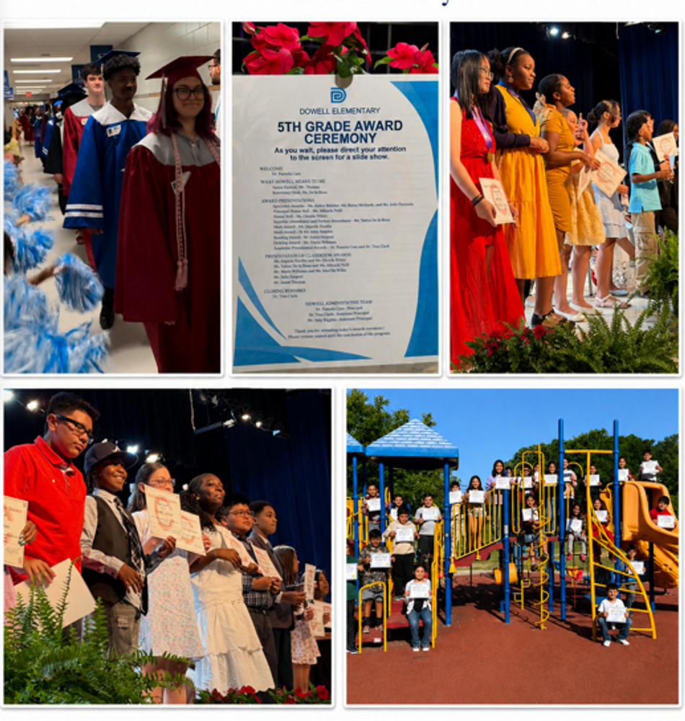

Message from the Principal
Dear Dowell Families,

As we close out another wonderful school year, I want to thank you for your continued support, partnership, and encouragement. It has been a joy to celebrate so many special moments with our students, staff, and families, and we are so proud of the growth, hard work, and accomplishments we have seen throughout the year.

This week, we celebrated several exciting milestones. Our 5th Grade Awards Ceremony was a beautiful opportunity to recognize our students for their achievements, leadership, and growth. We are so proud of our 5th graders and cannot wait to see all they accomplish in middle school! We also enjoyed the Kindergarten performance!

We welcomed back some very special former Dolphins during our senior walk. But first, you were a Dolphin! 🐬 Congratulations to these graduating seniors! Best wishes on your new adventures. We are so proud of you all!

We celebrated our amazing ESOL students who officially exited the ESOL program after earning qualifying scores on the ACCESS assessment. We are incredibly proud of their hard work, perseverance, and growth in English language development. Their dedication and determination have truly paid off, and this accomplishment is worth celebrating! A huge thank you to our teachers, staff, and families for supporting these students throughout their journey. We cannot wait to see all the great things they continue to achieve.

As an important summer FYI, our building will be closed for construction this summer as we receive new flooring in the hallways, every office, and every classroom, along with new windows. Because of this work, the school building will be closed to visitors until late July. We are excited for these improvements and look forward to welcoming everyone back into a refreshed building!

Please mark your calendars for Meet and Greet on July 30 and the first day of school on August 3.

Thank you again for a wonderful school year. We hope all of our Dowell families enjoy a safe, restful, and fun summer break! We look forward to seeing everyone soon.

With appreciation,

Dr. Cain



New Bus App
Greetings Parents,
All buses have been transferred over to the new Parent Portal App and will no longer be trackable on Here Comes the Bus. If you would like to track your students' buses for the remainder of the school year, please download the Parent Portal Application. See the link or QR code below.

For the next school year, you will need to complete your student(s) registration in the Parent Portal App. Please look for more information to come on that soon.

If you have any questions, please reach out to Transportation @ 770-429-5816.

Thank you for your patience and understanding as we transition!

https://www.cobbk12.org/track-my-bus

Classroom Celebrations Request Form
Dear Teachers/Parents/Staff,
Do you want to celebrate with your students but don’t have the time for all the planning and details? Return this request form to the Cafeteria Manager and leave the party to us! Upon receipt of the request form, we will provide you with a price quote for your party within 48 hours. On the celebration day, we take care of everything for you!

Please see attached form for pricing items and pricing.

Also if you plan on bringing in a treat for your child's birthday please fill out the attached cupcake form at least 24 hours in advance for the teacher and front office staff to be aware. This helps with planning and any allergies in the classroom.

Community News

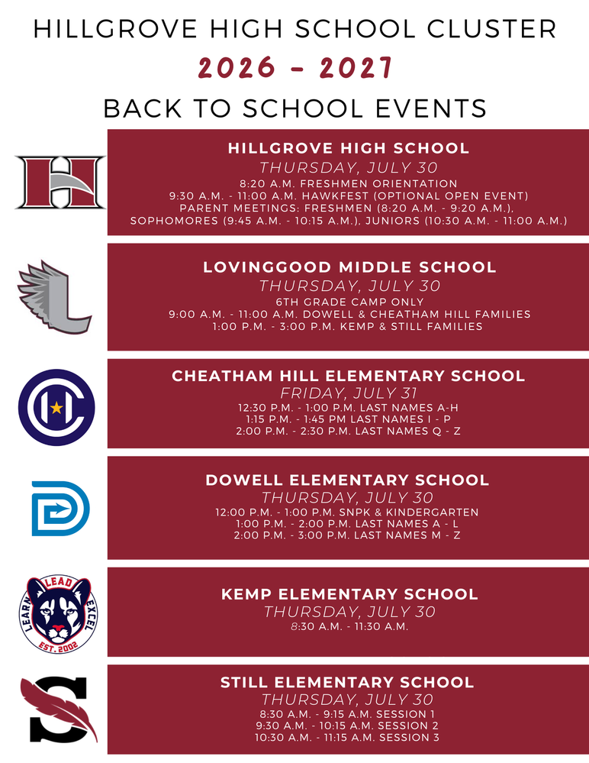



Fun Clubs Summer Camps
FunClubs are offering Summer Camps, sign up here: https://www.funclubs.com/camps

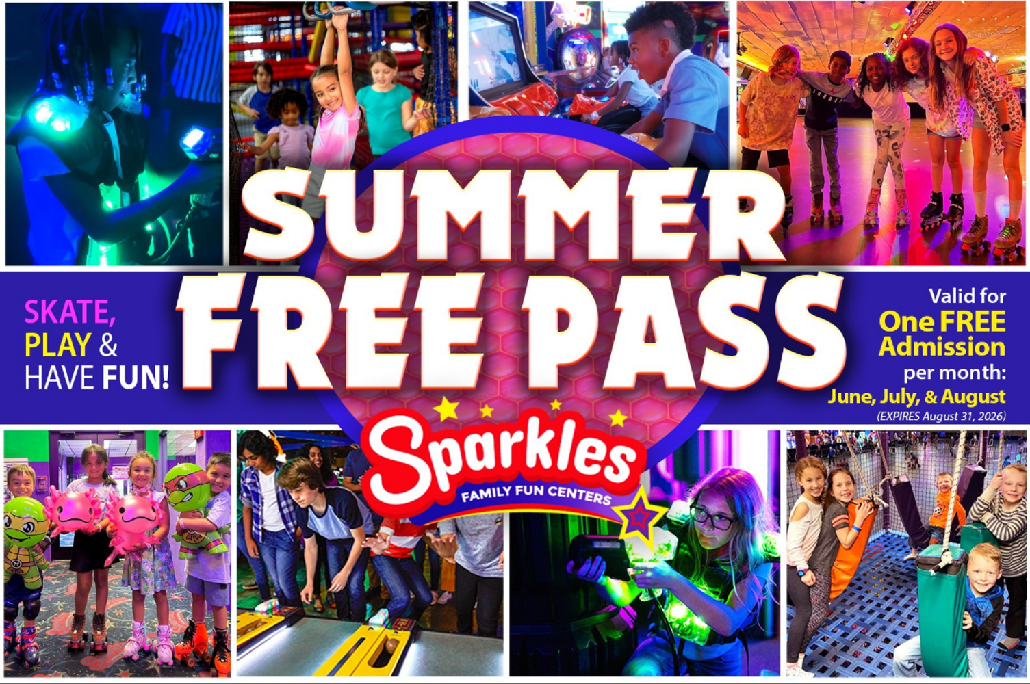

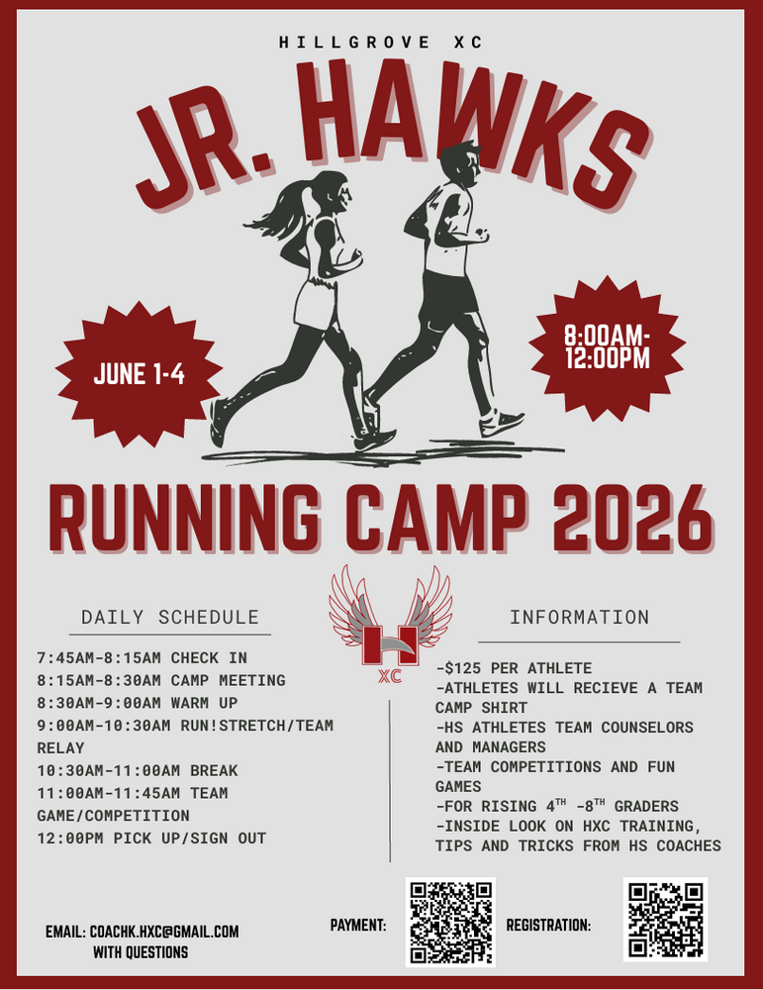



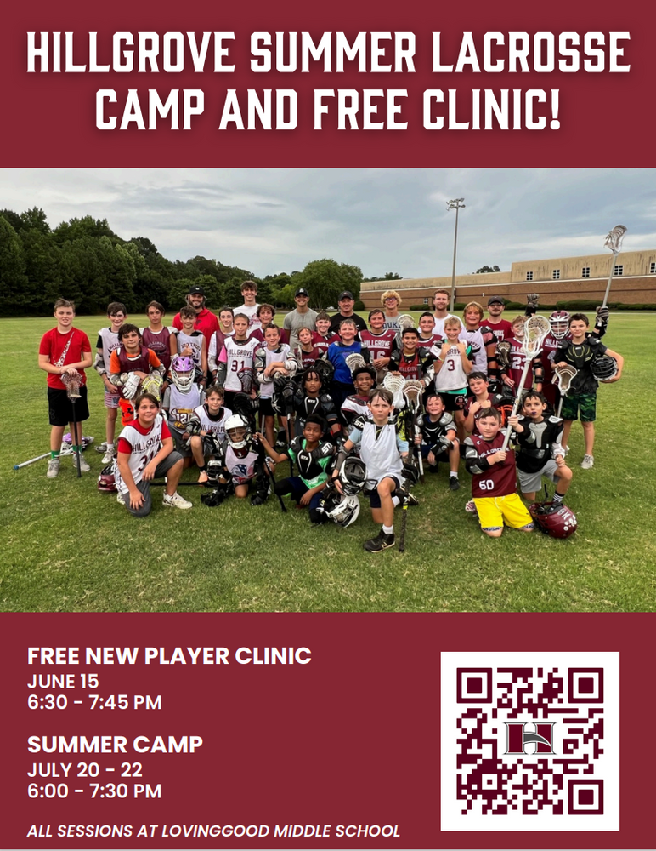

Lacrosse Registration Here



Evan Engram Registration

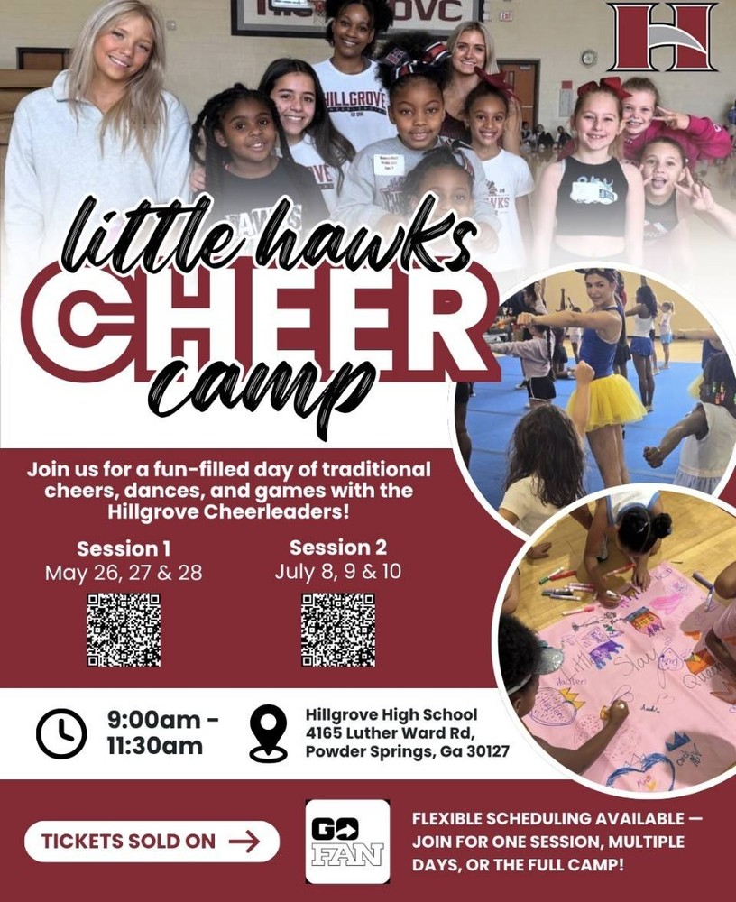



Register for Hillgrove SB Here

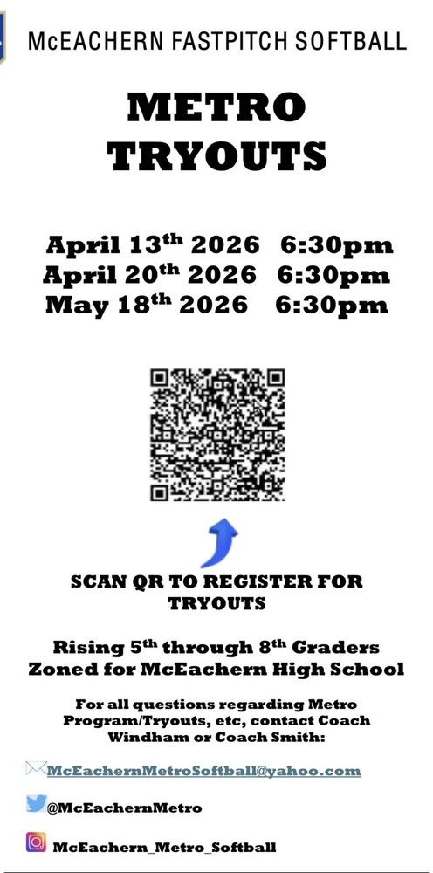

Register for McEachern SB Here

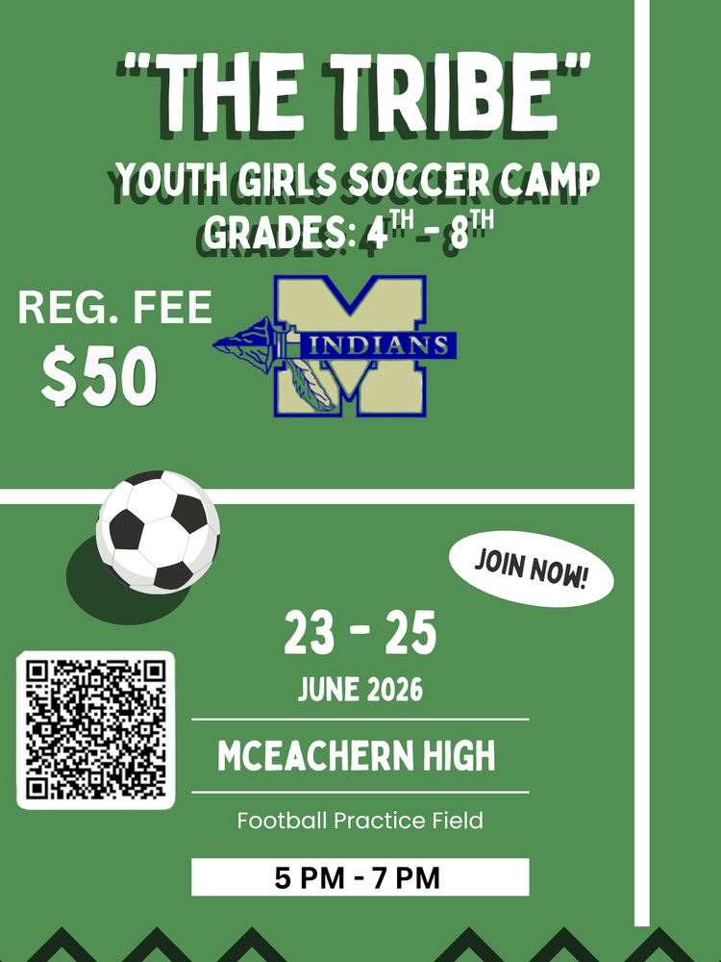

Register Here for The Tribe

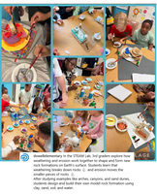

Follow us on social media.

https://www.instagram.com/dowellelementary

