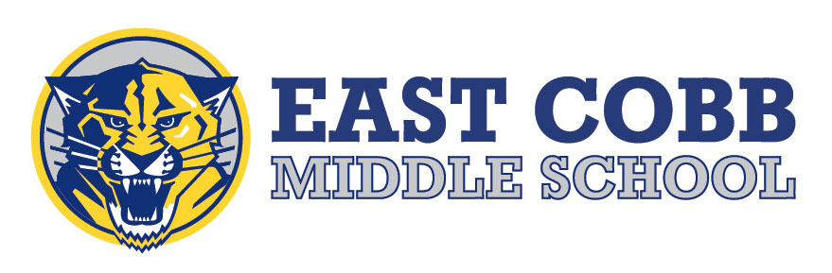

2023-2024 ACCEPTABLE SCHOOL ATTIRE

In keeping with our desire to promote a positive learning environment as well as student self-esteem and self-respect, students are to come to school dressed in appropriate, neat, and clean outfits that are not disruptive, distracting or in violation of the dress code. All students are encouraged to observe a standard of grooming and dress consistent with the level of formality of the school situation.

Attire:
Tops
- No spaghetti strapped tank tops, muscle shirts, or backless shirts
- No see-through shirts, bare midriffs, or camisoles
- Exposed cleavage is unacceptable

Bottoms
- Skirts/shorts…ECMS Administration deems mid-thigh as appropriate
- Pants MUST be worn at the waist
- Leggings may be worn with a top that fully covers the buttock
- NO: biker or running shorts, pajama pants/flannel pants
- NO: holes in skirts, shirts, shorts
- Pants may NOT have holes with skin exposed above the knee

Other
- No inappropriate phrases, graphics or lettering is permitted.
- No sunglasses, hats, bandanas, head scarves, visors, sweatbands, or hoods. Hats/bandanas on belt loops/pockets are not allowed.
- No shower shoe flip flops, no house slippers
- No visible under garments

Clothing which, at the discretion of the school, calls undue attention to an individual or interferes with the planned educational program may not be worn to school. The school reserves the right to make judgments regarding student attire.

Students and parents are asked to cooperate with the school. Students who violate the policy or are by administration discretion found to be dressed inappropriately will be required to change clothes before being permitted to return to class. Those who will not or cannot correct their dress will be isolated for the day. Repeat offenders will be subject to additional disciplinary action.

