**Frequently Asked Questions**

1. 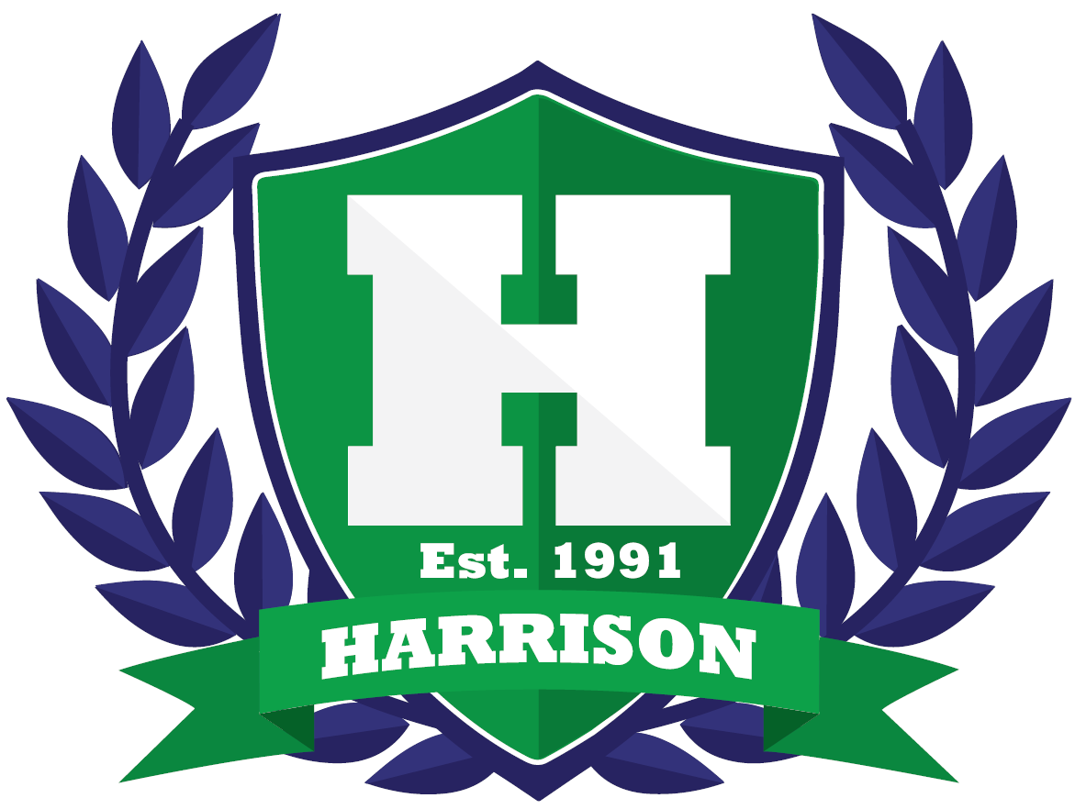**What is the reason for adding an academic support/enrichment course at Harrison, and how will it help the students?** Hoya Block courses have been created to provide students additional assistance for their coursework and high-stakes standardized testing. In addition to the Hoya Block courses, morning and afternoon tutoring sessions will still be available for students.
2. **How have stakeholders been involved with the creation of Hoya Block?** During the 2015-2016 school year, the Hoya Block committee was formed and comprised of members from each academic department to analyze school data to determine the Hoya Block goals. Academic departments met to create the needed courses based on the data and goals. School Council, PTSA, administration, and student representatives were invited to participate in discussions regarding the creation of the academic support program at Harrison.
3. **When will Hoya Block take place?** Hoya Block will take place twice a week between the first and second periods. The block schedule, which has proven to be very successful at Harrison, will remain in effect. Please see Harrison’s official bell schedule for details. For the fall semester, Hoya Block will begin towards the end of August and will conclude at the end of November. For the spring semester, Hoya Block will begin in January and will conclude at the end of April.
4. **Do students have a choice in which Hoya Block course they are placed?** Students who would benefit from additional assistance in their course work or testing will be placed in an appropriate Hoya Block course. If a student has not been identified as needing academic assistance, he/she can sign up for an academic support class or an enrichment Hoya Block course.
5. **How will students know if they have been academically placed in a Hoya Block course or if they can choose a Hoya Block course?** Hoya Block information will be provided on each student’s schedule before the start of each semester of Hoya Block.

1. **What types of Hoya Block courses will be offered?** There will be a variety of PSAT, support, enrichment, honors, and AP courses offered to all students within each department.
2. **How will students sign up for a Hoya Block course?** A registration process will occur during Advisement, where students will sign up online for a particular enrichment course. Hoya Block will begin the fourth week of each semester for the scheduling process to occur during the first three weeks of each semester. More details about Hoya Block registration will be provided the first week of school, in the parent eblast, and on the school website.
3. **How often will the Hoya Block course change for a student?** A student’s Hoya Block course will change each semester unless it is beneficial for the student to remain in the same academic or enrichment course.
4. **Will a grade be assigned for the Hoya Block course?** No, a grade will not be assigned for the Hoya Block course. However, school rules will still apply for attendance and behavior.
5. **Who do I contact if I still have questions about Hoya Block?** If you still have questions about Hoya Block, contact Shay Kappel, Assistant Principal, at [Shaleen.kappel@cobbk12.org](mailto:Shaleen.kappel@cobbk12.org) or 678-594-8104 ext. 050.