**Hollydale Activities to Build Partnerships**

Please consider joining us through some of the events listed below. Volunteer opportunities may be virtual or face to face.

**Volunteer Opportunities:**

* Classroom Readers (In person or virtual)
* Hero Workday
* Title I Planning Committee

**Partnership Meetings:**

Annual Title I Parent Informational Meeting

Open House

Meet and greet

Title I Parent Input Meetings

Parent Teacher Conference Week

**Family Engagement Opportunities:**

Literacy Nights

Strategy Training to Assist Students at Home

Parent Resource Room

**What is a School-Parent Compact?**

Congue nihil imperdiet doming id quod mazim placerat facer minim veni am ut wisi enim ad minimeniam, quis erat nostr uexe

rci tation ullamcorper nostru exerci tation ullam corper et iusto odio dig nissim qui blandit praesent lupta. Tummer delenit

augue duis dolore te feugait nulla facilisi. Con erattis sectetuer adip iscing elit, sed erat diam nonummy nibh magna erat.

**Jointly Developed**

The parents, students, and staff of Hollydale worked together and shared ideas to develop the school-parent compact for achievement. Teachers suggested home learning strategies, parents added ideas to make them more specific, and students told us what would help them learn. Parents are encouraged to participate in the annual review process of the compact and make changes based on students’ needs. Parents are welcome to contribute comments at any time. Please contact Carmen Rodriguez at 678 594 8143 or [carmen.rodriguez@cobbk12.org](mailto:carmen.rodriguez@cobbk12.org) to provide feedback.

*2024-2025*

*Hollydale Elementary*

*School-Parent Compact for Achievement*

Grade 3rd,4th,and 5th

*Revised August 2, 2024*

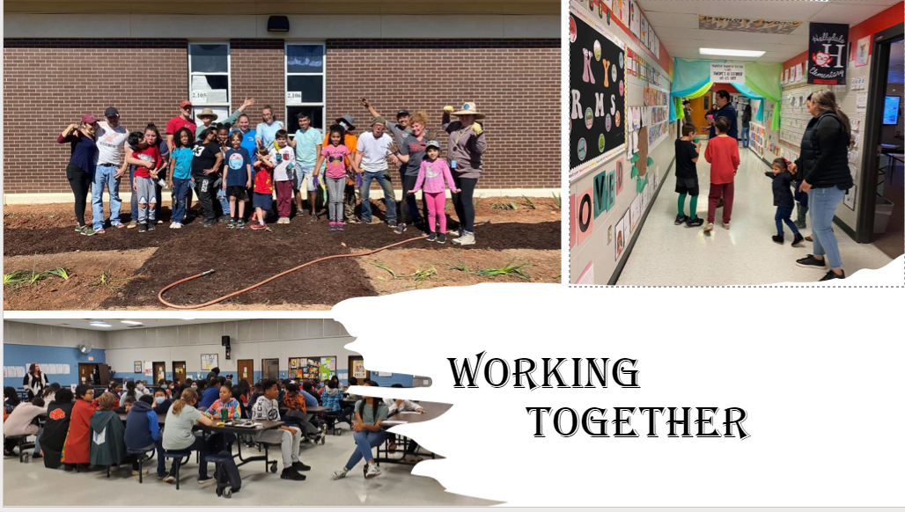

* CTLS Parent
* ParentVUE
* Weekly Folders
* Parent Handbook
* School Website
* Weekly News & Notes
* Email
* Parent/Teacher Conferences
* Facebook &Twitter
* Flyers
* District Website
* School Marquee

**Some communications may be provided virtually**

If you would like more information, please contact:

**Carmen Rodriguez**

678 594 8143 or

carmen.rodriguez@cobbk12.org

**Jennifer Ridgway, Principal**

**Jennifer.ridgway@cobbk12.org**

**2901 Bayberry Drive**

**Marietta, GA 30008**

**678 594 8143**

**www.cobbk12.org/hollydale**

*A School-Parent Compact is an agreement that parents, students, and teachers, develop together. It explains how parents and teachers will work together to make sure all of our students succeed. This compact includes strategies to help connect learning at school to learning at home.*

**Hollydale Activities to Build Communication**

**Hollydale Goal(s) for Student Achievement**

**Goal # 1 Reading:**

* The percentage of scoring proficient and distinguished in 3rd , 4th and 5th grade will increase from 25% to 30% as mesasured by the 2024-2025EOG ELA Assessment.

**Goal # 2 Math**:

* The percentage of 3rd – 5th grade students scoring proficient and distinguished will increase by 5 % from May 2024 as measured by the EOG Math Assessment.

**District Goals for Student Achievement**

* By SY26, increase growth by 2 percentage points, for students scoring at the proficient and distinguished levels, as evidenced by state assessments.
* By SY28, increase graduation rate from 8% to 88% as measured by GaDOE adjusted cohort gracuation rate.

**Hollydale Students**

Hollydale Elementary School students join staff and parents to develop ideas about how they can succeed in school and be “Engaged, Equipped and Empowered” in reading and math.

**Strategy/activity #1**: Working with their family on the strategies the parents learned during the curriculum events.

**Strategy/activity #2:** Share communication from the teacher and complete my homework, read 20 minutes every day and practice math at home.

**Strategy/activity #3:** Practicing citing text evidence using the strategies learned in class.

**Strategy/activity #4:** Using the technology resources provided by the teacher to practice reading, writing and math.

**Hollydale Families**

Hollydale Elementary School parents join staff to develop ideas about how families can support students’ in reading and math. Families may have other ideas to add to the list.

**Strategy/activity #1**: Attend Curriculum events or get information from my child’s teacher if a family member cannot attend.

**Strategies/activity #2:** Check the daily communication and encourage reading, writing, and practicing math at home regularly.

**Strategies/activity #3**: Help monitor, and encourage their students cite textual evidence using various strategies from class.

**Strategies/activity #4:** Help their students use online resources to practice reading and math at home.

[Zearn.org](http://www.dreambox.com)

Cobb digital Library Resources

Resources can be accessed through the student’s Clever account.

**Hollydale Teachers**

The 3rd, 4th, and 5th grade teachers work with students and their families to develop students’ success in reading and math. The focus of our key connections with families is:

**Strategy/activity #1**: Offer curriculum events to address strategies for student success in reading, writing and math.

**Strategy/activity #2**: Provide families with daily communication with homework to practice reading, writing and math.

**Strategy/activity #3**: Provide families with examples of strategies for citing text evidence such as underlining my answer using highlighters, using post-it notes as well digital tools.

**Strategy/activity #4**: Provide technology-based resources to assist in practicing reading and math skills at home.

**Visit Our Website:**

**www.cobbk12.org/hollydale**

*One Team, One Goal, Student Success!*

*Teachers, Parents, and Students-Together for Success*