**Hollydale Activities to Build Partnerships**

Please consider joining us through some of the events listed below. Volunteer opportunities may be virtual or face to face.

**Volunteer Opportunities:**

* Classroom Readers (In person or virtual)
* Hero Workday
* Title I Planning Committee

**Partnership Meetings:**

Annual Title I Parent Informational Meeting

Open House

Meet and greet

Title I Parent Input Meetings

Parent Teacher Conference Week

**Family Engagement Opportunities:**

Literacy Nights

Strategy Training to Assist Students at Home

Parent Resource Room

**What is a School-Parent Compact?**

Congue nihil imperdiet doming id quod mazim placerat facer minim veni am ut wisi enim ad minimeniam, quis erat nostr uexe

rci tation ullamcorper nostru exerci tation ullam corper et iusto odio dig nissim qui blandit praesent lupta. Tummer delenit

augue duis dolore te feugait nulla facilisi. Con erattis sectetuer adip iscing elit, sed erat diam nonummy nibh magna erat.

**Jointly Developed**

The parents, students, and staff of Hollydale worked together and shared ideas to develop the school-parent compact for achievement. Teachers suggested home learning strategies, parents added ideas to make them more specific, and students told us what would help them learn. Parents are encouraged to participate in the annual review process of the compact and make changes based on students’ needs. Parents are welcome to contribute comments at any time. Please contact Carmen Rodriguez at 678 594 8143 or [carmen.rodriguez@cobbk12.org](mailto:carmen.rodriguez@cobbk12.org) to provide feedback.

*2024-2025*

*Hollydale Elementary*

*School-Parent Compact for Achievement*

Grade K,1st,and 2nd

*Revised August 2,2024*

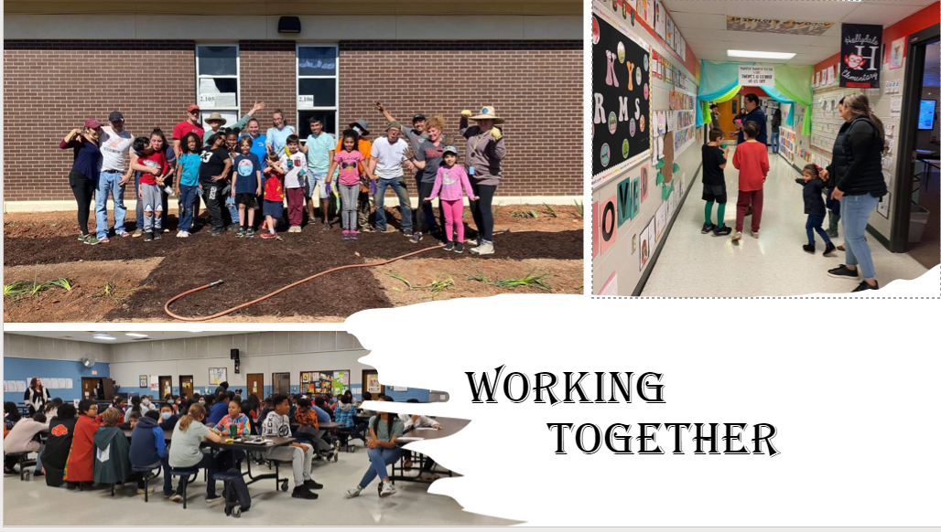

* CTLS Parent
* ParentVUE
* Weekly Folders
* Parents Handbook
* School Website
* Weekly News & Notes
* Email
* Parent/Teacher Conferences
* Facebook &Twitter
* Flyers
* District Website
* School Marquee

**Some communications may be provided virtually**

If you would like more information, please contact:

**Carmen Rodriguez**

678 594 8143 or

carmen.rodriguez@cobbk12.org

**Jennifer Ridgway, Principal**

**Jennifer.ridgway@cobbk12.org**

**2901 Bayberry Drive**

**Marietta, GA 30008**

**678 594 8143**

**www.cobbk12.org/hollydale**

*A School-Parent Compact is an agreement that parents, students, and teachers, develop together. It explains how parents and teachers will work together to make sure all of our students succeed. This compact includes strategies to help connect learning at school to learning at home.*

**Hollydale Activities to Build Communication**

**Hollydale Goal(s) for Student Achievement**

**Goal # 1 Reading:**

* The percentage of kindergarten, 1st and 2nd grade students scoring prepared will increase by 35% from August 2024 to May 2025, as measured by Amira.

**Goal # 2 Math:**

* The percentage of kindergarten students fluently adding and subtracting within 5 (using a variety of strategies) will increase from 0% to 80 % as measured by the 2024-2025 GKIDS 2.0 Assessment.
* Thepercentage of 1st and 2ndgrade students scoring prepared will increase from 8% in August 2024 to 25% in May 2025 as measured by the 2024-2025 Spring administration of the Beacon assessment.

**District Goals for Student Achievement**

* By SY26, increase growth by 2 percentage points, for students scoring at the proficient and distinguished levels, as evidenced by state assessments.
* By SY 28, increase graduation rate from 87% to 88% as measured by GaDOE adjusted cohort graduation rate.

**Hollydale Teachers**

The K, 1st, and 2nd teachers work with students and their families to develop student’ success in reading and math. The focus of our key connection with families is:

**Strategy/activity #1**: Offer Curriculum events focused on grade level standards and academic areas that need to be strengthened.

**Strategy/activity #2**: Provide families with a daily communication to relay student progress and provide resources for practicing reading, writing and math regularly at home.

**Strategy/activity #3:** Provide parents with High Frequency Words to work with the studet(k-1st grade).

**Strategy/activity #4:** Provide online resources and websites to assist students in practicing reading and math at home.

**Hollydale Families**

Hollydale Elementary School parents joined staff to develop ideas about how families can support students’ in reading and Math. Families may have other ideas to add to the list.

**Strategy/activity #1**:Plan to attend the curriculum events to learn new strategies to use at home and help their students in Reading and Math.

**Strategy/activity #2**: Check the daily communication, and use resources to help their students practice reading, writing and math at home.

**Strategy/activity #3:** Practice High Frequency Words with the student regularly.

**Strategy/activity #4**: Help their students in reading and math by ussig technology resources at home such at: www.abcya.com, www.starfall.com,www.prodigy.com, [www.dreambox.com](http://www.dreambox.com),www headsprout.com

Cobb Digital Library Resource

Resources can be accessed through the students Clever Account.

**Hollydale Students**

Hollydale Elementary school students joined staff and parents to develop ideas about how they can succeed in school and be “Engaged, Equipped and Empowered” in reading and math.

**Strategy/activity #1**:Practice using reading and math strategies shared during the curriculum events.

**Strategy/activity #2**: Share communication from the teacher and complete my homework, read 20 minute every day and practice math at home.

**Strategy/activity #3**: Practice High frequency Words with a family member.

**Strategy/activity #4**:Use online resources to practice math and reading at home.

**Visit Our Website:**

**www.cobbk12.org/hollydale**

*One Team, One Goal, Student Success!*

*Teachers, Parents, and Students-Together for Success*