School Plan for Shared Student Achievement

**What is it?**

This is a plan that describes how Hollydale Elementary will provide

opportunities to improve family engagement to support student learning.

Hollydale Elementary values the contributions and involvement of families to

establish an equal partnership for the common goal of improving student

achievement. This plan describes the different ways that Hollydale Elementary

will support family engagement and how parents can help plan and participate

in activities and events to promote student learning at school and at home.

**Jointly Developed**

Hollydale Elementary invites all parents to complete the Fall school improvement input survey/evaluation to provide suggestions on the school’s Title I program. All parents are also invited to attend the Spring school improvement input meeting to revise this parental involvement policy, our school-parent compact, building staff capacity professional learning topics, and the parental involvement budget. Additionally, parent input and comments regarding this plan are welcome during the school year. The plan is posted on our school Web site for parents to view and submit feedback throughout the year. All parent feedback received during the year will be used to revise the plan for the next school year. We also distribute an annual survey that is posted online to ask parents for their suggestions on the plan and the use of the 1% reservation of funds for parental involvement. Parents can also give feedback during any parent meetings and activities during the school year.

**Who is it for?**

All students participating in the Title I, Part A program, and their parents and families, are encouraged and invited to fully participate in the opportunities described in this policy.  Hollydale Elementary will provide full opportunity for the participation of Neglected and Delinquent proxy parents, parents and families with limited English, parents with disabilities, and parents of migratory children.

**Where is it available?**

Every family will receive the plan during Parent-Teacher Conference week. It is also available on the school website and a copy is in the front office binder. Parents can also retrieve a copy of the plan in the Parent Resource Center. We will gladly mail the plan to you upon request.

**What is Title I?**

Hollydale Elementary is identified as a school having a Schoolwide Title I program as part of the Every Student Succeeds Act (ESSA). Title I is designed to support State and local school reform efforts tied to challenging state academic standards which reinforce and enhance efforts to improve teaching and learning for students. Title I programs must be based on effective means of improving student achievement and include strategies to support parental involvement. All Title I schools must jointly develop with all parents a written parental involvement policy.

**Hollydale Elementary**

***Family-School Engagement Policy***

***for Shared Student Success***

*2024–2025 School Year*

*Jennifer Ridgway, Principal*

*Cobb County School District*

*2901 Bayberry Drive*

*(678) 594-8143*

[*https://www.cobbk12.org/hollydale*](https://www.cobbk12.org/hollydale/Title1)

*Revised August 2, 2024*

**Hollydale Elementary**

**Academic Goals**

**Goal # 1 Reading:**

* The percent of kindergarten, 1st and 2nd-grade students scoring prepared will increase by 35% from August 2024 to May 2025, as measured by Amira.
* The percentage of students scoring proficient and distinguished in 3rd, 4th, and 5th grade will increase from 25% to 30% as measured by the 2024-2025 EOG ELA Assessment.

**Goal # 2 Math**

* The percentage ofkindergarten students fluently adding and subtracting within 5 (using a variety of strategies) will increase from 0% to 80% as measured by the 2024-2025 GKIDS 2.0 Assessment.
* The percentage of 1st and 2nd-grade students scoring prepared will increase from 8% in August 2024 to 25% in May 2025 as measured by the 2024-2025 spring administration of the Beacon assessment.
* The percentage of 3rd – 5th grade students scoring proficient and distinguished will increase by 5% from May 2024 to May 2025 as measured by the EOG Math Assessment.

**Let’s Get Together!**

Hollydale Elementary will host the following events to build the capacity for strong parental involvement to support a partnership among the school, parents, and community to improve student academic achievement. Family and Community Engagement (FACE) activities will be held at various times to provide opportunities for all families to participate. If you are unable to attend and would like meeting information, please contact Hollydale Elementary.

**Incoming K Grade Parent Meeting-Tuesday, July 30, 2024, at 6:00 pm**

Rising Kindergarten Grade families are introduced to expectations and learning opportunities offered in elementary school.

**Hollydale Open House, August 22, 2024 –** Families will hear about yearly curriculum and assessments for the year and first semester.

**Annual Title I Meeting & House Bingo- Thursday, September 19, 2024 @ 6:00 pm location: Cafeteria.**

We invite you to an evening of learning about our Title I program, including the parent and family engagement policy, school-parent compacts, parents rights under Title I, highlights of the school improvement plan and the 1% reservation of funds for family engagement. Additionally, you’ll receive a description about our school’s curriculum and the assessments used to monitor student progress.

**Parent-Teacher Conferences – October 14-18, 2024**

Receive updates on your child’s progress in class and on assessments during Conference Week.

Parents may always request conferences with their child’s teacher, as needed.

**Fall School Improvement Input Survey- October 15-18, 2024**

Hollydale Elementary will send home the Title I Survey / Evaluation through CTLS Parent. Parents are asked to provide valuable feedback regarding the school, current and future family and community engagement activities and programs.

**Chat and Chew with Principal Ridgway,** Friday, October 25, 2024 & Friday, March 21, 2025 from 7 :15-8:00

**Kindness Week Assembly w/all Stakeholders, Thursday, November 14, 2024** Students will create skits or other expressions of art per Leadership habit to show how Leadership skills infiltrate our academic and social skills at Hollydale. One grade level will provide a choral performance as well.

**STEAM Wonderland Night Thursday, December 12, 2024, 6PM.**

**Spring School Improvement Input Forum- Thursday, March 13, 2025, from 8:00 am/6:00 pm**

Parents and educators review and discuss Hollydale Elementary’s Title I program, future parent activities, school-family compact and policy, family engagement budget and staff trainings.

**F.A.M.E:**

**Fall: Oct. 23, 30 Nov. 6,13,20 Dec. 4, 2024 @ 4:00pm -5:00pm**

**Spring: Jan.29 Feb. 5,12,26 March 5, 12, 19, 2025 @ 4:00 pm – 6:15 pm**

**Family Game Night, January 16, 2025 at 6PM –** Families and staff will gather and play fun games with a math focus. PTA Mtg will also take place. Grade levels will issue QR codes for digital curriculum info for the 2nd semester.

**Multicultural Night- Thursday, March 7, 2025, Parents and families will rotate through different station with their student to embrace various cultures through reading, writing, and hand on activities.**

Family-School Compacts

As part of this plan, Hollydale Elementary and our families will develop a family-school compact, which is an agreement that parents, teachers, and students will develop that explains how parents and teachers will work together to make sure all our students reach grade-level standards. The compacts will be reviewed and updated annually based on feedback from parents, students, and teachers during the School Improvement forum. The family-school compacts are distributed during Parent-Teacher Conference week October 15-18, 2024. Copies are also available throughout the year with each child’s teacher.

**2024-2025**

**Cobb County Schools**

**District Goals**

* By SY26, increase growth by 2 percentage points, for students scoring at the proficient and distinguished levels, as evidenced by state assessments.
* By SY28, increase graduation rate from 87% to 88% as measured by GaDOE adjusted cohort graduation rate.

8

**Parent Resource Center (Rm. 1.167)**

**Hours: Mon.-Fri.; 9:30am - 2:30pm**

Visit the Parent Resource Center (PRC) to check out books, study materials, and activities to use at home with your child. Computers are available for parents to explore CTLS Learn, CTLS Parent and educational resources.

Parental Involvement

Hollydale Elementary believes that parental involvement means the participation of parents in regular two-way, and meaningful communication involving student academic learning and other school activities, including ensuring:

* That parents play an integral role in assisting their child’s learning.
* That parents are encouraged to be actively involved in their child’s education at school.
* That parents are full partners in their child’s education and are included, as appropriate, in decision-making and on advisory committees to assist in the education of their child.

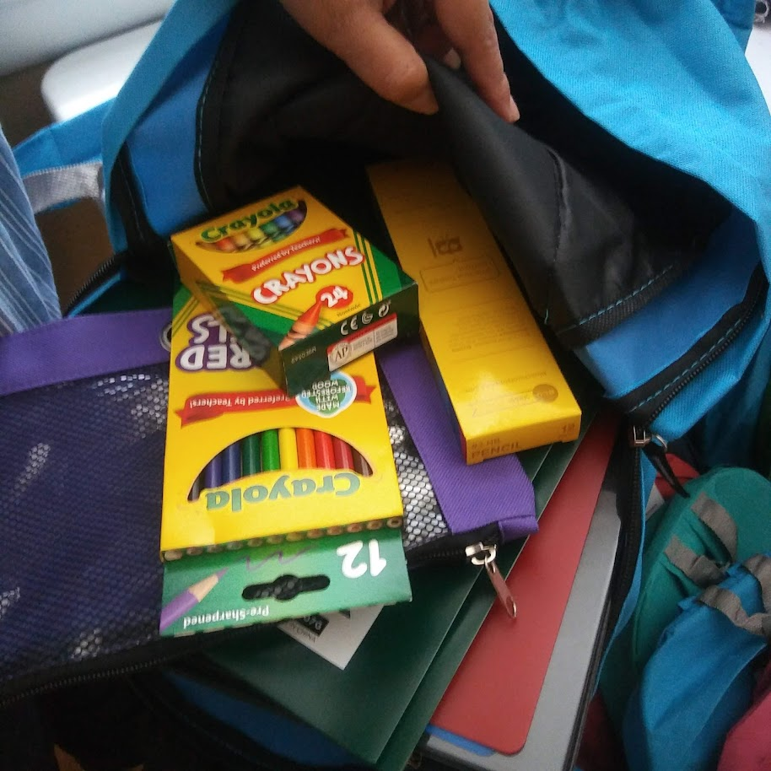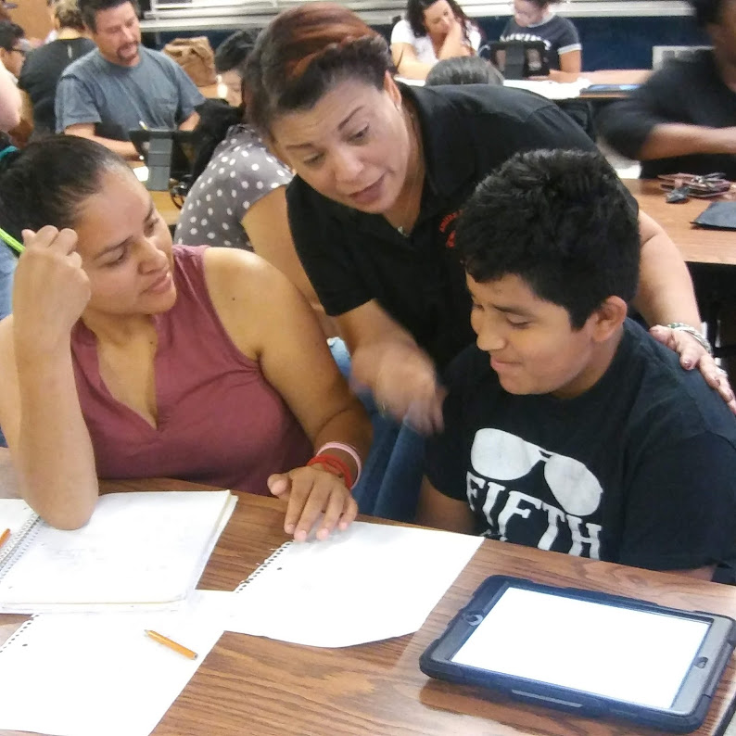

**One Team, One Goal, Student Success**

Hollydale Elementary will take the following measures to promote and support parents as an important foundation of the school in order to strengthen student academic performance and reach our school goals. We will:

* Ensure that all information related to school and parent programs, meetings, and other activities is published in both English and Spanish, posted on the school website, and included in the weekly Wednesday message for all parents.
* Provide two trainings each semester for staff during their planning periods on strategies to improve communication with parents and ideas to increase family engagement.
* Partner with our feeder schools by conducting joint meetings and events for parents and sending school information about parent engagement activities to help prepare parents and their child for school transitions.
* Share information in English and Spanish on the school blog and in the school newsletter for parents to understand the school’s academic standards and assessments as well as the ways parents can monitor their child’s progress and work with educators.
* Communicate with all families and the community on a regular basis regarding schoolwide events and activities, through CTLS Parent, school website, social media, Weekly News & Notes and flyers, etc.
* Work with our parents to develop relevant trainings and helpful presentations to educate our staff on the importance of parental involvement.
* Provide necessary materials and handouts for parents at conferences, meetings, and activities to help parents work with their child to improve their child’s achievement.
* Use our Parent Facilitators and Education Partners to improve awareness of the activities and events listed in the school parental involvement policy
* Collect feedback from parents at all events and offer a variety of surveys throughout the school year to respond to parents’ input regarding parental involvement activities and requested meetings.

**Parental Involvement Matters**

Hollydale Elementary is committed to helping our parents and families attend the family activities listed in this policy. Please call or email us if you need assistance with childcare or transportation to participate in our programs.

Carmen Rodriguez, Parent Facilitator

Phone Number: 678 594 8143 or   
carmen.rodriguez@cobbk12.com

Principal Advisory Council

The purpose of the Principal Advisory Council is to bring together parents, community members, and school staff to create a better understanding of and mutual respect for each other’s concerns and share ideas for school improvement.

The Principal Advisory Council meets three times per school year. Along with the principal, council members include:

1. Two staff members (one being the current Teacher of the Year).

2. Two parents (one being the current PTSA president).

3. Two members of the community (one being a Partner in Education representative).

4. High Schools *only* should include the president of the student government association or the senior class president.

If you would like to share your ideas and perspective with the Principal Advisory Council please contact Jennifer Ridgway, school principal, Jennifer.ridgway@cobbk12.org

**Share Your Thoughts**

We want to hear from you. If you have any suggestions or if there is any part of this plan that you feel is not satisfactory with the students’ and the school’s goals for academic achievement, please provide us with your comments in the space provided and leave this form in the Main Office:

|  |  |  |  |
| --- | --- | --- | --- |
| Name (Optional): |  | | |
| Phone Number (Optional): | | |  |
| Email Address (Optional): | |  | |

Suggestions, Compliments, Concerns:

Parental Involvement Standards

Hollydale Elementary and our parents have adopted the National PTA Standards for Family-School Partnerships as the school’s model in engaging parents, students, and the community. These standards are:

1. Welcoming All Families
2. Communicating Effectively
3. Supporting Student Success
4. Speaking Up for Every Child
5. Sharing Power
6. Collaborating with Community

**Parent Involvement Opportunities**

I am interested in participating on the Principal Advisory Council.

I am interested in volunteering in the front office.

I am interested in volunteering in the media center.

I am interested in other volunteer opportunities, please contact me as needed.

|  |  |  |  |  |
| --- | --- | --- | --- | --- |
| Name: |  | | | |
| Child’s Name and Grade: | | |  | |
| Phone Number: | | | |  |
| Email Address: | |  | | |

To return this form via email to carmen.rodriguez@cobbk12.org

or deliver form to the school’s Main Office.