Friday at Five, October 23, 2026



Would you like to advertise your child’s birthday? If so, pay $25 at least a week before your child’s birthday on My Payments Plus, and we will wish him/her a Happy Birthday on our marquee sign! (We will only post the first name and the date) All proceeds for this go to the American Heart Association.
Tutoring for students: We are offering tutoring students at different times during the day, including some evening online options. Check out the schedule attached to this message.
Halloween costumes: Students may wear Halloween Costumes Friday, October 30, if they bring $1. The money should be turned in during homeroom and will go to support the American Heart Association.
Costumes should…
- Be in good taste (No serial killer costumes, no offensive costumes, no fake blood)
- Follow the Cobb County dress code
- Not include a mask
- Not include face paint
- Hats may be work if it is part of the costume. (For example, a student dressed as a baseball player may wear a baseball cap)
- Not include a prop that violates CCSD policy (No plastic knives, swords, weapons)
This is a community fundraiser that should be a fun day for our students and staff!
Daniell is hosting a sock drive for Must Ministries! See the flyer below and bring in new socks in their original package! Turn in socks to Homeroom. For each pair of socks donated, that Homeroom will receive a point towards their Olympic score!


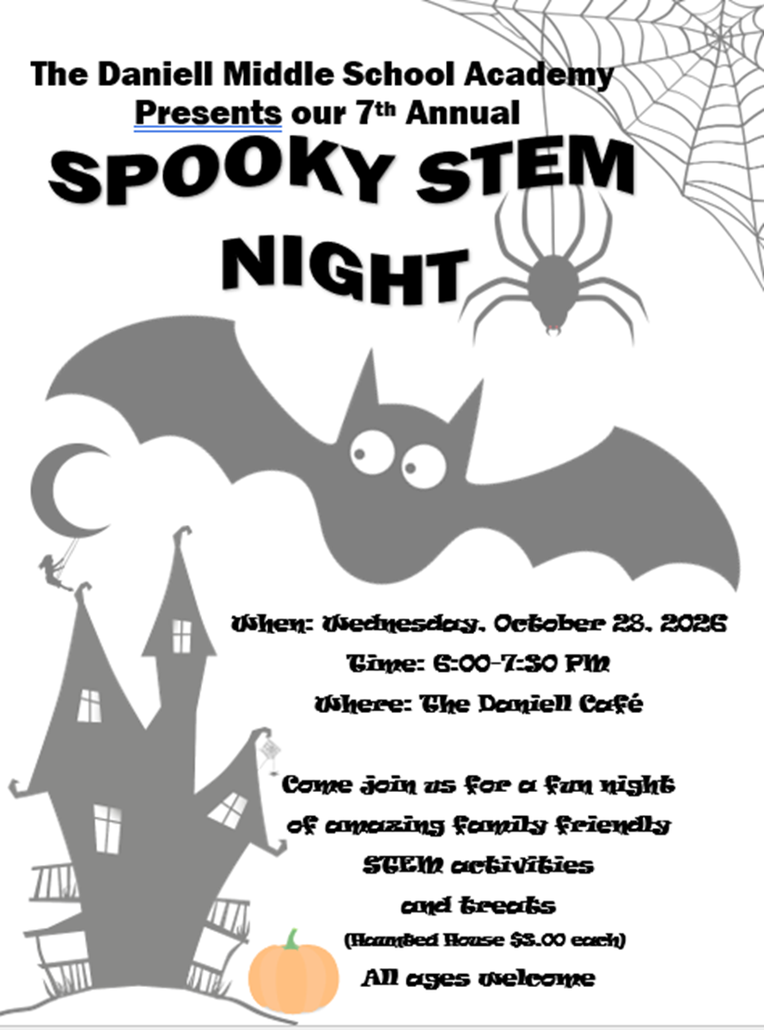

Sprayberry is moving their Trunk or Treat to the stadium this year on Halloween from 10-2!
We'll have bouncy houses ($10 wristband), food vendors, and trick or treating from our student groups and some community partners. Free parking and entry.
Check out the link and attached flyer for more details!
https://www.cobbk12.org/sprayberry/jam-boo-ree-october-31-2026.119426

Nov. 4 is the 6th grade dance, and Nov. 5 is the 7th grade dance from 4:30 – 6:00 pm. The theme this year is Luau. Students are welcome to wear Hawaiian themed shirts that day at school if you are staying for the dance! Students will begin to see the café start to be transformed into a Luau setting to get kids excited about the dance!
Dance permission slips for both 6th & 7th graders will go home Monday, October 26. They are due back Friday, October 31. Dance tickets will be on sale during lunch for $20/ticket Tuesday, October 27 through Thursday, October 29. Students must have purchased a dance ticket and turned in a permission form in order to attend the dance.
We have a list of students whose families already joined PTSA whose dance ticket was included in the price of the PTSA membership. Those students only need to return a permission slip to attend.
Students should not bring outside food or drinks into the school with them in the morning. Please help us with this and encourage your child to finish before entering the school. Thank you!
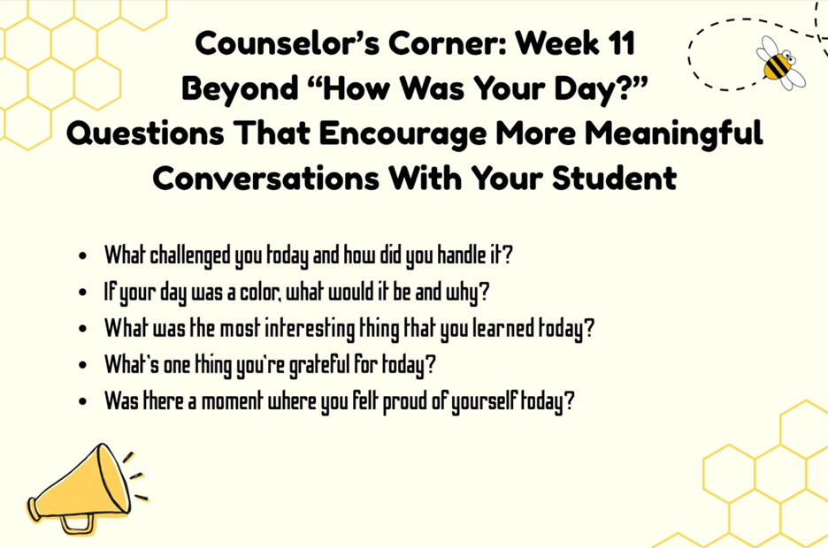

Have a great weekend!

There are 2 attachments with this post. Click the links below to view the attachments.

