An image that contains text, clip art

Automatically generated description

**Brumby Elementary**

***Family-School Participation Policy***

***for shared student success***

*2024–2025 School year*

*Sandra Alford, Principal*

*Cobb County School District*

*815 Terrell Mill Road*

*(770) 916-7070*

[*www.cobbk12.org/brumby*](http://www.cobbk12.org/brumby)

*Reviewed June 1, 2023*

**Brumby Elementary Academic Goals**

**Reading Goal:**

50% of K students will score in the on-track or at/above range on the AMIRA assessment by May 2025.

1st grade students scoring in the on-track or at/above range on the AMIRA assessment will increase from 18% in May 2024 to 35% in May 2025.

2nd grade students scoring in the on-track or at/above range on the AMIRA assessment will increase from 62% in May 2024 to 75% in May 2025.

3rd-5th grade students scoring proficient and distinguished on the ELA EOG will increase from 25% in May 2024 to 30% in May 2025.

3rd-5th grade students reading on grade level on the ELA EOG will increase from 53% in May 2024 to 60% in May 2025.

**Math Goal:**

K students scoring at the prepared level or higher will increase by 20 percentage points from Dec 2024 BEACON math assessment to the May 2025 BEACON math assessment.

1st grade students scoring at the prepared level or higher will increase by 20 percentage points from August 2024 BEACON math assessment to the May 2025 BEACON math assessment.

2nd grade students scoring at the prepared level or higher will increase by 20 percentage points from August 2024 BEACON math assessment to the May 2025 BEACON math assessment.

3rd-5th grade students scoring proficient or distinguished on the Math EOG will increase from 18% (90 students) in May 2023 to 35% (175 students) in May 2025.

School Plan for Shared Student Achievement

**What is it?**

This is a plan that outlines how Brumby Elementary will provide opportunities to enhance family engagement to support student learning. Brumby Elementary values the contributions and participation of families to establish an equal partnership for the common goal of improving student achievement. This plan describes the different ways Brumby Elementary support family involvement and how parents can help plan and participate in activities and events to promote student learning at school and at home.

**Co-developed**

Brumby Elementary invites all parents to complete the fall school improvement input survey/evaluation to provide suggestions on the school's Title I program. All parents are also invited to attend the spring input meeting to review this parent engagement policy, our school-parent compact, staff capability professional learning issues. and the parent involvement budget. In addition, input and feedback from parents regarding this plan is welcome throughout the school year. The plan is posted on our school's website for parents to view and submit feedback throughout the year. All parent feedback received during the year will be used to revise the plan for the upcoming school year. We also distribute an annual survey that is posted online to ask parents for their suggestions on the plan and use of the 1% parent engagement fund reserve. Parents can also give feedback during any parent meetings and activities during the school year.

**Who is it for?**

All students participating in the Title I, Part A program, and their parents and families, are encouraged and invited to participate fully in the opportunities outlined in this policy.  Brumby Elementary will provide a full opportunity for the involvement of neglected and delinquent parents, parents and families with limited English, parents with disabilities, and parents of migrant children.

**Where is it available?**

Each family will receive the plan during the week of the Parent-Teacher Conference. It is also available on the school's website and a copy is in the main office folder. Parents can also retrieve a copy of the plan from the Parent Resource Center. We will gladly mail you the plan upon request.

**What is Title I?**

Brumby Elementary is identified as a school that has a school-wide Title I program as part of Every Student Success Act (ESSA). Title I is designed to support state and local school reform efforts tied to challenging state academic standards that reinforce and enhance efforts to improve student teaching and learning. Title I programs must be based on effective means to improve student achievement and include strategies to support parent involvement. All Title I schools must jointly develop a written parent engagement policy with all parents.

**Cobb County Schools**

**District Goals**

 By SY26, increase growth by 2 percentage points, for students scoring at the proficient and distinguished levels, as evidenced by state assessments.

By SY28, increase graduation rate from 87% to 88% as measured by GaDOE adjusted cohort graduation rate.

**Let's Get Together!**

Brumby Elementary will host the following events to build capacity for strong parent involvement to support a partnership between school, parent, and community to improve students' academic performance. Family and Community Engagement (FACE) activities will take place at various times to provide opportunities for all families to participate. If you are unable to attend and would like information about the meeting, please contact Brumby Elementary School’s parent facilitator.

**Annual Title I Meeting – August 29, 2024: 8:00 AM Brumby Elementary Learning Commons**

We invite you to an evening of learning about our Title I program, including the parent and family engagement policy, school-parent compacts, parents rights under Title I, highlights of the school improvement plan and the 1% reservation of funds for family engagement. Additionally, you’ll receive a description about our school’s curriculum and the assessments used to monitor student progress.

**Parent-Teacher Conferences – October 15-18, 2024**

Receive updates on your child’s progress in class and on assessments during Conference Week.

Parents may always request conferences with their child’s teacher, as needed.

**Fall School Improvement Input Survey- October 28th, 2024**

Brumby will send home the Title I Survey / Evaluation through CTLS Parent. Parents are asked to provide valuable feedback regarding the school, current and future family and community engagement activities and programs.

**Rising 6 Grade Parent Meeting- March 18, 2025: 6:00 PM**

Rising 6 Grade families are introduced to expectations and learning opportunities offered in middle school. East Cobb Middle School and Brumby Elementary School will collaboratively organize this event.

**Spring School Improvement Input Forum- April 24, 2025, at 8:00 AM in the Brumby Media Center**

Parents and educators review and discuss Brumby’s Title I program, future parent activities, school-family compact and policy, family engagement budget and staff trainings.

**Rising Kindergarten Parent Meeting and Orientation- May 2, 2025, at 8:00 AM**

Rising kindergarten families are introduced to expectations and learning opportunities offered in elementary school.

**Other Parent Activities Provided by the School**

**Family Engagement Curriculum Workshops: 5:30 PM on Aug 22, 2024; Oct 24, 2024; Jan 9, 2025; and Mar 20, 2025**

Parents will learn about the curriculum their student will be learning each quarter and ways to support their child at home.

Family-School Pacts

As part of this plan, Brumby Elementary and our families will develop a family-school compact, which is an agreement that parents, teachers, and students will develop that explains how parents and teachers will work together to make sure all our students meet grade level standards. The covenants will be reviewed and updated annually based on feedback from parents, students, and teachers during the School Improvement forum. Family-school covenants are distributed during the week of the Parent-Teacher Conference from October 15-18, 2024. Copies are also available throughout the year with each child's teacher.

8

An image that contains text, clip art

Automatically generated description

**Parent Resource Center (Learning Commons)**

**Hours: Mon.-Fri. 9:30am—3pm**

Visit the Parent Resource Center (PRC) to learn about how you can support your child at home. Computers are available for parents to explore CTLS Learn, CTLS Parent and educational resources.

**One Team, One Goal, Student Success**

Brumby Elementary will take the following steps to promote and support parents as an important foundation of the school to strengthen students' academic performance and achieve our school goals. We:

* Make sure all information related to school and parent programs, meetings, and other activities is posted in English, Spanish, and Portuguese and posted on the school's website.
* Provide two trainings each semester for staff during their planning periods on strategies to improve communication with parents and ideas for increasing family engagement.
* Partner with our feeder schools by holding joint parent meetings and events and sending school information about parent engagement activities to help prepare parents and their children for school transitions.
* Share information in English and Spanish on the school's blog and school newsletter so parents understand the school's academic standards and assessments, as well as ways parents can monitor their child's progress and work with educators.
* Communicate with all families and the community on a regular basis regarding events and activities throughout the school, through CTLS Parent, the school's website, social media, campus signage and brochures, etc.
* Work with our parents to develop relevant trainings and useful presentations to educate our staff about the importance of parent involvement.
* Provide necessary materials and handouts for parents at conferences, meetings, and activities to help parents work with their children to improve their child's performance.
* Use our parent facilitators and educational partners to improve awareness of the activities and events listed in the school's parent engagement policy
* Collect feedback from parents at all events and offer a variety of surveys throughout the school year to respond to parent feedback regarding parent engagement activities and requested meetings.

**Parent involvement matters**

Brumby Elementary is committed to helping our parents and families attend the family activities listed on this page. Call or email us if you need help with childcare or transportation to participate in our programs.

**Irka Serrano**

(770) 916-7070 or   
[Irka.serrano@cobbk12.org](mailto:Irka.serrano@cobbk12.org)

Parental involvement

Brumby Elementary believes that parent involvement means parental involvement in regular two-way and meaningful communication involving students' academic learning and other school activities, including ensuring:

* That parents play an integral role in assisting their children's learning.
* That parents be encouraged to actively participate in their children's education at school.
* That parents are full partners in their children's education and are included, as appropriate, in decision-making and advisory committees to assist in their children's education.

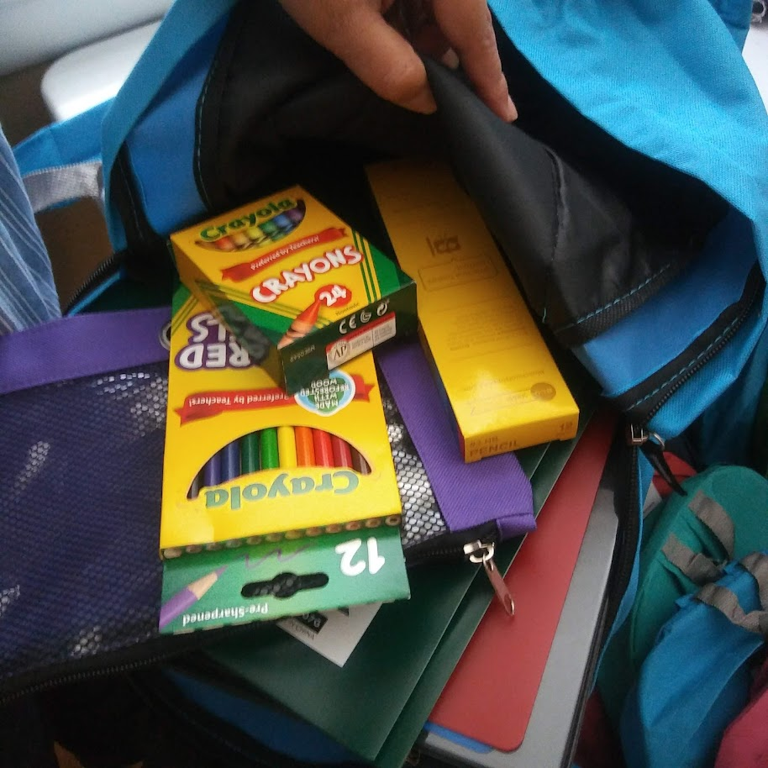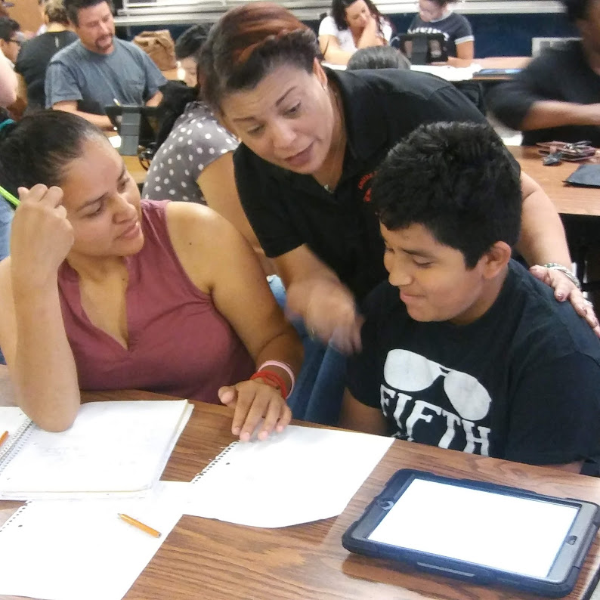

Main Advisory Board

The purpose of the Main Advisory Council is to engage your parents, community members, and school staff to create better understanding and mutual respect for each other's concerns and share ideas for school improvement.

The Main Advisory Council meets three times per school year. Along with the director, board members include:

1. Two staff members (one of them is the current Master of the Year).

2. Two parents (one of them is the current president of the PTSA).

3. Two community members (one of them is a Partner in Education representative).

4. High schools should *only* include the president of the student government association or the president of the upper class.

If you would like to share your ideas and perspectives with the Senior Advisory Council, please contact Sandra Alford, the school's principal, [Sandra.alford@cobbk12.org](mailto:Sandra.alford@cobbk12.org)

Parent Involvement Standards

Brumby Elementary and our parents have adopted the PTA National Standards for Family-School Partnerships as the school's model for engaging parents, students, and the community. These standards are:

1. Welcoming all families
2. Effective communication
3. Supporting student success
4. Speaking for each child
5. Sharing power
6. Collaboration with the community

**Opportunities for Parent Involvement**

I am interested in participating in the Main Advisory Council.

I am interested in volunteering at the main office.

I am interested in volunteering at the media center.

I am interested in other volunteer opportunities, please contact me as needed.

|  |  |  |  |  |
| --- | --- | --- | --- | --- |
| Number: |  | | | |
| Name and grade of child: | | |  | |
| Phone Number: | | | |  |
| Email address: | |  | | |

To return this form by email to the parent facilitator Irka Serrano’s email at [Irka.Serrano@cobbk12.org](mailto:Irka.Serrano@cobbk12.org)

or deliver the form to the school’s Main Office.

**Share your thoughts**

We want to hear from you. If you have any suggestions or if there is any part of this plan that you feel is not satisfactory with the academic achievement goals of the students and the school, please provide us with your feedback in the space provided and leave this form at the Main Office:

|  |  |  |  |
| --- | --- | --- | --- |
| Name (optional): |  | | |
| Phone number (optional): | | |  |
| Email address (optional): | |  | |

Suggestions, compliments, concerns: