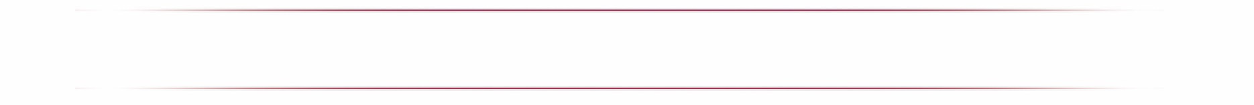

Literature – Specific Rules/Guidelines

LITERATURE is the art of writing. The author (student submitting entry) is a person who expresses their own thoughts and ideas through the use of words. Authors submit a single literary work, handwritten or typed, using grade-appropriate grammar, punctuation and spelling. Collections of literary work (such as poems and short stories) are not accepted.

Consider the following literary styles to portray your original work of fiction or nonfiction: Prose, Poetry, Drama, Reflective essay, Narrative, Short story.
An explanation of the storyline and/or the significance of the literature style might be a useful addition to the artist statement. Whether an entry displays formal writing technique or a simple approach, it will be judged primarily on how well the student uses his or her artistic vision to portray the theme, originality and creativity. Illustrated entries, including books, with pictures drawn by the student author are acceptable; however, only literary content is judged.

Acceptable Use of Type, Dictation and Translation:
- Be typed by another person as long as the original work or a copy of the original work is attached.
- Be dictated to another person and printed or typed in exact words as spoken by the student if the student is in pre-school, kindergarten or 1st grade. (Transcribers should make every attempt to retain the same level of language and accuracy that is reflected in the student’s original work).
- Students for whom English is not their first language may submit literature entries in their own language. An interpretive translation in English must accompany the entry.
- Translators should make every attempt to retain the same level of language and accuracy that is reflected in the student’s original work.
Copyright: Use of copyrighted material is prohibited. Plagiarized entries will be disqualified.

Submission Requirements:
  - Only new pieces of artwork inspired by the theme may be submitted.
  - Each entry must be the original work of one student only.
  - Entry must not exceed 2,000 words.
  - Hand written & typed entries are accepted on 8.5x11 paper (one sided only).
  - Number each page.
  - Include student name, entry title, arts category and division on back of entry.

All participants must also follow Official Rules for Participation

