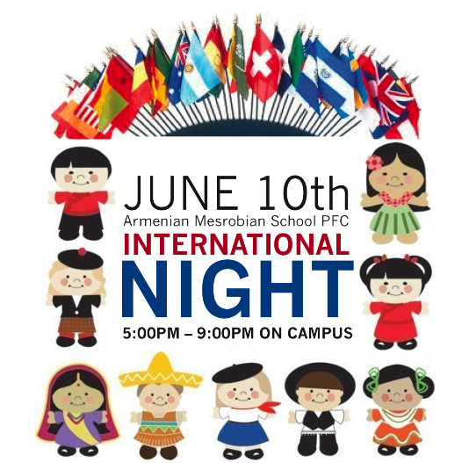

***FREE ADMISSION & FAMILY FRIENDLY***

** Drinks available for $1 **

**Dr**

**Thursday: February 27th**

**Drop-In: 6:00-8:00pm**

***Lost Mountain Middle***

**INTERNATIONAL**

**NIGHT**

***Since 2011***

***Many Nations, Many Friends!***

***Free Festivities for All Ages!***