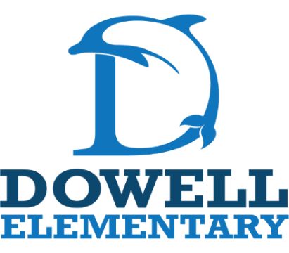
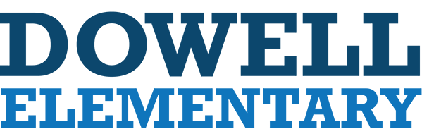

Kindergarten Supply List
2026-2027
-1 Large Backpack
-1 hard case pencil box
-(DLI students need 2 pencil boxes)
-1 pack of pencils
-12 Glue Sticks
Specials Teachers:
- Disinfectant wipes
- tissues
- baby wipes

-1 Large Bottle Gel Hand Sanitizer
-3 Boxes of Family Size Kleenex
-2 Containers of disinfectant wipes
-2 packs of baby wipes
-6 Boxes of Crayola Crayons (24 ct.)
-2 packs of 4 dry erase markers (black)
-1 Pair of Scissors
-(DLI students need 2 pairs of scissors)
-1 can of Play-Doh
-Boys – Gallon Ziplock Bags and 1 box of forks or spoons
-Girls – Sandwich Ziplock Bags and 1 pack of Styrofoam cups

