 Kindergarten Class Supplies for School 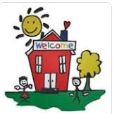
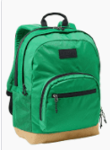  1 Backpack | 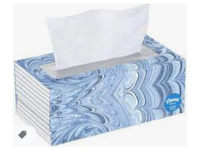  2 boxes of tissues | 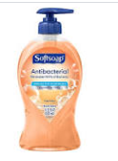  2 bottles of Unscented liquid soap  7.5 FL OZ or more | 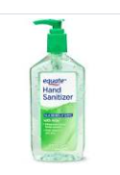  2 large bottles of sanitizer with pump 12 FL OZ
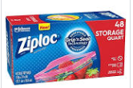  1 large box of quart-size Ziplock bags | 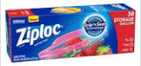  1 large box of gallon-size Ziplock bags | 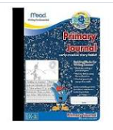  2 Primary Compositional Notebooks | 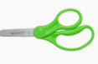  1 pair of blunt-tip scissors
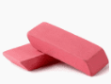  Erasers | 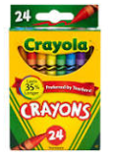  1 box of 24 count crayons | 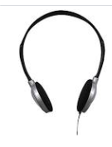  Headphones (priority) | 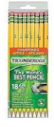  Number 2 Pencils
Supplies for Home 
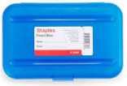  1 durable pencil box | 1 box of 24 count crayons | 1 pack of pencils | 1 pair of scissors
Erasers | 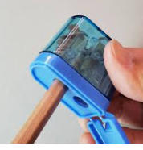  Pencil sharpener

