How to access Clever from home / Cómo acceder a Clever desde casa
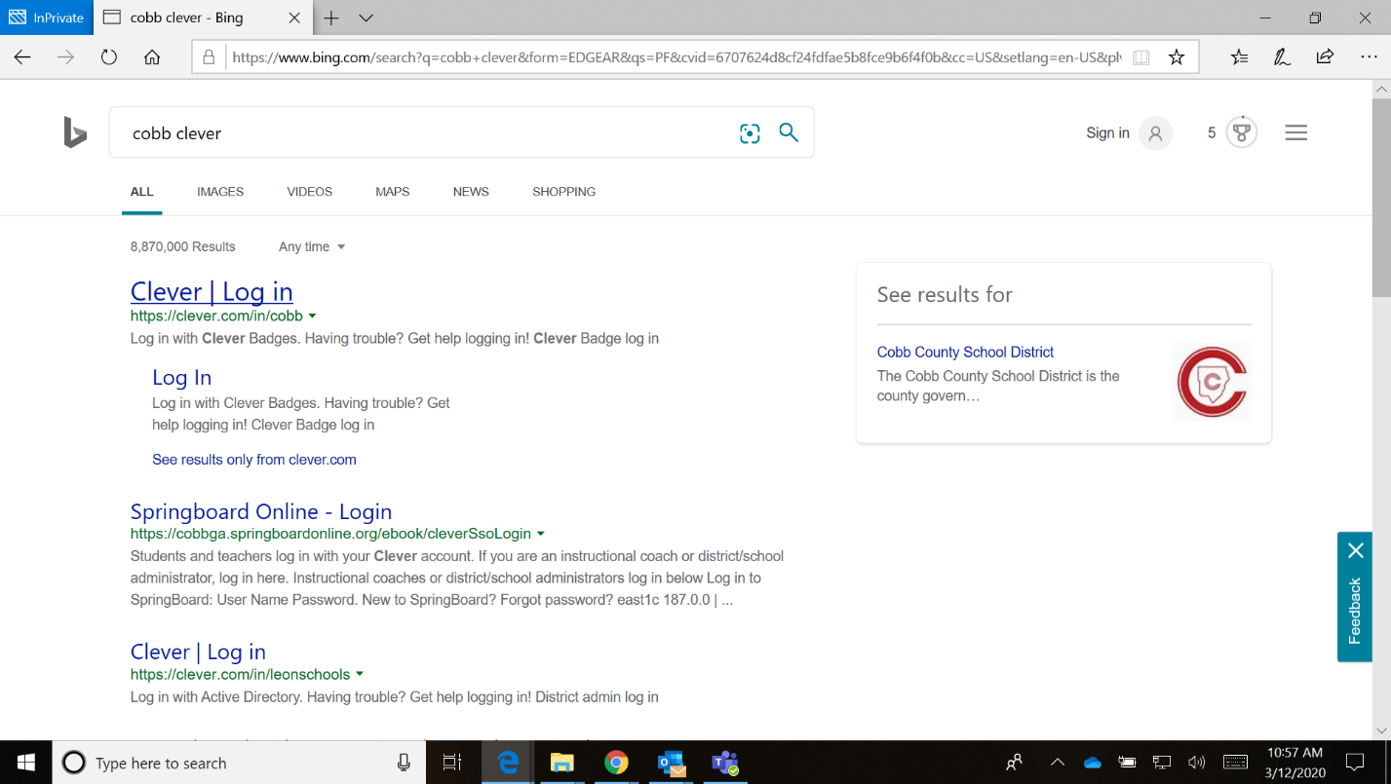

Using Bing or Google search for
“cobb clever”
Usando Bing o Google busca por
“cobb clever”

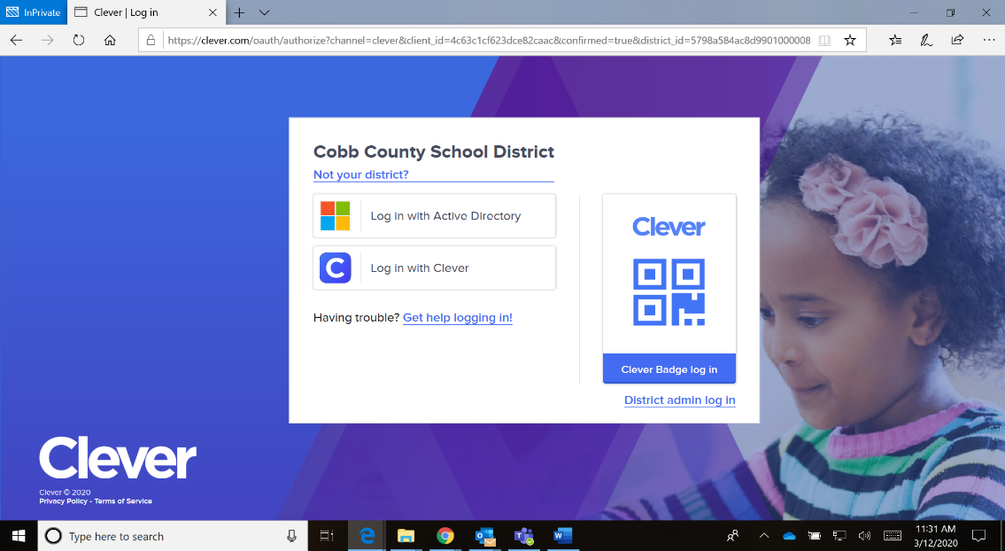

Click on Log in with Active Directory
Haga clic en Iniciar sesión con Active Directory

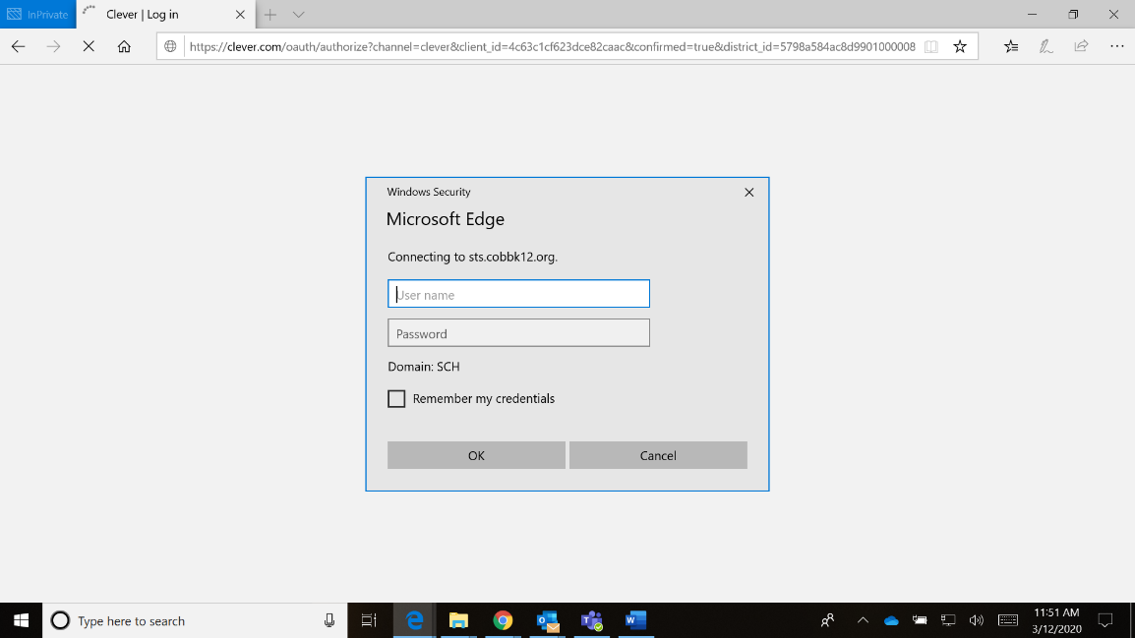
Sign in using / Iniciar sesión usando
Username: your student ID (otherwise known as breakfast number or lunch number)
Numero de estudiante/Numero de lunche
Password: computer password/ contraseña
If you are using a mobile device you might need to use / Si esta usando un telefono podia necessitar usar
Username: firstname.lastname@students.cobbk12.org
nombre.apellido@students.cobbk12.org
Password: computer password/ contraseña

