**FOR IMMEDIATE RELEASE                             CONTACT: Melanie Long**

boosters@wheelertheatre.com

375 Holt Rd. NE Marietta 30068

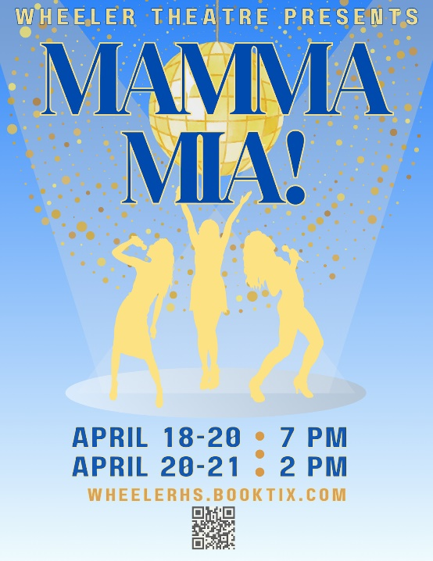

**Wheeler Theatre presents *MAMMA MIA!* The International Smash Hit Musical!**

MARIETTA, Ga. – **Wheeler High School Theatre rocks to ABBA’s timeless hits in the hilarious feel-good musical, *Mamma Mia!* April 18, 19 & 20 at 7 pm and April 20 & 21 at 2 pm.**

Told through Swedish pop group ABBA’s timeless music and inspiring the 2008 hit movie starring Meryl Streep and Pierce Brosnan, *Mamma Mia!* tells the uplifting story of a young woman's search for her birth father on the eve of her own wedding. Non-stop laughs, explosive dance numbers, the magical backdrop of a Greek island paradise, and infectious hits like “Dancing Queen,” “Super Trouper,” “Knowing Me, Knowing You,” “Take a Chance on Me,” and “The Winner Takes It All” make *Mamma Mia!* a trip down the aisle you’ll never forget!

*Mamma Mia!* is presented through a special arrangement with Music Theatre International (MTI). Rated PG -13. Take a chance on Wheeler Theatre for an ABBA-solutely amazing evening and see why people all around the world have fallen in love with this sunny, funny feel-good show!

**ADVANCE TICKETS are $12 at WHEELERHS.BOOKTIX.COM. Tickets at the door: $20 for adults; $15 for students with ID; $12 for kids 12 and under. CCSD Faculty/Staff receive one free ticket at the door with ID.**

# # #