My name is __________________________________________, and I was in your
__________________________________________ class during
Fall/Spring (circle one) semester of the
__________________________________________ school year. I am applying for the Mentorship program for the 2026-2027 school year, and I would appreciate it if you would consider filling out the staff recommendation form for me found at https://forms.office.com/r/kSZbezZFqq
or at the QR code below:
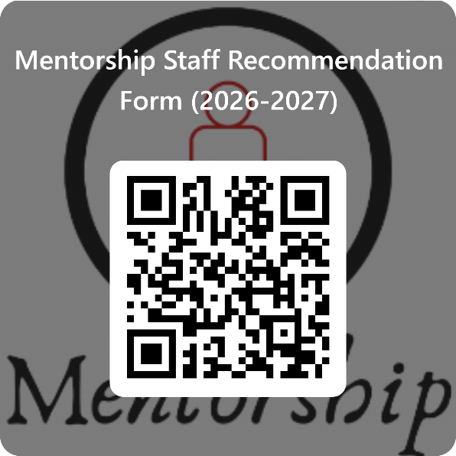
Thank you for your kind consideration to this request. The form is due by Thursday, February 26, 2026, and it should require no more than five (5) minutes of your time.

