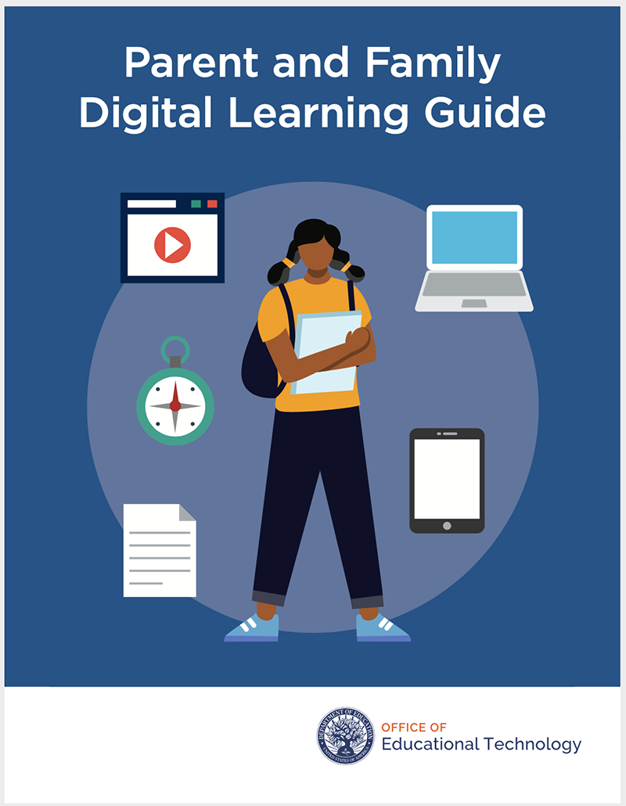
https://tech.ed.gov/files/2020/10/Parent-and-Family-Digital-Learning-Guide.pdf
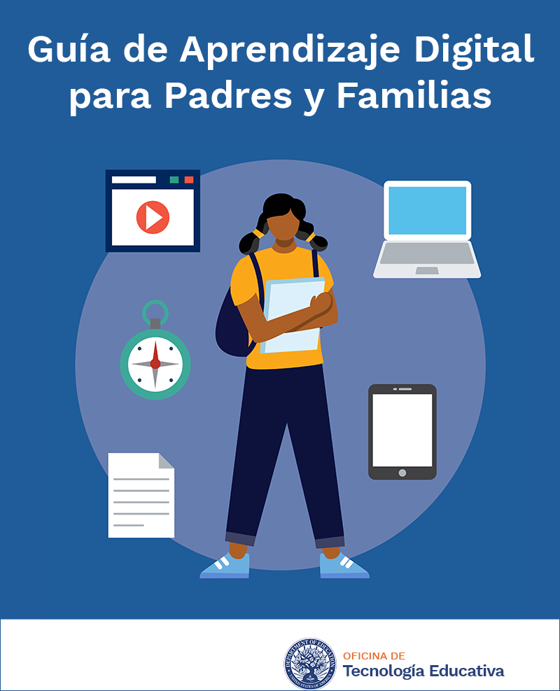
https://tech.ed.gov/files/2020/12/Parent-and-Family-Digital-Learning-Guide-ES.pdf

