**Brumby Elementary**

***Family-School Participation Policy***

***for shared student success***

*2023–2024 School year*

*Sandra Alford, Principal*

*Cobb County School District*

*815 Terrell Mill Road*

*(770) 916-7070*

[*www.cobbk12.org/brumby*](http://www.cobbk12.org/brumby)

*Reviewed June 1, 2023*

**Brumby Elementary**

**Academic goals**

**Reading Goal:**

K- 1st grade- By the end of the 2023-2024 year, we will increase the number of students scoring a composite reading score at or above benchmark by 20 percent from the first administration in August to the final administration in May as determined by the Acadience Reading Assessment.

2nd -5th grade- By the end of the 2023-2024 school year, we will increase the percentage of students scoring in the proficient and/or advanced range by 20 percentage points from the first administration in August to the final administration in May as determined by the district Reading Inventory assessment.

**Math Goal:**

From the August 2023 administration to the May 2024 administration of the Math Inventory, students’ scores in the proficient and/or advanced categories will increase by a minimum of 35 percentage points.

School Plan for Shared Student Achievement

**What is it?**

This is a plan that outlines how Brumby Elementary will provide

Opportunities to enhance family engagement to support learning

students. Brumby Elementary values the contributions and participation of

families to establish an equal partnership for the common goal of improving

l student achievement. This plan describes the different ways Brumby Elementary

support family involvement and how parents can help plan and participate

in activities and events to promote student learning at school and at home.

**Co-developed**

Brumby Elementary invites all parents to complete the fall school improvement input survey/evaluation to provide suggestions on the school's Title I program. All parents are also invited to attend the spring input meeting to review this parent engagement policy, our school-parent compact, staff capability professional learning issues. and the parent involvement budget. In addition, input and feedback from parents regarding this plan is welcome throughout the school year. The plan is posted on our school's website for parents to view and submit feedback throughout the year. All parent feedback received during the year will be used to revise the plan for the upcoming school year. We also distribute an annual survey that is posted online to ask parents for their suggestions on the plan and use of the 1% parent engagement fund reserve. Parents can also give feedback during any parent meetings and activities during the school year.

**Who is it for?**

All students participating in the Title I, Part A program, and their parents and families, are encouraged and invited to participate fully in the opportunities outlined in this policy.  Brumby Elementary will provide a full opportunity for the involvement of neglected and delinquent parents, parents and families with limited English, parents with disabilities, and parents of migrant children.

**Where is it available?**

Each family will receive the plan during the week of the Parent-Teacher Conference. It is also available on the school's website and a copy is in the main office folder. Parents can also retrieve a copy of the plan from the Parent Resource Center. We will gladly mail you the plan upon request.

**What is Title I?**

Brumby Elementary is identified as a school that has a school-wide Title I program as part of Every Student Success Act (ESSA). Title I is designed to support state and local school reform efforts tied to challenging state academic standards that reinforce and enhance efforts to improve student teaching and learning. Title I programs must be based on effective means to improve student achievement and include strategies to support parent involvement. All Title I schools must jointly develop a written parent engagement policy with all parents.

An image that contains text, clip art

Automatically generated description

**Let's Get Together!**

Brumby Elementary will host the following events to build capacity for strong parent involvement to support a partnership between school, parent, and community to improve students' academic performance. Family and Community Engagement (FACE) activities will take place at various times to provide opportunities for all families to participate. If you are unable to attend and would like information about the meeting, please contact Brumby Primary.

**Meet and Greet—July 28th, 2023**

Parents and students are invited to come meet classroom teachers, find their bus routes, join PTA, purchase uniforms, and so much more.

**State of the School Meeting During Open House—August 24, 2023**

We invite you to a night of learning about our Title I program, including the parent and family engagement policy, school-parent compacts, parental rights under Title I, school improvement plan highlights, and the 1% funding set aside for family engagement. In addition, you will receive a description about our school's curriculum and assessments used to monitor student progress. A follow up feedback meeting will be held on **August 31st** for parents to provide input on community building and parent involvement.

**Open House—August 24, 2023**

During this event, teachers will share important information with parent, such as daily schedules, grade level curriculum, classroom expectations, and so much more.

**Fall Activity Literacy Night—September21st, 2023**

**Parent and Teacher Conferences – October 17-October 20, 2023**

Get updates on your child's progress in class and assessments during Conference Week.

Parents can always request lectures with their child's teacher, as needed.

**Fall School Improvement Information Survey-October 17—21, 2023**

Brumby Elementary will send home the Title I Survey/Assessment through Parent CTLS or provide a QR code for the parents to access the survey during conference week. Parents are asked to provide valuable feedback on current and future school, family and community engagement activities, and programs.

**Math Night January 25, 2024**. Come join us for a Fun Math Night. Discover what your child is learning in math and how you can support your child at home.

**International or STEAM Night-March**

**Spring School Improvement Input** Forum **April 12th, 2024**

Educators and parents review and discuss the Title I brumby program, future parent activities, school and family covenant and policy, family engagement budget, and staff training.

**Career Day-April 19th, 2024**

This is a day to encourage students to dream big, focus on academics, and prepare for life beyond school. Parents and community members will sign up to share their career with Brumby students.

**Rising Kindergarten Orientation-May 14th, 2024**

Parents will visit the school for a tour of classrooms and relevant areas of the building while their student participates in engaging activities with kindergarten teachers.

Family-School Pacts

As part of this plan, Brumby Elementary and our families will develop a family-school compact, which is an agreement that parents, teachers, and students will develop that explains how parents and teachers will work together to make sure all our students meet grade level standards. The covenants will be reviewed and updated annually based on feedback from parents, students, and teachers during the School Improvement forum. Family-school covenants are distributed during the week of the Parent-Teacher Conference from October 17th-20th, 2023. Copies are also available throughout the year with each child's teacher.

**2023-2024**

**Cobb County Schools**

**District Goals**

* Increase student achievement in all core content areas by 2% annually as measured by performance data.
* CCSD will increase the participation rate of families and communities participating in services/programs by 10% as measured by CTLS parent data, survey results, and web view module.
* By 2023, we will reorganize the PL framework to meet the needs of all schools to ensure alignment with the Superintendent's priorities as measured by PL opportunities, surveys, and student achievement.
* By the end of the 2025 school year, all schools will have identified practices and resources that support student success as measured by student academic, perception, or discipline data.

8

An image that contains text, clip art

Automatically generated description

**One Team, One Goal, Student Success**

Brumby Elementary will take the following steps to promote and support parents as an important foundation of the school in order to strengthen students' academic performance and achieve our school goals. We:

* Make sure all information related to school and parent programs, meetings, and other activities is posted in English, Spanish, and Portuguese and posted on the school's website.
* Provide two trainings each semester for staff during their planning periods on strategies to improve communication with parents and ideas for increasing family engagement.
* Partner with our feeder schools by holding joint parent meetings and events and sending school information about parent engagement activities to help prepare parents and their children for school transitions.
* Share information in English and Spanish on the school's blog and school newsletter so parents understand the school's academic standards and assessments, as well as ways parents can monitor their child's progress and work with educators.
* Communicate with all families and the community on a regular basis regarding events and activities throughout the school, through CTLS Parent, the school's website, social media, campus signage and brochures, etc.
* Work with our parents to develop relevant trainings and useful presentations to educate our staff about the importance of parent involvement.
* Provide necessary materials and handouts for parents at conferences, meetings, and activities to help parents work with their children to improve their child's performance.
* Use our parent facilitators and educational partners to improve awareness of the activities and events listed in the school's parent engagement policy
* Collect feedback from parents at all events and offer a variety of surveys throughout the school year to respond to parent feedback regarding parent engagement activities and requested meetings.

**Parent involvement matters**

Brumby Elementary is committed to helping our parents and families attend the family activities listed on this page. Call or email us if you need help with childcare or transportation to participate in our programs.

Luz Landaverde

(770) 916-7070 or   
Luz.landaverde@cobbk12.org

**Parent Resource Center (Learning Commons)**

**Hours: Mon.-Fri. 9:30am—3pm**

Visit the Parent Resource Center (PRC) to review books, study materials, and activities to use at home with your child. Computers are available for parents to explore CTLS Learn, CTLS Parent and educational resources.

Parental involvement

Brumby Elementary believes that parent involvement means parental involvement in regular two-way and meaningful communication involving students' academic learning and other school activities, including ensuring:

* That parents play an integral role in assisting their children's learning.
* That parents be encouraged to actively participate in their children's education at school.
* That parents are full partners in their children's education and are included, as appropriate, in decision-making and advisory committees to assist in their children's education.

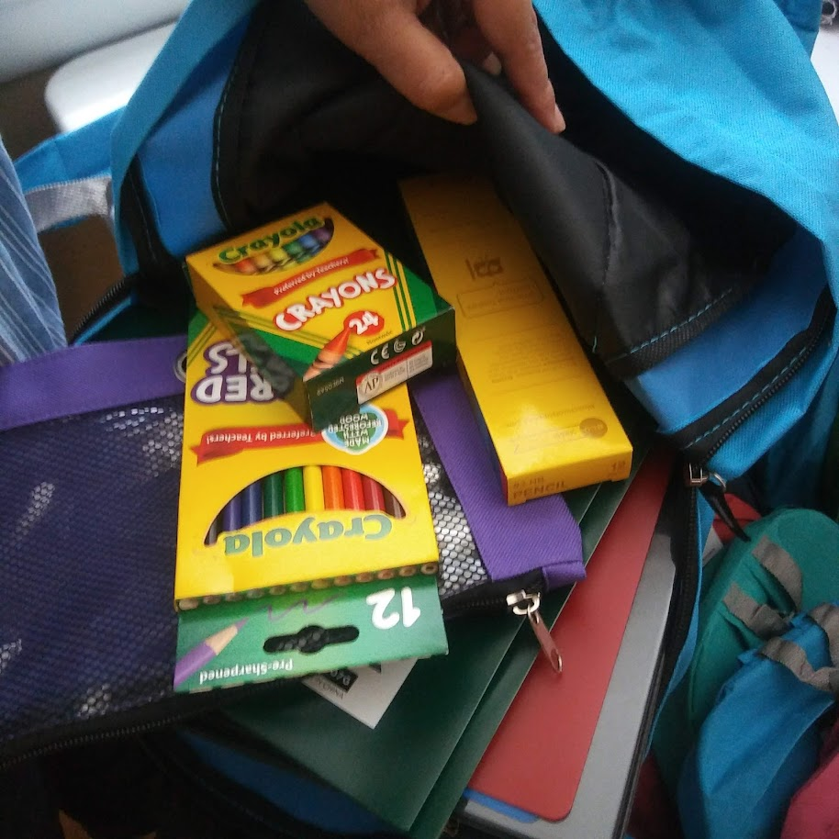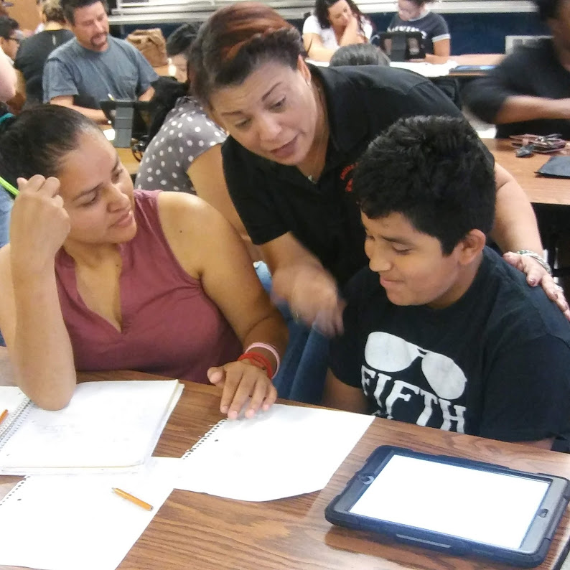

Main Advisory Board

The purpose of the Main Advisory Council is to engage your parents, community members, and school staff to create better understanding and mutual respect for each other's concerns and share ideas for school improvement.

The Main Advisory Council meets three times per school year. Along with the director, board members include:

1. Two staff members (one of them is the current Master of the Year).

2. Two parents (one of them is the current president of the PTSA).

3. Two community members (one of them is a Partner in Education representative).

4. High schools should *only* include the president of the student government association or the president of the upper class.

If you would like to share your ideas and perspectives with the Senior Advisory Council, please contact Sandra Alford, the school's principal, [Sandra.alford@cobbk12.org](mailto:Sandra.alford@cobbk12.org)

Parent Involvement Standards

Brumby Elementary and our parents have adopted the PTA National Standards for Family-School Partnerships as the school's model for engaging parents, students, and the community. These standards are:

1. Welcoming all families
2. Effective communication
3. Supporting student success
4. Speaking for each child
5. Sharing power
6. Collaboration with the community

**Opportunities for Parent Involvement**

I am interested in participating in the Main Advisory Council.

I am interested in volunteering at the main office.

I am interested in volunteering at the media center.

I am interested in other volunteer opportunities, please contact me as needed.

|  |  |  |  |  |
| --- | --- | --- | --- | --- |
| Number: |  | | | |
| Name and grade of child: | | |  | |
| Phone Number: | | | |  |
| Email address: | |  | | |

To return this form by email to the parent facilitator email

or deliver the form to the school's Main Office.

**Share your thoughts**

We want to hear from you. If you have any suggestions or if there is any part of this plan that you feel is not satisfactory with the academic achievement goals of the students and the school, please provide us with your feedback in the space provided and leave this form at the Main Office:

|  |  |  |  |
| --- | --- | --- | --- |
| Name (optional): |  | | |
| Phone number (optional): | | |  |
| Email address (optional): | |  | |

Suggestions, compliments, concerns: