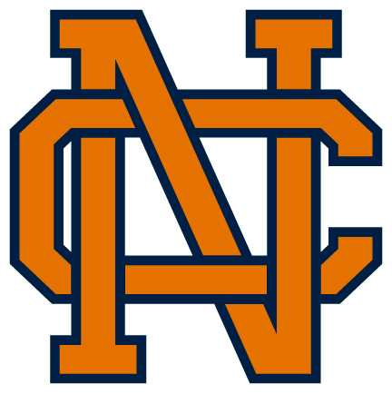North Cobb High School Student Parking Information
Parking Decal Prices are Based on Purchase Date
1st Semester |  |  | 2nd Semester
August – September | $50 | January – February |  | $50
October | $45 | March |  | $45
November | $40 | April |  | $40
December | $30 | May |  | $30
You must fill out the parking application using your Office365 student account and must upload an image of your driver’s license, current insurance card, and license plate. Please note that the application process takes 24-48 hours. Do not park on campus until you have a current decal affixed to your windshield.
Decals for a 2nd car for the same driver are available for $5. A separate application must be completed for the 2nd car. This is a great option to avoid problems when a car breaks down or when a family member needs to swap cars. Both cars may never be parked on campus at the same time. Families with siblings who both drive must purchase 2 first car decals.
- You may pay on mypaymentsplus.com using a debit/credit card or bring cash with you when you pick up your decal.
- Outstanding fines/fees must be cleared (parking citations, missing textbooks, Media Center fees, etc.) prior to receiving a decal.
- A new application must be completed each semester per CCSD.

Pickup Schedule

Tuesday, July 30 – Wednesday, July 31 for applications submitted by 7/28
9:00 - 12:00 – Main office
1:00 - 3:00 – Main office
Thursday, August 1st – Friday, August 9th for applications submitted by 8/7
Before and after school outside Admin 1
Main Cafeteria during all lunches
After Friday, August 9th
Before and after school from Mrs. Reese

Other Information

Ticketing begins the 2nd week of each semester and continues randomly throughout the semester.

