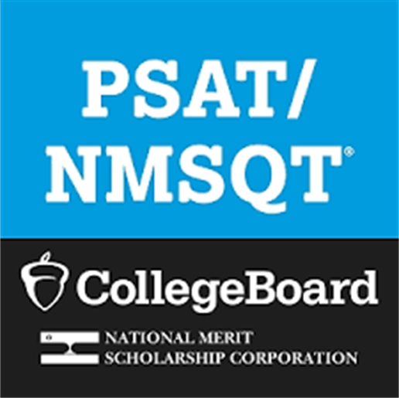


Get Ready for the Digital PSAT/NMSQT

Payment Information

9th Grade: $17.00
10th Grade: No Cost
11th Grade: $15.00

Go to MyPaymentsPlus to make a payment.

Deadline to pay is
Friday, September 4th.

If you have questions, please contact Robin Dowdy, Assistant Principal, at robin.dowdy@cobbk12.org.

Visit https://www.cobbk12.org/southcobb/psatnmsqt.136124

South Cobb High School will administer the digital PSAT/NMSQT (National Merit Qualifying Test) the morning of Wednesday, October 21, 2026, to all 10th graders (at no cost) and to 9th and 11th graders who pay for the test.
The PSAT/NMSQT will be administered DIGITALLY. This means students must bring their fully charged CCSD laptop and charging cord the morning of testing. For more information about the digital test and the importance of taking the test, visit SAT SUITE OF ASSESSMENTS
The Junior year PSAT/NMSQT results are used for students to enter the National Merit Scholarship and the National Achievement Scholarship Programs.
The PSAT/NMQST is the only way to qualify.
For more information on the PSAT/NMSQT visit PSAT/MNSQT Fall 2026 Student Guide.

PSAT/NMSQT PRACTICE
College Board Practice Tests
Digital SAT Khan Academy

PSAT/NMSQT SCORES
COLLEGEBOARD UNDERSTANDING SCORES

