**READ 180/System 44 Home Access**

Dear Parent or Guardian:

While your student is home for an extended period of time, we want to be sure they continue their learning by having home access to their reading intervention program. They will be able to continue learning using the software and will be able to access digital books and take quizzes on those books Monday – Friday 7:00 AM to 6:00 PM.

**Student Access to READ 180 Universal or System 44 NG:**

From an iPad:

1. Download either the READ 180 Universal app or the System 44 NG app (depending on which program your child is enrolled in)
2. Go to “Settings” to configure the app for use (see attached instructions)

From a computer:

1. Go to the appropriate URL for your student’s grade level:

Elementary: <https://h100000058.education.scholastic.com>

Middle:   <https://h100004008.education.scholastic.com>

High: <https://h100003989.education.scholastic.com>

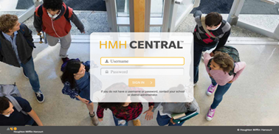

1. Enter the student’s username and password (both are the Student ID #)
2. Please limit software usage to 20-minute sessions once per day, Monday-Friday. This is the recommended usage based on program research.