Sanders PTA


Is your child asking for their own device?
Do they want more freedom online?
How will you know if they are ready?

Join Sanders PTA for the PTA Connected: Ready, Tech, Go! workshop and find out.
Monday April 27th, 2026
Sanders Elementary Media Center
10:30 – 11:30 PTA: Ready Tech Go
or scan QR code
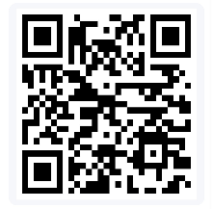

During this educational event, parents and caregivers will:
- Reflect on various aspects of screen readiness.
- Become familiar with tools and resources that help families determine screen readiness and discuss digital life.
- Gain new ideas to promote a healthy digital home.

