**Russell Elementary**

**Red Ribbon Week Activities**

October 21st – 25th, 2024

*I Elect to Be Drug Free*

**Monday – October 21st Wear RED Day and Pledge to Be Drug Free**

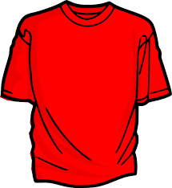

**Turn Your Back on Drugs** – Students and staff will wear Red shirts.

---------------------------------------------------------------------------------------------------------------------------------------

**Tuesday – October 22nd Band Together, Say NO to Drug Free**

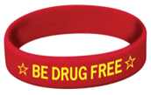

***Band Together* to be Drug-Free** – All students and staff will wear Your Red Ribbon Band.

---------------------------------------------------------------------------------------------------------------------------------------

**Wednesday – October 23rd Write Off Drugs, Elect to Be Drug Free**

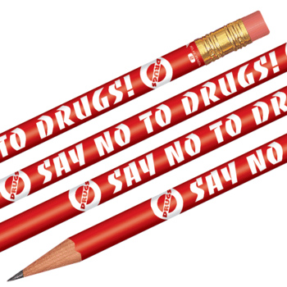

**Write off Drugs** – Students and staff write with your Red Ribbon Pencil.

---------------------------------------------------------------------------------------------------------------------------------------

**Thursday – October 24th Team Up Against Drugs**

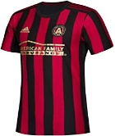

**Team Up** -Students and staff will wear their favorite sport team shirt.

---------------------------------------------------------------------------------------------------------------------------------------

**Friday - October 25th  Give Drugs the Boot!**

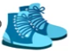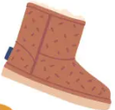

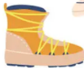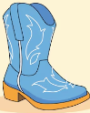

**Boot Drugs Out** – Students and staff will dress in their favorite boots.