Dear Parents/Guardians,

Thank you for your interest in BMS Running Club! We are excited to have this opportunity here at Barber! Our running club is designed to allow students to move and work towards fitness goals and gaining a healthier lifestyle overall. Participants will walk, jog, and/or run at their physical ability. Running club will meet once per week on Tuesdays from 4:15 -5:15 p.m. (with prompt parent pickup at the front of the school). *Please plan for a prompt pick-up at 5:15 p.m., as coaches have other time-sensitive responsibilities* *thereafter.* There is no cost to running club, however, a donation is welcomed. One of our goals will be to participate in a local 5K, of which will have a registration cost. Members will be given a free club t-shirt after regular attendance.

Running club attire is the same for P.E. classes. Long-sleeved undershirts and jogging pants may be needed during the winter months. Students are asked to bring a water bottle each session. For inclement weather, an announcement will be made to update students before 4:15 p.m.



July/August 2025

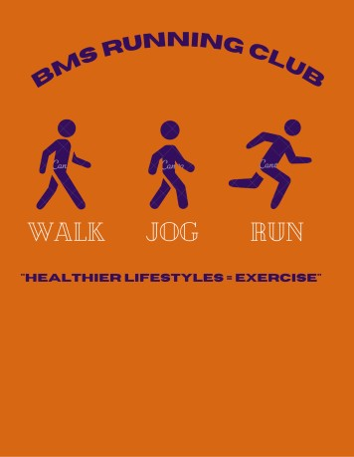

All grade levels (6th, 7th & 8th) are welcome to join at any time. Announcements will be made in school, via CTLS, the Barber Middle School website, and later with REMIND101.

Please show up and participate, if interested! Our start date is Tuesday, August 19, 2025. We look forward to seeing you soon.

Best Regards,

Ms. Bush (Sponsor/Coach) Mr. Gallant (Coach)

Allison.bush@cobbk12.org David.gallant@cobbk12.org

**BMS Running Club**

**Membership Form**

**Student ____________________________________________________________ Grade _______**

**T-Shirt Size ___________ Medical Concerns _______________________________________**

**S – M – L - XL**

**Parents/Guardians __________________________________________________________________**

**Phone ____________________________________ Email____________________________________**

**Parents/Guardians __________________________________________________________________**

**Phone ____________________________________ Email____________________________________**

**Permission for Club photographs (e.g., Yearbook)**

**Yes _____**

**No ______**

***Return completed forms to the front office for Ms. Bush.***

