For each School Strategic Plan goal, identify progress on any action steps.
Provide data to support the impact/implementation.
Implementation artifacts and evidence for impact should align to the SSP.
School Name: Campbell High School
Monitoring Date: January 13, 2026

GOAL #1  Literacy | The percentage of 9th grade students scoring proficient and distinguished (levels 3 and 4) on the iReady Assessment will increase by 3% as measured by the iReady Assessments given at beginning of school year and end of school year.

Action Step(s) | Summary of Artifacts Indicating Implementation  (See SSP) | Data Summary of Evidence Indicating Impact  (See SSP) Include progress toward goals
 | Artifacts: CCC Unit Plans and CCC meeting minutes will show Vocabulary implementation strategies.  Artifact Summary:  CCC Unit Plans and CCC Meeting Minutes were reviewed and showed evidence of strategies to improve vocabulary. | Evidence: 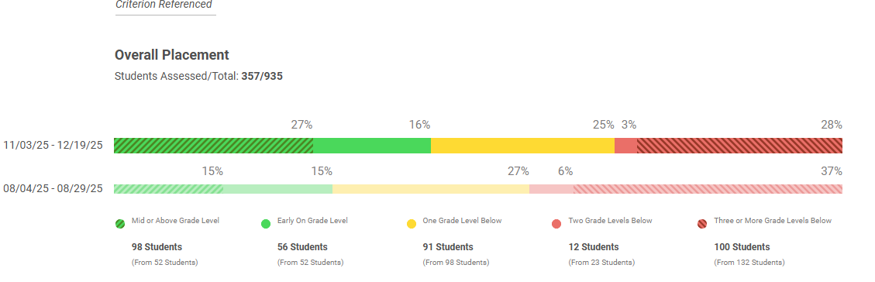  Evidence Summary:  There is clear growth at the top, with students performing mid or above grade level increasing from 15% to 27%.  The most at-risk group decreased, as students three or more grade levels below dropped from 37% to 28%.  The percentage of students two grade levels below was reduced by half, from 6% to 3%.  The one-grade-level-below group remained relatively stable, shifting slightly from 27% to 25%.  Overall, the data shows positive upward movement, with fewer students in the lowest performance bands and more students reaching or approaching grade-level proficiency.
 | Artifacts:  Artifact Summary: | Evidence:  Evidence Summary:
 | Artifacts:  Artifact Summary: | Evidence:  Evidence Summary:

GOAL #2  Math | The percentage of Algebra I students scoring proficient and higher (levels 3 and 4) will increase by 3% as measured by the final 2025-2026 Algebra I EOC, going from 35.3% to 38.3%

Action Step(s) | Summary of Artifacts Indicating Implementation  (See SSP) | Data Summary of Evidence Indicating Impact  (See SSP) Include progress toward goals
 | Artifacts: Weekly lesson plans and class walk-through forms.  Artifact Summary:  Weekly lesson plans and CCC minutes showed a focus on specific domains with aligned strategies. | Evidence:  CCSD Milestones data:  Algebra EOC data Winter 2024-2025 SY: 47.7%  Algebra EOC data Winter 2025-2026 SY: 46.6%  Evidence Summary:  There was a slight overall decline in performance from Winter 2025 to Winter 2026.  Domain 11: Data and Statistical Reasoning emerged as the weakest area, with 33% of students scoring below target. The mean score in this domain decreased from 1.79 in the 2025 school year to 1.70 in the 2026 school year, representing a modest decline of 0.09. This domain remains an area of concern and requires targeted improvement.  Overall, the data reflect a marginal decrease in performance of 1.1%.
 | Artifacts:  Artifact Summary: | Evidence:  Evidence Summary:
 | Artifacts:  Artifact Summary: | Evidence:  Evidence Summary:

GOAL #3
School Selected

Action Step(s) | Summary of Artifacts Indicating Implementation  (See SSP) | Data Summary of Evidence Indicating Impact  (See SSP) Include progress toward goals
 | Artifacts:  Artifact Summary: | Evidence:  Evidence Summary:
 | Artifacts:  Artifact Summary: | Evidence:  Evidence Summary:
 | Artifacts:  Artifact Summary: | Evidence:  Evidence Summary:

Provide a rationale/reason as to why any action step was not implemented.
Goal # | Action Step(s) | Non-Implementation: Causes, Carriers, Concerns, etc…

