***Second Grade Supplies***

* 2 Bound Hard-Cover Composition Notebook
* 3 Wide Ruled 1 subject Spiral Bound Notebooks
* 1 Package Wide Line Notebook Paper
* 1 (1 inch) White Clear View Binder
* 2 Packages of #2 Sharpened Ticonderoga Pencils
* 2 Boxes of 24-Count Crayola Crayons
* 3 Large or 8 Small Elmer Glue Sticks
* 1 Pair 5” (blunt tip) Fiskars Scissors
* 4 Wide Tipped EXPO Black Dry Erase Markers
* 1 Zippered Pencil Pouch with Grommets
* 1 Plastic Pencil Box (5 X 8)
* 2 Boxes (12ct) Crayola Colored Pencils
* 1 Large Pink Eraser
* 1 Pump Bottle Purell/Germ X Hand Sanitizer
* 2 Boxes of Tissues
* 2 Containers of Clorox Wipes
* 1 Box of Gallon Size Baggies
* 2 Red Ballpoint Pens
* 1 Package of Sticky Notes
* 1 Container of Wet Wipes/Baby Wipes for Art
* 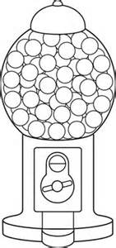1 Pair of Over The Ear Headphones – No Earbuds