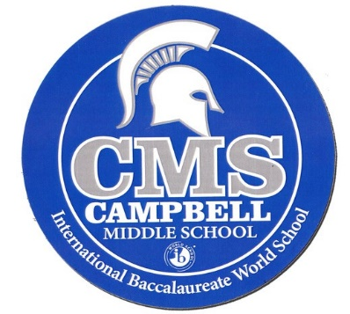Name \_\_\_\_\_\_\_\_\_\_\_\_\_\_\_\_\_\_\_\_\_\_

Teacher \_\_\_\_\_\_\_\_\_\_\_\_\_\_\_\_\_\_\_\_

3295 Atlanta Road

Smyrna, GA 30080

678-843-6873

[www.cobbk12.org/CampbellMS](http://www.cobbk12.org/CampbellMS)

Twitter: @cmsspartans1

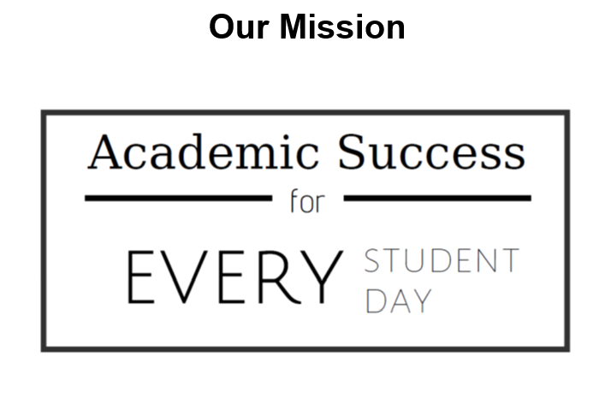

**JR. SPARTANS ARE:**

Responsible

Respectful

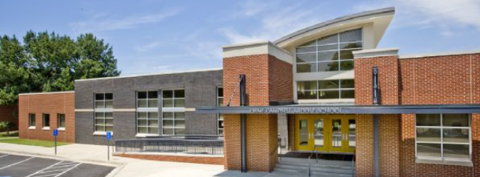and Safe



Welcome to CMS!



**Dr. Camille Havis, Principal**

Welcome to Campbell Middle School! We are excited about the learning opportunities students will participate in this year. As Cobb’s only International Baccalaureate Middle Years World School, students will be exposed to instruction and learning that is based on a world perspective and will challenge all students to be successful in our global society. The opportunities are abound at our school, and we urge each student to take advantage of these experiences as well as our extra-curricular clubs and activities.

The faculty and staff pride themselves in working with the students, parents, and community stakeholders at Campbell Middle School. We are committed to excellence and look forward to a fantastic school year!

**This Agenda is considered a Textbook**

Student Agendas will be issued and treated the same as a textbook. If you lose or damage your agenda, you will be required to replace the agenda for a cost of $10.00.

**Protocol for Resolving Issues**

We encourage all parents to work with the classroom teacher first. If the teacher cannot resolve the issue, then:

Ms. Erin Thaler – 6th grade AP & Scheduler

Ms. Eva Miano – 7th grade AP & Test Coordinator

Mr. Erik Thompson – 8th grade AP & Buses



OUR VISION





**HONOR CODE**

As a member of The Middle Years International Baccalaureate Program, Campbell Middle School is committed to developing students who will make a meaningful contribution to the world, both during and after their educational experience. Students and faculty are part of a class, school, district and global community devoted to learning. There is honor in being part of this community. Therefore, in order to sustain this honor, each individual must take personal responsibility to conduct himself or herself by demonstrating honesty and integrity in their conduct. Acts of lying or cheating compromise the principles of what it means to be a citizen of Campbell Middle School. As an IB school, the expectation is that each student will strive to promote respect, responsibility, honesty, compassion, and will encourage the same conduct from their fellow students. This means unless otherwise indicated, any work submitted by a student is to be the original work of that student since cheating and plagiarism undermine the basic trust that must exist between the faculty and students.

* **Disciplinary Action**
  + **Assignment of a zero for that particular grade**
  + **Teacher notification to parent regarding incident**
  + **Student / Administrator conference**
* **After the first offense, all subsequent offenses are directed to the grade level administrator for insubordination. Incidents of cheating are cumulative over the student’s middle school enrollment.**



International Mindedness



**IB MISSION STATEMENT**



The International Baccalaureate aims to develop inquiring, knowledgeable and caring young people who help to create a better and more peaceful world through intercultural understanding and respect.

To this end, the organization works with schools, governments, and international organizations to develop challenging programs of international education and rigorous assessment.

These programs encourage students across the world to become active, compassionate, and lifelong learners who understand that other people, with their differences, can also be right.

**IB LEARNER PROFILE TRAITS**

The aim of all IB programs is to develop internationally minded people who, recognizing their common humanity and shared guardianship of the planet, help to create a better and more peaceful world.

I**nquirers** – They develop their natural curiosity. They acquire the skills necessary to conduct inquiry and research and show independence in learning. They actively enjoy learning and this love of learning will be sustained throughout their lives.

**Knowledgeable** – They explore concepts, ideas and issues that have local and global significance. In so doing, they acquire in-depth knowledge and develop understanding across a broad and balanced range of disciplines.

**Thinkers** – They exercise initiative in applying thinking skills critically and creatively to recognize and approach complex problems, and make reasoned, ethical decisions.



International Mindedness



**Communicators** – They understand and express ideas and information confidently and creatively in more than one language and in a variety of modes of communication. They work effectively and willingly in collaboration with others.



**Principled** – They act with integrity and honesty, with a strong sense of fairness, justice, and respect for the dignity of the individual, groups, and communities. They take responsibility for their own actions and the consequences that accompany them.

**Open-minded** – They understand and appreciate their own cultures and personal histories, and are open to the perspectives, values, and traditions of other individuals and communities. They are accustomed to seeking and evaluating a range of points of view and are willing to grow from the experience.

**Caring** – They show empathy, compassion, and respect towards the needs and feelings of others. They have a personal commitment to service, and act to make a positive difference to the lives of others and to the environment.

**Risk-takers** – They approach unfamiliar situations and uncertainty with courage and forethought and have the independence of spirit to explore new roles, ideas, and strategies. They are brave and articulate in defending their beliefs.

**Balanced** – They understand the importance of intellectual, physical, and emotional balance to achieve personal well-being for themselves and others.

**Reflective** – They give thoughtful consideration to their own learning and experience. They are able to assess and understand their strengths and limitations in order to support their learning and personal development.



The Jr. Spartan Bell Schedule



**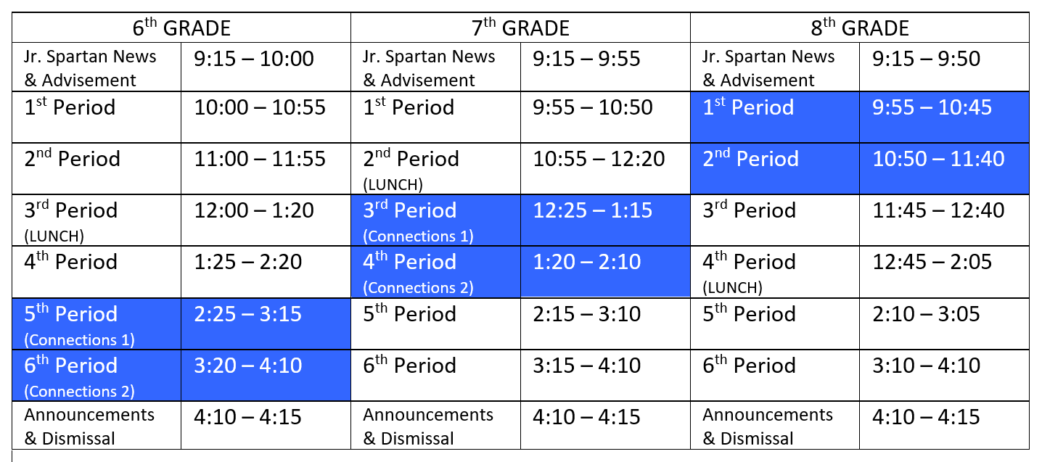**

**IMPORTANT DATES**

|  |  |
| --- | --- |
| 8/1/22 | First day of School |
| 9/5/22 | Labor Day (No School) |
| 9/26/22 -  9/30/22 | Fall Break (No School) |
| 10/17/22 -  10/21/22 | Conference Week Q1 Report Card |
| 11/8/22 | Election Day  Staff Workday |
| 11/21/22 -  11/25/22 | Thanksgiving Break (No School) |
| 12/15/22  12/15/22 | Early Release |

|  |  |
| --- | --- |
| 12/19/22 -  1/3/23 | Winter Break  (No School) |
| 1/4/23 | 1st Day 2nd Semester |
| 1/16/23 | MLK Day (No School) |
| 2/20/23 -  2/24/23 | Mid-Winter Break |
| 4/3/23 -  4/7/23 | Spring Break  (No School) |
| 5/23/23 | Early Release |
| 5/24/23 | Last Day of School (Early Release) |



JUNIOR SPARTAN PRIDE





**RESPECTFUL / RESPONSIBLE / SAFE**

Positive Behavior Intervention and Support (PBIS) at Campbell Middle School promotes positive behavior. We acknowledge students for demonstrating appropriate behavior at school. Our school-wide expectations are for students, staff, and visitors to be **Respectful, Responsible, and Safe**. Students are able to manage their own behaviors through PBIS Rewards as well as keep track of infractions for misbehavior.

PBIS Rewards is a technology-based Management System that helps us with our behavior incentive program. You can learn about PBIS Rewards at their website ([www.pbisrewards.com](http://www.pbisrewards.com)).

Our students can earn rewards throughout the day by meeting our behavior expectations. These rewards are in the form of electronic points. They can redeem these points for privileges, tangible items, access to events, and other similar things. Our expectation is that we will see overall behavior improve throughout the school and that the number of referrals we have will decrease.

PBIS Rewards has a Parent App that will give you some insight into how your child is doing with respect to our PBIS program. A parent letter will be sent home to provide you with directions on how to manage the app.



PBIS MATRIX FOR COMMON AREAS



|  |  |  |  |  |  |
| --- | --- | --- | --- | --- | --- |
|  | **Hallway** | **Cafeteria** | **Arrival** | **Bus** | **Restroom** |
| **Be Respectful** | Use appropriate language at volume level ≤ inside voice | Use appropriate language at volume level ≤ inside voice | Follow adult directives | Use appropriate language at volume level ≤ inside voice | Keep facilities clean |
| **Be Responsible** | Go directly to your classroom destination | Throw away all trash in your area | Report to the correct location: arrival area, media center, or homeroom  Go to your locker:  5 minutes or less | Follow directions the FIRST time they are given | Get in, take care of business, and return to class  Have a pass  Use your assigned restroom |
| **Be Safe** | Stay with your line or have a pass  Walk in a single file line on the right side of the hallway  Keep hands, feet, and objects to yourself | Keep hands, feet, and objects to yourself  Remain seated at your table until permission is given | Stay in your arrival location  Be in homeroom by 9:15am | Stay seated at all times  Keep hands, feet, and objects to yourself | Keep hands, feet, and objects to yourself |



ACCEPTABLE SPARTAN ATTIRE



###### Students are required to be

###### appropriately dressed every day.

In keeping with our desire to promote student self-esteem and self-respect, students are to come to school dressed in appropriate, neat, and clean outfits that are not disruptive, distracting, or in violation of the dress code. All students are encouraged to observe a standard of grooming and dress consistent with the level of formality of the school situation.

Tops

* No tank tops, camisoles, off-the-shoulder tops, backless shirts, or muscle shirts.
* No see-through shirts or bare mid-drifts.
* Exposed cleavage is unacceptable.

Bottoms

* Skirts and shorts must not exceed 3” above the knee.
* NO yoga pants/spandex, leggings, boxers, pajama/flannel pants or biking/running shorts.
* Jeggings with pockets are allowable
* No holes/frays in pants/jeans/attire with exposed skin
* Pants MUST be worn at the waist.

Other

* No inappropriate phrases, graphics or lettering is permitted.
* No sunglasses, hats, bandanas, visors, or hoods. Hats on belt loops/pockets are not allowed.
* No flip flops or slides or crocs.
* No visible under garments.



ACCEPTABLE SPARTAN ATTIRE



The school reserves the right to make judgments regarding student attire. Students and parents are asked to cooperate with the school. Students who violate the policy will be required to change clothes before being permitted to return to class. Those who will not or cannot correct their dress will be isolated for the day. Repeat offenders will be subject to additional disciplinary action.

* The school reserves the right to revise the above list at any time and to make judgments in individual cases. Consequences are as follows:
  + **1st offense** – Student Warning and phone call home from the teacher.
  + **2nd offense** – Silent Lunch and phone call home from the grade level Admin.
  + **3rd offense** – Chronic insubordination and Admin referral to ISS. Student will be placed in ISS on that day the 3rd offense occurs.

**DESIGNATED “Hat or Pajama or Costume Day” ATTIRE**

For certain events, the principal may allow variance from the above for students at a cost of $1.

# \*The school reserves the right to revise and

# to make judgments in individual cases.



**SCHOOL COMMUNICATION**



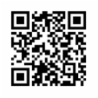Campbell Middle School provides several ways for parents to stay involved in the school. Parents may find the following resources helpful when communicating with the school:

**Web Site:** Current school information can be found on our school web site.

## <https://web.cobbk12.org/campbellms>

**E-mail:** All Campbell Middle School faculty and staff members have e-mail and send messages through the CTLS platform. Teacher e-mail addresses can be found on the school web site under the faculty and staff page.

**Grade Reports:** These are available via Parent Vue every 4 1⁄2 weeks through your student.

**Professional School Counselors:** Grade level counselors are available to arrange conferences about home, school, other student well-being concerns.

**6th Grade – Erica Lester**

**7th Grade – Alex Gorrell**

**8th Grade – Cinde Valencia**

**Synergy Grade Book:** Web-based student information system which allows parents to view student grades, missing assignments, and attendance. First time users should visit the Parent Resource Center for their security code and instructions for accessing the student information available through Synergy.



**PARENT ENGAGEMENT**



**PTSA**

Membership in the Campbell Middle School PTSA is vital to the school’s success. It is highly recommended that all families join our PTSA and volunteer throughout the year in the many activities sponsored by the PTSA. Information regarding the PTSA will be available at the Meet and Greet before school starts as well as the first Open House. In addition, information is posted in the main office and there is a link to PTSA on the school web site.

Parents are strongly encouraged to participate in committees through PTSA and the school. A sign-up form is available at the school. Sample volunteer opportunities include: Front Office Aide, Media Center Volunteers, School Dances, Organizations & Clubs, Communication / Parental Involvement, Membership, Hospitality, Reflections, Fundraising, Finance, Eighth Grade Farewell Activities, and Multicultural Night Committee.

You may contact our PTSA board regarding events, volunteering, or any questions/ concerns through their website. <https://www.campbellmiddleschoolptsa.com/>

President Latoya Palmer-Addy

1st VP Communications James Collins

2nd VP Family & Fundraising Alison George

Treasurer Barbara Stewart

Secretary Bibiana Zamora



**PARENT ENGAGEMENT**



**Principal’s Advisory Council**

The Principal’s Advisory Council is intended to provide a means by which parents, community members, and school staff can work together to create a better understanding of and mutual respect for each other’s concerns and share ideas for school improvement.

Candace Ellis Teacher of the Year

Tanika Parrish Academic Coach

Latoya Palmer-Addy PTSA President

Beth Seelinger Parent

Tim Gould Smyrna City Council

OPEN Business Partner

Alex Gorrell Counselor

Sandra Jaime Parent Facilitator

The CMS Foundation is a nonprofit organization comprised of parents and faculty. The Foundation’s vision is to provide funding necessary to ensure each student’s success and to passionately inspire innovative education that maximizes the overall academic experience at Campbell Middle School fostering a creative and confident environment. <https://campbellmiddlefoundation.org/>



**GENERAL INFORMATION**



**PARENT CONTACT INFORMATION**

It is a requirement that parents keep the school advised of pertinent contact information such as home address, e-mail address, home, work, and cell phone numbers. Emergency contact information must also be kept updated, as only listed persons will be allowed to check out your students. Because your student is a minor child in middle school, it is a requirement that the school have an updated contact number to reach a parent, guardian, or emergency contact at all times. Failure to update contact information can leave your child at risk if there were to be an emergency and the school could not reach you. **We cannot release a student to Uber or any ride service.**

**THE PARENT RESOURCE CENTER**

Our Parent Resource Center is funded through Title I and provides information, resources, and opportunities for **ALL** parents/guardians of students attending Campbell Middle School. Our parent facilitator is available during regular school hours to assist parents with access to the Synergy Grade book, resources for helping students improve in school, resources for becoming involved in your child’s education, family, and community resources among other areas. In addition, computers are available for parents to use to access student information and other school related resources. Please visit the CMS website or the Parent Resource Center for more information.

**Padres que necesiten comunicarse con la escuela en español por favor llamar al** 678-842-6873 ext. 044 Sandra Jaime



**WHEN THERE IS AN ISSUE**



**ISSUES WITH OTHER STUDENTS**

If your child is having problems with social issues involving other students, it is recommended that the grade level counselor be contacted to address the issue. The counselors are familiar with the students on each grade level and can assist in a variety of ways to solve social issues. In addition, the grade level administrator may also be contacted to assist.

**ISSUE WITH A TEACHER**

If your concern relates to a specific teacher, it is necessary for you to first make contact with that teacher to discuss the concern. Assistant principals and counselors will assist if you are unable to contact the teacher, but parents will always be referred to the teacher first to resolve class level issues.

**ISSUES WITH ADMINISTRATORS**

If after seeking the assistance of the above personnel, there are unresolved issues, please contact the principal to assist.

**RESTORATIVE CONFERENCE**

A restorative conference is a structured meeting between students, adults, and both parties’ family and friends, in which they deal with the consequences of a wrongdoing and decide how best to repair the harm. This process allows for all involved in a situation to express their feelings, ask questions, and have a say in the outcome. If you are interested in using this process to address a concern, please contact your child’s guidance counselor.



**PHONES SHOULD BE OUT OF SIGHT**



**CELL PHONES & SOCIAL MEDIA**

Because we have seen an increase in cyber bullying nationwide, and we have seen an increase in students recording other students without their consent (such as fighting), students may not use cell phones without the teachers consent for 2022-2023. Phones are allowed in the morning until 9:15, during lunch, and beginning at 4:10 for dismissal. If they need to contact you, they can visit the front office with a pass from the teacher. In addition, Social Media web sites (Facebook, Instagram, Snapchat, etc.) are not to be accessed during the school day either through school or personal technology. **Finally, students are prohibited from recording a fight, inappropriate activity, or another student or staff without permission. Students who violate these policies may receive a level 2 offense (up to 5 days out of school suspension) for violating CCSD code F2, F3, or F4**.

**REMINDER:**

Students will be asked to put away their phones the first time it is seen. If a student chooses to take it back out because they got a text, missed a call, or just want to check the time, it will constitute a cell phone violation. Hence when an adult is generous the first time, students are expected to be courteous in their response and simply put the phone away as a sign of respect for not making it a big deal the first time.

**Cell Phones/iPads/Tablets/ (other similar devices):** Students are NOT permitted to display personal technology devices. **We are not searching for phone as the school assumes no liability for lost, stolen or damaged devices.**



**BEHAVIOR EXPECTATIONS**



**CLASSROOM BEHAVIOR EXPECTATION PLANS**

Each teacher will develop a classroom plan at the beginning of the school year outlining expectations and general classroom procedures. Students will follow the teacher's classroom rules. Teachers will use the PBIS classroom behavior matrix and set their own class rules for being Respectful, Responsible, and Safe within their classroom.

**TEACHERS CONSEQUENCES**

**FOR STUDENT MISBEHAVIORS**

|  |  |
| --- | --- |
| **ADMINISTRATIVE DETENTION:**  Detention is held during the student’s lunch period. They will bring their lunch to the office (or designated area) of their grade level administrator. | **PARENT CONFERENCE:**  The teacher(s), counselor, or administrator will communicate with the student’s parent by phone, e-mail, or in person to discuss the student’s behavior and appropriate action to correct the problem. |
| **ISOLATION:**  Students are isolated within their teacher’s classroom or in another classroom. The duration of the isolation is at the discretion of the team teachers with administrative approval and may range from one period or more for a student who may need time to utilize self-control. Students are provided all assignments and expected to complete their work during isolation period. |
| **BEHAVIOR CONTRACT:**  In some cases, when a student exhibits persistent behavioral or academic problems, it may be necessary to place the student on a daily contract which is monitored closely by the student’s teachers and parents. The contract may contain a rating of behavioral or academic goals and require a teacher and a parent signature. |



**BEHAVIOR EXPECTATIONS**



**SCHOOL BEHAVIOR EXPECTATION PLANS**

When discipline cannot be handled in the classroom, the grade level administrator will become involved.

**ADMINISTRATOR CONSEQUENCES**

**FOR STUDENT MISBEHAVIORS**

|  |
| --- |
| **STUDENT REMOVAL:**  If a student becomes disruptive in class, the teacher will warn the student to stop the behavior. If the inappropriate behavior continues, the teacher may call an administrator to remove the student from the classroom for the remainder of the class period. At the administrators’ discretion, the student may return to his or her class and/or may possibly be assigned additional consequences, if necessary. |
| **IN-SCHOOL SUSPENSION (ISS):**  Students attend school but are isolated from other students during the day(s) in ISS. Students are expected to do their assignments and credit is given when the work is submitted. **Students are not allowed to participate in school functions during the day(s) or evening(s) of the ISS assignment.** Students who misbehave or refuse to do their work in ISS will be given extra ISS day(s) or out- of-school suspension. **Students assigned to ISS should report to homeroom at the beginning of the day; after morning announcements they should report to ISS.** Students who choose not to follow these procedures will receive further disciplinary action. If a student misses any day of the assigned ISS, the days will need to be made up upon return to school. An administrator may use isolation in lieu of ISS. The isolation is still considered and treated as ISS. |
| **OUT-OF-SCHOOL SUSPENSION (OSS):**  When a student’s behavior is unacceptable, suspensions from school can be assigned. Students should keep up with their work by checking their teacher’s blogs and arrange for their parent/guardian to pick up assignments from the Front Office. **Students who are suspended are not allowed to be on campus or to attend any school sponsored events during the day(s) or evening(s) of the suspension.** Once suspended, a student cannot be on the premises of **any Cobb County public school**. Parents/guardians should take action to ensure appropriate student behavior upon return to school. |
| **ALTERNATIVE SCHOOL**  The Cobb County Alternative Education Program may be recommended for students who commit a heinous offence or who repeatedly violate the CCSD Code of Conduct. |



**ACADEMIC EXPECTATIONS**



**HOMEWORK**

Students and/or parents should check teacher blogs to confirm information regarding homework assignments and other classroom assignments. Parents should check their students’ agenda where assignments should also be listed.

**INDEPENDENT READING**

All students should read 30 minutes every night.

CMS subscriptions are provided by ELA teachers.

“Library Pass” Cobb Public Library Access

\*All you need to log in is your student ID\*

<http://www.cobbcat.org/librarypass/>

**MAKE-UP WORK**

Students and/or parents should utilize CTLS to check on work missed while being out of school. Students will have five (5) days prior to the end of the quarter to make up any work from a particular day that has been marked as an excused absence during that quarter.

**LATE WORK**

Students and/or parents should utilize CTLS to check on major projects and other assignments. Students will be marked down five points each day the assignment is late NOT to exceed the 5th day.

**HONOR ROLL**

The Principal’s Honor Roll is achieved by making all A’s and all S’s in conduct. In addition, Campbell’s Honor Roll will recognize student students making the A/B Honor Roll and all S’s in conduct each semester with lunchtime rewards, certificates, and other special activities.



**ACADEMICS**



**CURRICULUM**

Students at CMS will take the following academic courses: English Language Arts, Science, Math, and Individuals & Societies (Social Studies). All students at CMS will take a world language class as part of the IB Middle Years Programme requirements. Students will also participate in Academy classes: Art, Business & Computer Science, Music Appreciation, Pre-Engineering, Computer Science, Drama, Band, Chorus, Orchestra, Health and Physical Education, or Math Support / Reading Support.

**GIFTED PROGRAM**

The Georgia State Board of Education defines gifted students as “students who demonstrate a high degree of intellectual, and/or creative abilities, exhibit an exceptionally high degree of motivation, and/or excels in specific academic fields, and who needs special instruction and/or special ancillary services to achieve at levels commensurate with his or her abilities.” Cobb County provides services for identified gifted students at all levels.

Students who were being served through the gifted program at the elementary level will receive services at the middle school level. In addition, middle school students will have an opportunity for evaluation for gifted services. This will occur through system-wide assessment in the fall for seventh grade students. If you have questions regarding the gifted program, please contact the school’s Gifted Coordinator. [Molly.Groebner@cobbk12.org](mailto:Molly.Groebner@cobbk12.org)



**EXTRA CURRICULAR**



Students will have the opportunity to participate in extra-curricular activities. Students should listen for announcements regarding the dates and times that these activities will begin. Parents may also check the website to contact the sponsors of the activities.

**In order to be eligible for any extra-curricular activity, a student must be in good behavioral standing.** Students participating in extra-curricular activities must be picked up no later than 15 minutes after the end of the activity. Failure to do so may result in not being able to participate in future activities.

**Administration reserves the right to exclude any student from school activities** (including dances, clubs, pep rallies, etc.) if there is reason to believe that their behavior could cause a disruption to the program.

**FIELD TRIPS**

Our field trips are funded through parent/guardian funding which are collected to enable students to participate. Individual student participation in field trip activities will be contingent upon the student’s conduct record. Students and parents will be notified if a student is in danger of losing the privilege to attend a field trip.

**LOCKERS**

At this time, the school building leadership team has decided we will not have locker for first semester. We will revisit this decision at the beginning of 2nd semester.



**CAFETERIA & MEDIA CENTER**



**CAFETERIA**

Breakfast is offered to all students between 8:35 am - 9:15 am each morning. Students not eating breakfast need to report directly to their assigned homeroom teacher. Breakfast and lunch are currently FREE to all students at the time of this publishing. Students may only receive 1 breakfast and 1 lunch.

Students are encouraged to prepay for lunches. In support of our school lunch program, we ask that you do not bring meals from fast food restaurants when bringing your child lunch. The child will need to eat in the front office should fast food be brought as the meal.

**\*Note: cell phones and other devices can be used with teacher permission in the cafeteria during meal service.**

**MEDIA CENTER**

The CMS Media Center has research materials, magazines, books, Internet access, audio-visual materials, and computer programs. All students receive an orientation to the media center at the beginning of the school year. Students are financially responsible for all items they check out. Unpaid media fees will prohibit a student from participating in grade level field days and receiving of final report cards.

**LOST OR DAMAGED INSTRUCTIONAL MATERIALS**

All books and instructional materials issued to the student are his/her responsibility. If books and materials are lost or damaged, the student must pay the replacement cost. **This also applies to any lost or damaged books from the Media Center.**



**SCHOOL BUS CONDUCT**



Our goal is to provide each student that is eligible to ride the bus the most safe and sufficient means of transportation to our schools. As citizens of Cobb County, students have a right to a safe and comfortable trip to and from school. Safety rules and regulations have been developed to assure all students who are eligible to ride the bus understand their responsibility to follow the bus rules. When rules are broken, the privilege of riding the bus may be suspended. The behavior of students on a school bus is considered an extension of classroom behavior. Maintaining proper and safe conduct while on the bus shall be the joint responsibility of the student, parent, bus driver and school officials. Students shall observe the following code of conduct established by the Cobb County Public Schools:

1. Students must show proper respect to the driver at all times and obey all driver instructions.
2. Large toys, insects, glass bottles, animals, plastic bags, straight or safety pins, skateboards or objectionable and dangerous items are not allowed.
3. No tobacco, illegal drugs, alcohol and weapons or look-alike items.
4. Students will keep their arms and head inside the bus at all times.
5. Nothing is to be thrown in, out or from the bus.
6. The use of obscene language or gestures is forbidden.
7. Destruction or defacing school property is not allowed.
8. Fighting or physical play is not allowed.
9. Drivers are able to assign seats to middle school students.
10. Students must be quiet at railroad crossings.
11. Students must be seated at all times.
12. The emergency door, windows and hatches are to be used only at the direction of the driver.
13. Students **must** be at the bus stop five minutes prior to the scheduled time and are to wait in an orderly manner.
14. Any behavior that is considered disruptive or unsafe by the driver will be handled through the use of the Safe Rider Program.



**SAFE RIDER PROGRAM**



**1st Offense** – Driver Student Conference & Parent Contacted (Courtesy Notice). Student on probation and reassigned to the front of Bus for 1 week.

**2nd Offense** – Driver Student Conference & Parent Contacted (Courtesy Notice). Student on probation and reassigned to the front of Bus for 2 weeks.

**3rd Offense**\* – Referral submitted; 3-Day Bus Suspension. Upon return, student placed on probation and reassigned to the front of bus for 1 week

**4th Offense**\*\* – Referral submitted, 5- Day Bus Suspension. Upon return, student placed on probation and reassigned to the front of bus for 2 weeks.

**5th Offense** – Referral submitted; Transportation Director recommends bus suspension for remainder of the year.

\*At 3rd offense, Safe Rider Class and

Behavior Contract required.

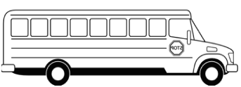



**ATTENDANCE POLICY**



**Upon returning to school after being absent, students must bring a note from a parent or physician explaining the reason for the absence.** Students must attend at least one-half the academic day (3 1⁄2 hours) to be counted present.

CCSD recognizes the following as excused absences:

Personal Illness

A death or serious illness in the immediate family

Recognized religious holidays observed by the student’s faith

Absences mandated by order of governmental agencies

Conditions which render school attendance impossible or hazardous to one’s health or safety

Serving as a page in the Georgia General Assembly

Pursuant to Georgia Compulsory Attendance Statute, O.C.G.A. § 20-2-690, et seq., a parent or legal guardian who fails to send his or her child to school may be charged with a misdemeanor. At its discretion, a court having jurisdiction may subject the parent or guardian to a fine not to exceed $100.00, imprisonment not to exceed thirty (30) days, or both if found guilty of violating the Compulsory Attendance Statute. Each day’s absence shall be considered a separate offense as related to the penalty. For this reason, it is important to attend school daily and arrive at school on time. Excessive tardies will be referred to an administrator.

**After Three (3) Unexcused Absences:** The teacher will contact the parent or guardian by telephone, letter, or through parental conference regarding attendance.

**After Five (5) Unexcused Absences:** A letter will be sent from a school administrator to the parent or guardian regarding attendance.

**After Seven (7) Unexcused Absences:** A School Social Worker referral will be generated.



**WHAT DO I DO IF?**



I am here at 8:15am, but before 8:35am:

Students are able to enter the school at 8:15 and attend a silent study hall in the theater until 8:35. Students must remain in the theater until dismissed to homeroom at 8:35.

**I have been absent:**

A student returning to school must bring a written note from a parent / guardian explaining the reason for the absence. All notes must be given to the Attendance Office (not the homeroom teacher) upon returning to school.

**An absence due to a medical visit will require an excuse note from the doctor’s office in order to be excused.**

Students will have the same amount of days as they were absent, to turn in missed work. It is the responsibility of the student to make up any work missed. If absent from school, check teacher blogs for notes and assignments. If the absence extends beyond three days, please contact teachers to have work ready with at least 24 hours’ notice.

**I am tardy to school:**



Any student not in homeroom by 9:15 is considered tardy to school and must sign in at the attendance office. Students must have a tardy pass to give their teacher upon arrival to class.

**I need to leave early:**

Parents and adults on the student’s checkout list **need to show a valid picture ID at the time of check-out.**

**NO CHECK OUTS ARE PERMITTED AFTER 3:30**



**WHAT DO I DO IF?**



**I become sick at school:**

Please report to the clinic with a PASS from your teacher to see the nurse. The nurse will use the clinic's phone to call home, if needed. Students too sick to return to class will be kept at the clinic until the student can be picked up.

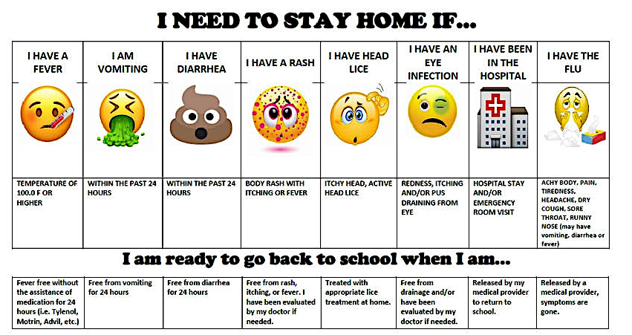

**I missed the bus:**

**Morning:** Your parents are responsible for getting you to school if you miss the bus. Your absence will not be excused for missing the bus.

**Afternoon**: Parents must pick you up from school by 5pm.

**I am late to class:**

If a teacher holds you after class, they will give you a pass in your agenda for your next class. If a student does not have an acceptable reason for his/her tardiness, then the student will have to report to class, and receive an unexcused tardy.

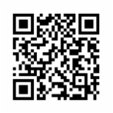

**WHAT DO I DO IF?**



**I need a bus pass to ride another bus:**

Approval for a temporary bus change is only given for an extreme emergency. For a temporary bus change the parent or guardian must provide a written note stating the reason for the temporary change of transportation. **This note must be turned in before 10AM and must include a contact phone number in which the parent / guardian who wrote the note can be contacted to verify the information.** Phone requests will not be accepted. Temporary change of bus transportation lasting more than 3 days must be approved by the transportation field coordinator assigned to CMS.

###### NO NOTES WILL BE ACCPTED BY BUS DRIVERS OR DURING DISMISSAL.CMS_IBSpartan_blueDark.png Please understand that the safety of your student is of the utmost importance to us and our transportation department. For this reason alone, the process above must be followed as outlined to assure that your student is taken home in the afternoon in the safest and most appropriate way possible. We thank you in advance for your understanding.

**I need to take medication during the day:**

Parents must complete an “Authorization to Give Medicine at School Form” (Form JLCD-2) available at school for each medication given. Medication must be in the original labeled container and brought to the school clinic by a parent. Students may carry inhalers, EpiPens or insulin with the proper form on file in the clinic (Authorization to Carry Prescription Medication).



**GENERAL INFORMATION**



**VIOLATIONS COVERED BY COBB COUNTY BOARD OF EDUCATION POLICY**

Student behavior and the consequences for misbehavior are covered by the Administrative Rules of the Cobb County Board of Education. Some of these rules carry consequences that are cumulative throughout the middle school years and even into the high school years in some cases. Some behaviors may result in reporting to appropriate law enforcement agencies. A complete copy of all Administrative Rules listed below will appear in the first day student folder, and they are also available on the Cobb County School District website.

Classroom teachers will review and discuss these rules with students, and they will have a chance to ask questions to clarify understanding. Parents should review the rules as well. Both parents and students will be asked to sign a form stating their acknowledgement and understanding of the rules regarding student behavior. The rules listed below are available for review in the CCSD Middle School Student Handbook:

* + Administrative Rule JICDA-M – Student Code of Conduct
  + Administrative Rule JLCD – Medication
  + Administrative Rule JKDB – Long Term Suspension/Expulsion
  + Administrative Rule JICK – Sexual Harassment
  + Administrative Rule JKG – Chronic Disciplinary Problem Students
  + Administrative Rule JJICA – Interscholastic/ Extracurricular Activities Code of Conduct



**REMEMBER**



**Campbell Middle School**

**Creating and Supporting IB Globally Minded Students**

**SOCIAL EMOTIONAL LEARNING**

PBIS

Restorative Conferences

2nd Step Curriculum

Sources of Strength

**ACADEMIC**

**INTERVENTIONS**

Quarterly Grade Recovery

Reading Support Classes

Math Support Classes

Morning School Tutoring

**STUDENT**

**INCENTIVES**

Quarterly Honor Roll

Fresh Air Friday

PBIS Points

Student of the Month

PTSA Celebrations

**MASTER**

**SCHEDULE**

6 Period Day

2 Connection Classes

Dual Language 6th & 7th

Foreign Language all 3 years

**WRAP AROUND**

**SERVICES**

Clothing Closet

Loaded Backpacks

Holiday Meals

Check & Connect

**PARENT**

**ENGAGEMENT**

PTSA

CMS Foundation

Principal Advisory Committee

Field Trip Volunteers

School Store

