Honors US History

Summer Assignment 2025

**Directions**: You will need to read the following context and excerpts from *Common Sense* by Thomas Paine. As you read, you will need to annotate the document.

Your annotations should include the following Underline/highlight important passages or phrases

* Make notes along the margins – which help you summarize or interpret the material
* Make note of concepts and/or terms you do not understand – include those in your margin notes

**Grading**: You will turn in the annotated reading for 50% of your grade. The remaining 50% will derive from a quiz covering this material.

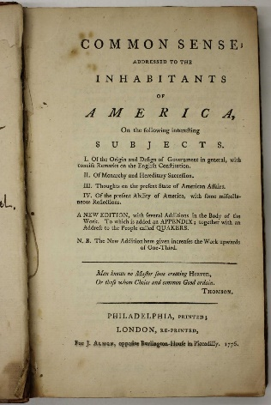**Link to required reading**:

[Thomas Paine, Common Sense, Part III-IV, 1776, excerpts (americainclass.org)](https://americainclass.org/sources/makingrevolution/rebellion/text7/painecommonsense3and4.pdf)