|  |  |  |  |
| --- | --- | --- | --- |
| **Student Application for Admission to**  **6th, 7th or 8th Grade STEM Cohorts** | | | |
| PERSONAL INFORMATION – PLEASE PRINT ALL INFORMATION | | | |
| Today’s Date__________________________ | | | |
| Name | | | |
| Last First Middle Initial Grade Level | | | |
|  | | | |
|  | | | |
| Do you have a school-issued laptop: Yes No  Do you have Internet Access at home daily: Yes No  Do you have a cellphone: Yes No  Do you have permission to use your cellphone at school for work on websites: Yes No  Are you in a yearlong connections class like band, orchestra, chorus, dance, etc.: Yes No  Are you in any AC Classes? Yes No | | | |
|  | | | |
| School 365 Email Address:  Personal Email Address: | | | |
| PREVIOUS EXPERIENCE | | | |
| **Homeroom Teacher:** _______________________ **Have you been in a STEM class before**: YES NO | | | |
| List clubs or other activities you are involved in at school or in your community including Saturdays: | | | |
| 2024 – 2025 Grades – Please go to StudentVue and put your final grades for the following subjects: (REQUIRED) | | | |
| 1st | 2nd | 3rd | Subject |
|  |  |  | Language Arts |
|  |  |  | Social Studies |
|  |  |  | Science |
|  |  |  | Math |
|  |  |  | Connections 1 |
|  |  |  | Connections 2 |
|  | | | |
| QUESTION 1: - Please explain how motivated you are to learn things independently without a teacher's assistance. Give examples of things that you have learned on your own. Write on loose-leaf paper. | | | |
| QUESTION 2: – Please explain why you would like to join the STEM cohort for two years. Write on loose-leaf paper. | | | |
| **QUESTION 3:** Describe a project that you have created or built. Add pictures of the final product. Write on loose-leaf paper. Print and attach your pictures. | | | |
| **QUESTION 4:** A substitute teacher is in one of your STEM classes. Students are acting up and disrupting the class. What do you do? Why? Write on paper. | | | |
| **QUESTION 5:** The STEM Cohort is going on a field trip, or do they have a guest speaker. As a STEM student, what are some things you should be doing? Explain. Write on paper. | | | |
| **QUESTION 6:** Tell us something amazing about yourself that would convince us to accept your application. What would make you a great addition to the STEM Cohorts? Write on loose-leaf paper. | | | |

|  |
| --- |
| I authorize the investigation of all statements contained in this application. I understand that misrepresentation or omission of facts called for is cause for denial of admission. Further, I understand and agree that my work will be my best, and I will meet every challenge.  Date Signature |
|  |

**STEM Handbook**

**Please read carefully and include a parent and student signature.**

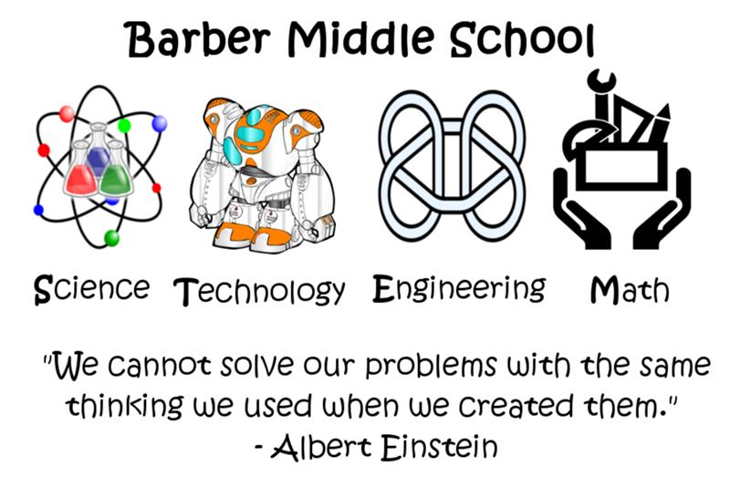

**Program Standards**

1. Students must earn a minimum of 80% in each academic course to maintain “good standing” status.
2. Students who earn a grade below 80% in any academic course will be placed on academic probation.
3. Requirement of attending Braves Club and/or Saturday may result if a student earns two or more Ds in academic courses in any given semester or earns a grade of F in any math and/or science course.
4. Students are expected to participate in a STEM-related activity/competition: Games for Change Competition, County/Regional Competitions, North Central Technology Competition (NCTC), or other approved activity/competition each year. Non-participation must be explained and pre-approved.
5. Daily, students are expected to read CTLS posts from teachers.
6. Students should have no attendance issues.
7. Students/Parents of the STEM cohort are encouraged to contribute $60 towards their/their student’s STEM experiences. This will offset the cost of field trips, supplies, and programs used for the STEM experience. Students/Parents may fundraise to offset the costs or pay the contribution directly.

**ACADEMIC PROBATION**

1. Students and parents will receive notice of probationary status. An Action Plan (which may consist of steps including but not limited to the following: tutoring, one-on-one instruction, and a reduction in non-academic activities) will be created. Students on academic probation must earn at least 80% in the next nine weeks in that subject area.

2. Upon successful fulfillment of #1, students will return to a “good standing” academic status.

3. Students who do not meet the academic requirements outlined in #1 may be required to attend Braves Club and/or Saturday School.

**DISCIPLINARY PROBATION**

A student may be placed on disciplinary probation for the following reasons:

1. Five (5) or more unexcused absences in a semester.

2. A single disciplinary referral that results in any days of Out-of-School Suspension (OSS).

3. A single disciplinary referral that results in 2 or more days of In-School Suspension (ISS).

4. Any violations of Rule JCDA-R* (Student Conduct: Code of Conduct).

5. Violation of Honor Code • Students placed on disciplinary probation will return to Good Standing if they do not violate Rule IDAI-R or JCDA-R during the same and the following semester. • Any actions resulting in disciplinary consequences more than the above-mentioned grounds for disciplinary probation may result in a conference will all teachers and the school administration.

**\*All Rules may be downloaded at** [**www.cobbk12.org**](http://www.cobbk12.org)**.**

**ACADEMIC INTEGRITY**

The STEM community is committed to four pillars of academic integrity: honesty, trust, respect, and responsibility. The community Honor System places academic honesty at the center of our curriculum by asking each of us to live by our honor code on a daily and continuing basis because the integrity of everyone is fundamental to the integrity of the whole.

Honor Code: I will not lie, cheat, or steal in academic endeavors. I will act if I become aware that the Honor Code is compromised. Academic misconduct is generally defined as any action or inaction that is offensive to the integrity and honesty of the academic community members. This offense includes, but is not limited to:

a. Seeking, using, giving, or obtaining unauthorized assistance* or information in any academic assignment or examination, including but not limited to:

1. lab data 2. lab reports 3. daily assignments 4. quizzes and tests 5. papers 6. projects

*Unauthorized assistance includes but is not limited to communication-related to quiz/test questions with students who have yet to complete assessment and reading aides or technology not specifically authorized by the teacher.

b. Plagiarizing includes but is not limited to:

1. stealing and passing off (the ideas or words of another) as one's own; 2. using another's production without crediting the source; 3. committing literary theft; use of AI; or hacking school use websites;

c. Providing other students with information about a quiz, test, or classroom activity;

d. Intentionally providing false information for the purpose of gaining an academic advantage;

e. Intentionally giving false evidence in any meetings with teachers or administration or refusing to give evidence when requested by teachers or administration.

**HONOR CODE VIOLATION CONSEQUENCES**

**First Offense**

Honor Code Violation form from the teacher.

* If the student accepts responsibility, there is a resulting grade of zero for the assignment on which the violation occurred, the student is placed on Disciplinary Probation, parent(s) are notified, and a letter is placed in the student’s file.
* If the student does not accept responsibility, the student is brought before the administration and/or teachers, whose decision will dictate further possible action

**Second Offense**

Honor Code Violation form from the teacher.

* If the student accepts responsibility, there is a resulting grade of zero for the assignment on which the violation occurred, the student is placed on Disciplinary Probation, parent(s) are notified, and a letter placed in the student’s file
* Student placed on Disciplinary Probation if not in the same or immediately subsequent semester

Required Signatures:

Recognizing that enrollment in a STEM Program is a privilege, not a right, we the undersigned, have read, fully understand, and agree that the expectations outlined in this document serve as requirements for participation in the STEM Program.

Date: _______________________________________

_______________________________ _______________________________________

Student Name (Please print) Student Signature

_______________________________ _______________________________________

Parent Name Parent Signature

**Math Teacher Recommendation (Put in Watts’ box; do not give it back to the student)**

Student Name: _______________________________________________

Name of Teacher Completing Recommendation: ___________________________________

Applicant Current Grade in your Class: ____________

Is this student on RTI? Yes No

Is your class AC? Yes No

Is the student in Sped or 504? Yes No

What is the student’s Math Inventory Score? ______________

**For each of the following areas, please rate the applicant in comparison with other students you have known at this level:**

Please use the following scale: 5 = Outstanding 4 = Above Average 3 = Average 2 = Below Average

1. Academic Success 2 3 4 5
2. Intellectual Ability 2 3 4 5
3. Ability to work on a team 2 3 4 5
4. Creativity 2 3 4 5
5. Determination/Effort 2 3 4 5
6. Respect for Others 2 3 4 5
7. Potential for Growth 2 3 4 5
8. Integrity 2 3 4 5
9. Self-Confidence 2 3 4 5
10. Self-Discipline 2 3 4 5

I would recommend this student for participation in the Barber Middle School STEM Cohort. Yes No

Teacher Signature: _________________________________________________________

Any additional helpful information about this student:

________________________________________________________________________________________________________________________________________________________________________________________________________________________________________________________________________________________________________________________________________

**Science Teacher Recommendation (Put in Watts’ box; do not give it back to the student)**

Student Name: _______________________________________________

Name of Teacher Completing Recommendation: ___________________________________

Applicants Current Grade in your Class: ____________

Is this student on RTI? Yes No

Is your class AC? Yes No

Is the student in Sped or 504? Yes No

**For each of the following areas, please rate the applicant in comparison with other students you have known at this level:**

Please use the following scale: 5 = Outstanding 4 = Above Average 3 = Average 2 = Below Average

1. Academic Success 2 3 4 5
2. Intellectual Ability 2 3 4 5
3. Ability to work on a team 2 3 4 5
4. Creativity 2 3 4 5
5. Determination/Effort 2 3 4 5
6. Respect for Others 2 3 4 5
7. Potential for Growth 2 3 4 5
8. Integrity 2 3 4 5
9. Self-Confidence 2 3 4 5
10. Self-Discipline 2 3 4 5

I would recommend this student for participation in the Barber Middle School STEM Cohort. Yes No

Teacher Signature: _________________________________________________________

Any additional helpful information about this student:

____________________________________________________________________________________________________________________________________________________________________________________________________________________________________________________________________________________________________________________________________________________________________________________________________________________________________________________________________________________________________________

**ELA Teacher Recommendation (Put in Watts’ box; do not give it back to the student)**

Student Name: _______________________________________________

Name of Teacher Completing Recommendation: ___________________________________

Applicants Current Grade in your Class: ____________

Is this student on RTI? Yes No

Is your class AC? Yes No

Is the student in Sped or 504? Yes No

What is the student’s Reading Inventory Score? ______________________

**For each of the following areas, please rate the applicant in comparison with other students you have known at this level:**

Please use the following scale: 5 = Outstanding 4 = Above Average 3 = Average 2 = Below Average

1. Academic Success 2 3 4 5
2. Intellectual Ability 2 3 4 5
3. Ability to work on a team 2 3 4 5
4. Creativity 2 3 4 5
5. Determination/Effort 2 3 4 5
6. Respect for Others 2 3 4 5
7. Potential for Growth 2 3 4 5
8. Integrity 2 3 4 5
9. Self-Confidence 2 3 4 5
10. Self-Discipline 2 3 4 5

I recommend this student to participate in the Barber Middle School STEM Cohort. Yes No

Teacher Signature: _________________________________________________________

Any additional helpful information about this student:

________________________________________________________________________________________________________________________________________________________________________________________________________________________________________________________________________________________________________________________________________