 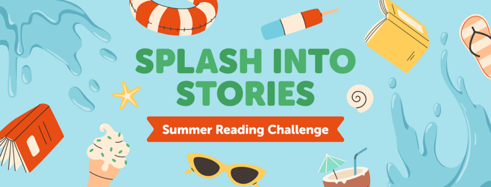

Dear Parent/Guardian:

We encourage students to keep reading all summer long! The Cobb County School District Library Media Education Department is partnering again with Cobb and Smyrna Public Libraries for our Summer Reading Challenge 2025. The student challenge is to read 20 minutes each day and at least 15 hours this summer. Students earn digital badges by logging reading minutes in Beanstack, our year-round reading engagement platform.

Reading throughout the summer for at least 20 minutes a day helps students maintain learning gains made in school and start the upcoming new school year off right. These resources can help:

**CCSD Library Media Education:** Visit [www.cobbsummerreading.com](http://www.cobbsummerreading.com/) for reading resources, ebooks, and links to learning resources, such as Cobb Digital Library.

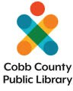**Cobb and Smyrna Public Libraries:** Visit <http://www.cobbcat.org/summer/> to sign up for Summer Reading, where students can log summer reading activities and minutes using Beanstack. City of Smyrna residents may also participate through the City of Smyrna Public Library.

**Beanstack:** Students use Beanstack to log minutes, earn badges, and win prizes! Students are automatically enrolled in the school Beanstack Summer Reading Challenge, and can sign up for Summer Reading at Cobb Public Library at [http://www.cobbcat.org/summer/.](http://www.cobbcat.org/summer/) Beanstack is available online and as a free app. CCSD students can sync their Beanstack school and Cobb County Public Library Beanstack parent accounts. Log once; count for both!

**Sora:** Cobb students can read ebooks and e-audiobooks all summer long with Sora. With hundreds of great titles, you’ll have plenty to choose from! Additionally, the “Sweet Reads” collection makes it easy to read the same books with friends. Visit soraapp.com or download the free app on your device.

Keep reading and logging your reading minutes this summer!