JJ Daniell Middle School
8th Grade Supply List 2025-2026
General Supplies needed for all classes  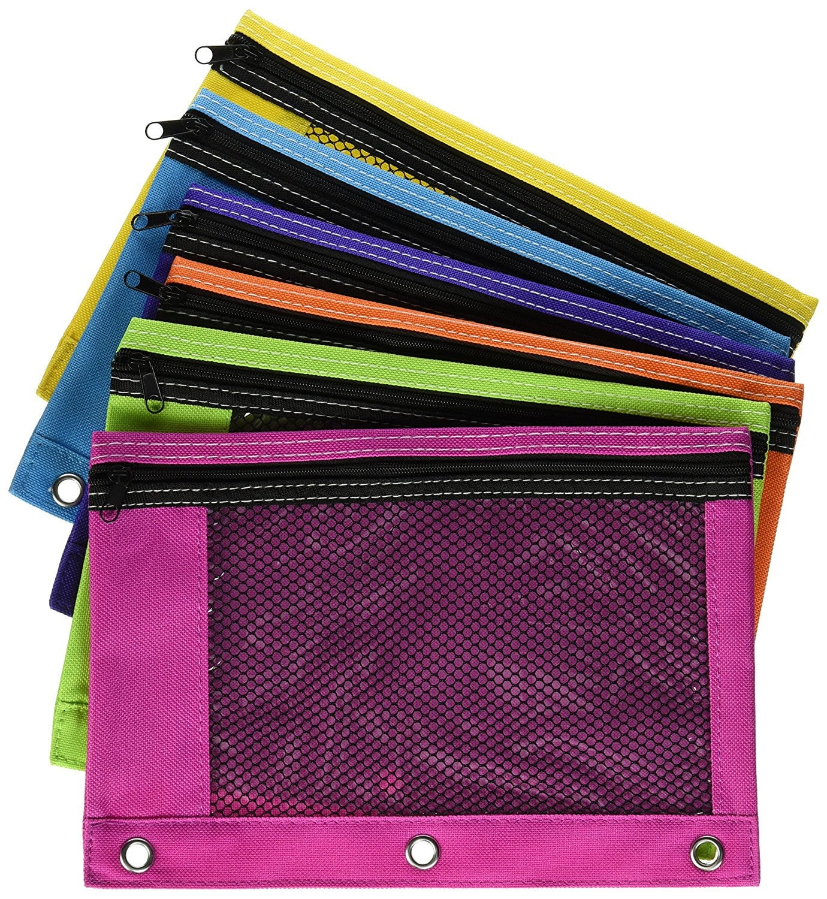  Any type of Pencil Pouch works | Keep in Pencil Pouch (refresh AS NEEDED throughout the year)  - Pencils (lots of pencils)  - Pens  - Handheld pencil sharpener  - Highlighters (4 colors)  - Glue stick(s)  - Scissors  - *Colored pencils (used frequently so please make sure you have)  - Optional: Student planner/assignment calendar  Laptop and charger (labeled with student's name)  Headphones/Earbuds (5 Below has USB headphones for $10) (AirPods and other wireless headphones are not allowed)
Homeroom Donations | Ream of copy paper  Tissues (3 boxes)  Paper towels (3 pack)  Lysol/Clorox Wipes  Hand Sanitizer  Box of Band-Aids
Language Arts Supplies | 2 pocket folder dedicated to ELA only OR a section in a binder  Looseleaf notebook paper  Independent reading book (from public library, school library, or personal library)  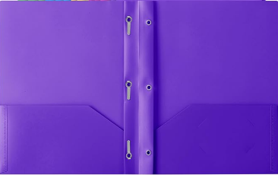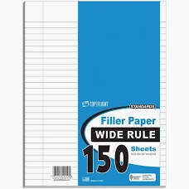
Social Studies Supplies | Notebook or a 2-pocket folder  Looseleaf Notebook paper
Math Supplies | Math 8  - Three-prong folder  - Looseleaf notebook paper  - Dry erase markers & erasers  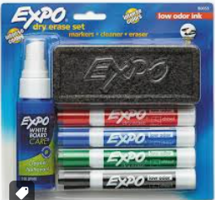  Algebra 1  - 1-inch binder  - Dividers  - Dry erase markers & erasers  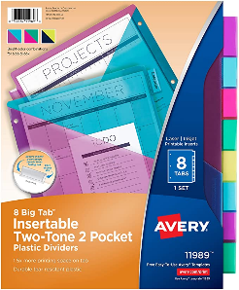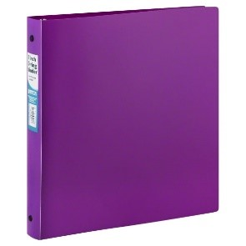
Science Supplies: | 1.5-inch binder designated for science  Dividers with pockets (5-6 tabs)  Post-its/sticky notes (any color) to keep with them or leave in class  *Colored pencils/markers- we have multiple projects throughout the year  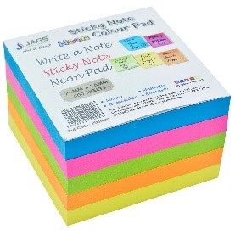
Miscellaneous | Extra Kleenex is always appreciated!  Pastel color copy paper is also appreciated!  Expo markers for teachers  A wireless or wired mouse, for the school computer, makes navigating much easier for the students. (optional)  Label all materials with a permanent marker

7th Grade Supply List 2025-2026

Binders/Folders/Paper:
• Notebook paper
• (5) plastic two-pocket folders: Science (green), Math (blue), ELA (red), Connections (color of choice)
*Two composition books (ELA)
Zippered pencil pouch, labeled with first and last name, with the following inside:
• Pencils/erasers
• Colored pencils or crayons
• Markers • Pens
• Expo markers for math whiteboards
• Calculator Four-function or Scientific (optional)
• Handheld pencil sharpener
• Glue sticks (optional)
• Highlighters (optional)
• Wired earbuds/headphones for laptop (3.5 mm plug)
Suggested donations for homeroom teacher:
• Tissues (high priority)
• Band aids (high priority)
• Hand sanitizer
• Clorox wipes
• Paper towels (for science)
• Rubber gloves (for science)
• Black Sharpies (for science)
• Gallon Ziplock bags (for science)
• Pencil donations
• Expo markers
Individual teachers may request additional supplies when school starts

6th grade Supply List – 2025-2026
General Supplies needed for all classes 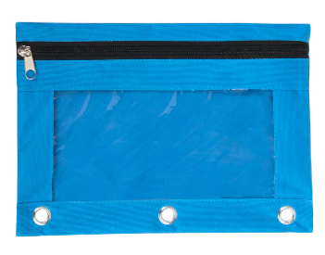  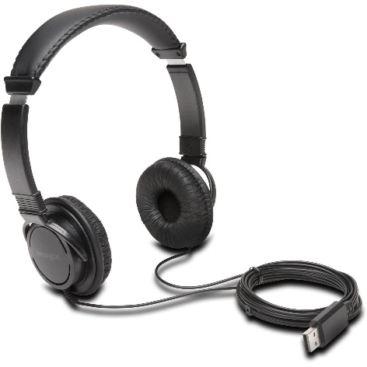 | Keep in Pencil Pouch (refresh AS NEEDED throughout the year)  - Pencils  - Pens  - Handheld pencil sharpener  - Highlighters (4 colors)  - Expo markers  - Glue sticks  - Scissors  - *Colored pencils (used frequently in multiple classes so please make sure you have these)  Laptop and charger (label both after distribution)  Headphones/Earbuds (5 Below has a good selection) (AirPods and other wireless headphones are not allowed)  3 packs of wide ruled lined notebook paper (refresh throughout the year)
Homeroom Donations | Ream of copy paper  Tissues (3 boxes)  Paper towels (3 pack)  Lysol/Clorox Wipes  Hand Sanitizer  1 box of Band-Aids (any brand)
Language Arts supplies  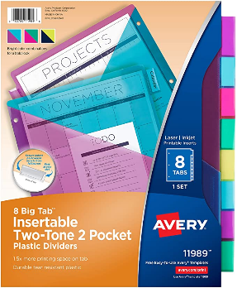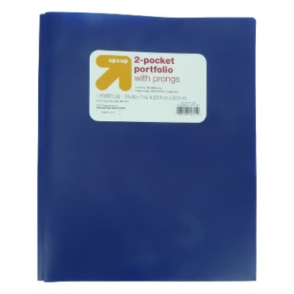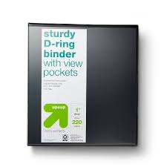 | 1” Binder just for ELA, any color  Dividers with pockets (3 tabs)  Looseleaf Wide-Ruled Paper in binder  AC classes will need a plastic folder, any color
Social Studies supplies | 1 inch binder or section in a binder designated for SS  1 subject spiral notebook keep in binder  *Colored pencils/markers- we have multiple projects throughout the year  Highlighters
Math Supplies  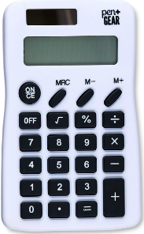 | 1 inch binder or section in a binder designated for Math  Notebook paper (looseleaf or in a spiral notebook) Refresh throughout year  Pencils only, NO pens!  Handheld pencil sharpener  Basic 4-function calculator  Black Expo markers (refresh throughout the year)  Colored pencils  MUST have notebook paper, a pencil, and calculator EVERY day!
Science Supplies  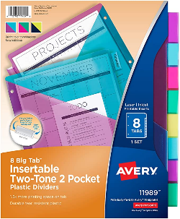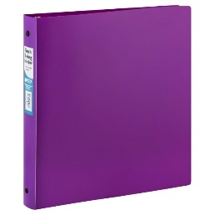 | 1-inch binder just for science (stays in the classroom)  Dividers with pockets (8 tabs)  Post-its/sticky notes (any color) to keep with them or leave in class  *Colored pencils/markers- we have multiple projects throughout the year
Miscellaneous | Extra Kleenex is always appreciated!  Pastel color copy paper is also appreciated!  Expo markers for teachers  A wireless or wired mouse, for the school computer, makes navigating much easier for the students. (optional)  Label all materials with a permanent marker

