Sanders Elementary School’s Activities to Build Partnerships
Please consider joining us through some of the events listed below. Volunteer opportunities may be virtual or face to face.

Volunteer Opportunities:
Join PTA Board
Parent Volunteer
Principal Advisory Council

Partnership Meetings:
Annual Title I Parent Informational Meeting
Family Data Day/Night
Open House
Title I Parent Input Meetings
Parent Teacher Conference Week

Family Engagement Opportunities:
Literacy Nights
Parent Café
Parent Resource Room
Strategy Training to Assist Students at Home
What is a School-Parent Compact?

Congue nihil imperdiet doming id quod mazim placerat facer minim veni am ut wisi enim ad minimeniam, quis erat nostr uexe
rci tation ullamcorper nostru exerci tation ullam corper et iusto odio dig nissim qui blandit praesent lupta. Tummer delenit
augue duis dolore te feugait nulla facilisi. Con erattis sectetuer adip iscing elit, sed erat diam nonummy nibh magna erat.
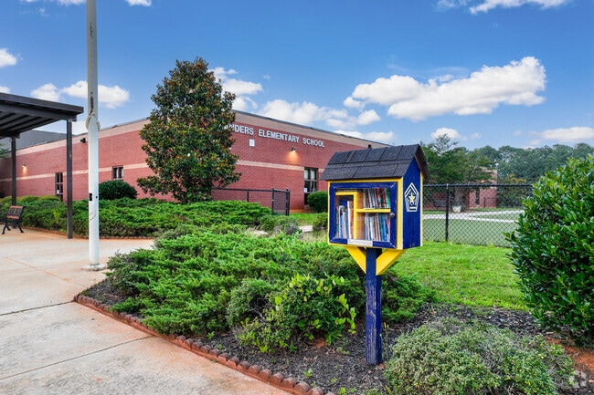
2026-2027
Sanders Elementary School

School-Parent Compact for Achievement

Grade K-2
Revised July 31, 2026

Tiffany Jackson, Principal
Tiffany.Jackson@cobbk12.org

1550 Anderson Mill Rd
Austell, GA 30106
(770) 770-819-2568
www.cobbk12.org/sanders



Jointly Developed

The parents, students, and staff of Sanders Elementary School worked together and shared ideas to develop the school-parent compact for achievement. Teachers suggested home learning strategies, parents added ideas to make them more specific, and students told us what would help them learn. Parents are encouraged to participate in the annual review process of the compact and make changes based on students’ needs. Parents are welcome to contribute comments at any time. Please contact Miriella Vazquez at 770-819-2568 or miriella.vazquez@cobbk12.org to provide feedback.

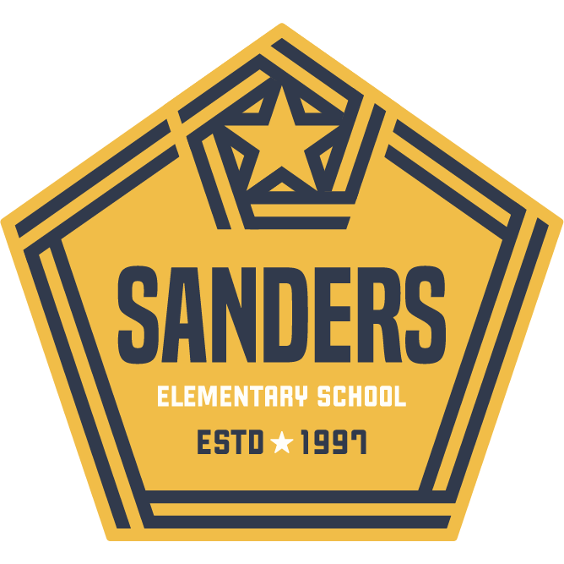

- CTLS Parent
- ParentVUE
- Weekly Folders
- Student Agendas
- School Website
- Monthly Newsletters
- Email

- Parent/Teacher Conferences
- Facebook &Twitter
- Flyers
- District Website
- School Marquee

Some communications may be provided virtually

If you would like more information, please contact:

Miriella Vazquez, Parent Facilitator
770-819-2568 or
Miriella.Vazquez@cobbk12.org
A School-Parent Compact is an agreement that parents, students, and teachers, develop together. It explains how parents and teachers will work together to make sure all of our students succeed. This compact includes strategies to help connect learning at school to learning at home.

Sanders Elementary School’s Activities to Build Communication

Sanders Elementary Goal(s) for Student Achievement

- Sanders Elementary will increase the number of kindergartens through 2nd grade students performing on or above grade level from 62% May 2026 to 65% May 2027 as measured by the spring administration of the AMIRA assessment.

- Sanders Elementary will increase the number of kindergartens through 2nd grade students performing on or above grade level from 28.5% in May 2026 to 31.5% in May 2027 as measured by the spring administration of the DRC Beacon Math assessment.
Visit Our Website:

www.cobbk12.org/sanders

District Goals for Student Achievement

- By SY29, increase by 2 percentage points the number of students performing at the proficient and distinguished levels, as evidenced by state assessments.

- By SY29, increase graduation rate from 89% to 91% as measured by GaDOE adjusted cohort graduation rate.

Sanders Elementary Students

Students will utilize resources provided at least twice a week for 15 minutes to practice phonemic awareness, sight words & spelling skills to build early literacy foundational skills.

Students will access CTLS Learn and learning websites and resources to practice math and reading skills.

Students will use activities and resources from Family Engagement events to practice math, problem-solving, and reading comprehension strategies to support their progress in mastering grade-level standards and increasing academic achievement.
Sanders Elementary Families

Families will encourage and assist their child with school-provided resources at least twice a week for 15 minutes to practice phonemic awareness skills, sight words, and spelling with the child to build early literacy foundational skills

Families will use CTLS Parent to communicate with teachers, view school-wide posts, access websites, learning resources and instructional videos to support their child at home.

Families will attend at least one Family Engagement event per semester, or get information from their child’s teacher, parent facilitator, or academic coach to help support their child’s academic achievement

Sanders Elementary Teachers

Teachers will provide families with resources through CTLS to support the Early Literacy Framework to build solid foundational literacy skills at home

Teachers will use CTLS weekly to communicate and will provide families access to instructional websites, learning resources, and instructional videos to address student needs in reading and math

Teachers will offer Family Engagement events focused on our school goals. Sanders will offer ELA and Math Nights, and Parent workshops that concentrate on strategies to increase academic achievement

Teachers, Parents, and Students-Together for Success

