BSDTaekwon-Do

ASP
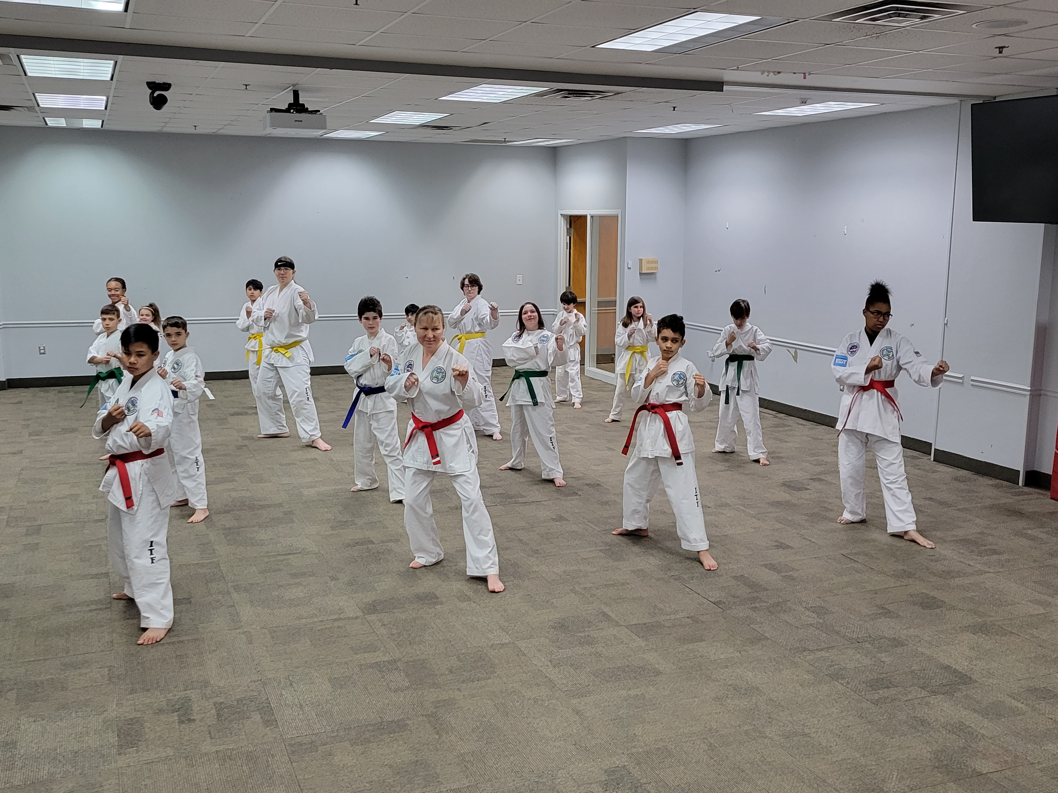  Classes 2023 and 2024  - Students must register with ASP at Pickett’s Mill  - Classes are on Wednesdays (except Early Release, school closing for bad weather, and Holidays)  - Class Times: 2:10 to 3:30  - Location: Pickett’s Mill Gym  - Grades: K through 5th (all returning students welcome) 25 student max  - Session 1 ($215.00) Aug 16-Dec 13  - Session 2 ($255) Jan 10-May 8  - 20% goes back to the school  - Family DiscountFirst sibling full tuition, each additional sibling at half tuition  - NO CONTRACT required but an insurance waiver must be completed by an adult before the first class.  Please send all payments to the Instructor, checks payable to Omar Welch, or pay online. | 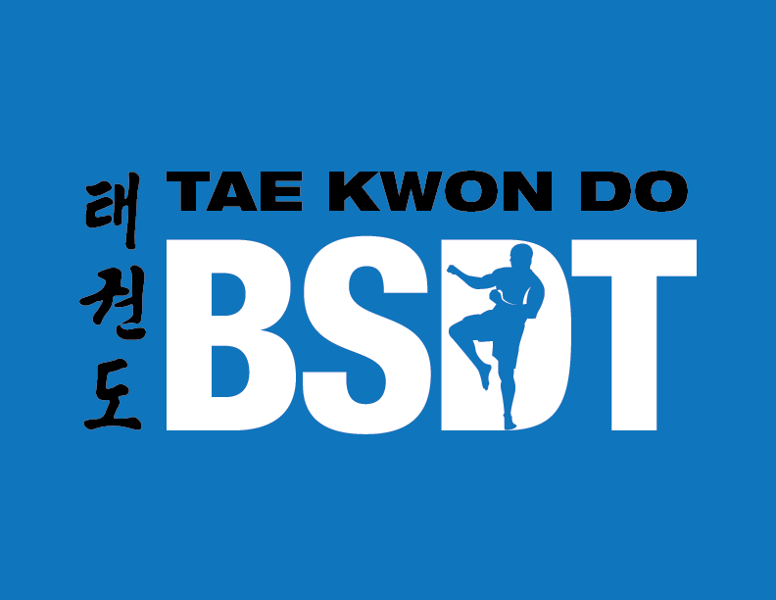  “to be the best that you can be”  We teach traditional Taekwon-Do skills! Improve coordination, focus, and confidence, while teaching self-control.  Mr. Omar Welch  Head Instructor  USTF Certified  USTF GA state director  Acworth, GA 30101  404-388-8238  bsdtaekwondo@gmail.com  www.bsdtaekwondo.com  facebook.com/bsdtaekwon-do
Name of Student/Teacher/Grade____________________________________________________
Parent’s Name______________________________________________________________________
Contact email/number_____________________________________________________________

