**Tapp Middle School**

***Family-School Engagement Policy***

***for Shared Student Success***

*2024 - 2025 School Year*

*Dr. Alvin Thomas, Principal*

*Cobb County School District*

*3900 Macedonia Road*

*Powder Springs, GA 30127*

*(770) 222-3758*

[Tapp Middle School (cobbk12.org)](https://www.cobbk12.org/tapp)

*Revised July 24, 2024*

**Tapp Middle School**

**Academic Goals 2024 - 2025**

Goal#1: By the end of the 2024-25 SY, increase the percentage of students scoring proficiency or higher on the ELA EOG by 3%.

Goal #2: By the end of the 2024-25 SY, increase the percentage of students scoring proficiency or higher on the MATH EOG by 3%.

School Plan for Shared Student Achievement

**What is it?**

This is a plan that describes how Tapp Middle School will provide

opportunities to improve family engagement to support student learning.

Tapp Middle School values the contributions and involvement of families to

establish an equal partnership for the common goal of improving student

achievement. This plan describes the different ways that Tapp Middle School

will support family engagement and how families can help plan and participate

in activities and events to promote student learning at school and at home.

**Jointly Developed**

Tapp Middle School invites all families to complete the Fall school improvement input survey/evaluation to provide suggestions on the school’s Title I program. All families are also invited to attend the Spring school improvement input meeting to revise this parental involvement policy, our school-parent compact, building staff capacity professional learning topics, and the parental involvement budget. Additionally, family input and comments regarding this plan are welcome during the school year. The plan is posted on our school Web site for families to view and submit feedback throughout the year. All family feedback received during the year will be used to revise the plan for the next school year. We also distribute an annual survey that is posted online to ask families for their suggestions on the plan and the use of the 1% reservation of funds for parental involvement. Families can also give feedback during any Family meetings and activities during the school year.

**Who is it for?**

All students participating in the Title I, Part A program, and their parents and families, are encouraged and invited to fully participate in the opportunities described in this policy.  Tapp Middle School will provide full opportunity for the participation of Neglected and Delinquent proxy parents, parents and families with limited English, parents with disabilities, and parents of migratory children.

**Where is it available?**

Every family will receive the plan during Parent-Teacher Conference week. It is also available on the school website and a copy is in the front office binder. Families can also retrieve a copy of the plan in the Parent Resource Center. We will gladly mail the plan to you upon request.

**What is Title I?**

Tapp Middle School is identified as a school having a Schoolwide Title I program as part of the Every Student Succeeds Act (ESSA). Title I is designed to support State and local school reform efforts tied to challenging state academic standards which reinforce and enhance efforts to improve teaching and learning for students. Title I programs must be based on effective means of improving student achievement and include strategies to support parental involvement. All Title I schools must jointly develop with all parents a written parental involvement policy.

**Let’s Get Together!**

Tapp Middle School will host the following events to build the capacity for strong parental involvement to support a partnership among the school, parents, and community to improve student academic achievement. Family and Community Engagement (FACE) activities will be held at various times to provide opportunities for all families to participate. If you are unable to attend and would like meeting information, please contact our Parent Facilitator Laura Shyman [Laura.Shyman@cobbk12.org](mailto:Laura.Shyman@cobbk12.org)

**Annual Title 1 Meeting- 8/13/2024 (6th Grade) & 8/15/2024 (7th & 8th Grade) at 5:30 – 6:30p**

We invite you to an evening of learning about our Title I program, including the parent and family engagement policy, school-parent compacts, parents rights under Title I, highlights of the school improvement plan and the 1% reservation of funds for family engagement. Additionally, you’ll receive a description about our school’s curriculum and the assessments used to monitor student progress.

**Parent-Teacher Conferences – October 14 – 18, 2024**

Receive updates on your child’s progress in class and on assessments during Conference Week.

Parents/Guardians may always request conferences with their child’s teacher, as needed.

**Fall School Improvement Input Survey Collection - October 14 – 18, 2024**

Tapp Middle School will send home the Title I Survey / Evaluation through CTLS Parent. Parents/Guardians are asked to provide valuable feedback regarding the school, current and future family and community engagement activities and programs.

**Rising 9th Grade Parent Meeting- at Tapp – November 2, 2024 – 6:00 – 7:00p**

Families are introduced to expectations and learning opportunities from McEachern Staff.

**Spring School Improvement Input Forum- April 22, 2025 - 6:00p – 7:30p**

Parents/Guardians and educators review and discuss Tapp Middle School’s Title I program, future parent activities, school-family compact and policy, family engagement budget and staff trainings.

**Rising 6th Parent Meeting- March 27, 2025 – 6:00 – 8:00p**

Rising 6th Grade families are introduced to expectations and learning opportunities offered in middle school.

**Family & Community Resource Fair – September 19, 2024 – 6:00 – 9:00p**

**2nd Annual STEAM Family Day – May 2, 2025 – 10:00a – 6:00p**

**2024-2025 CCSD District Goals**

* By SY26, increase growth by 2 percentage points, for students scoring at the proficient and distinguished levels, as evidenced by state assessments.
* By SY28, increase graduation rate from 87% to 88% as measured by GaDOE adjusted cohort graduation rate.

Family-School Compacts

As part of this plan, Tapp Middle School and our families will develop a family-school compact, which is an agreement that parents, teachers, and students will develop that explains how parents and teachers will work together to make sure all our students reach grade-level standards. The compacts will be reviewed and updated annually based on feedback from parents, students, and teachers during the School Improvement forum. The family-school Compacts are distributed during Parent-Teacher Conference week October 14 – 18, 2024. Copies are also available throughout the year in the Main Office and in the Parent Resource Room.

8

**Parent Resource Center (Rm. 300-b)**

**Hours: Mon.-Fri.; 10:00am – 3:30p**

Visit the Parent Resource Center (PRC) to check out books, study materials, and activities to use at home with your child. Computers are available for parents to explore CTLS Learn, CTLS Parent and educational resources.

Parental Involvement

Tapp Middle School believes that parental involvement means the participation of parents in regular two-way, and meaningful communication involving student academic learning and other school activities, including ensuring:

* That Parents/Guardians play an integral role in assisting their child’s learning.
* That Parents/Guardians are encouraged to be actively involved in their child’s education at school.
* That Parents/Guardians are full partners in their child’s education and are included, as appropriate, in decision-making and on advisory committees to assist in the education of their child.

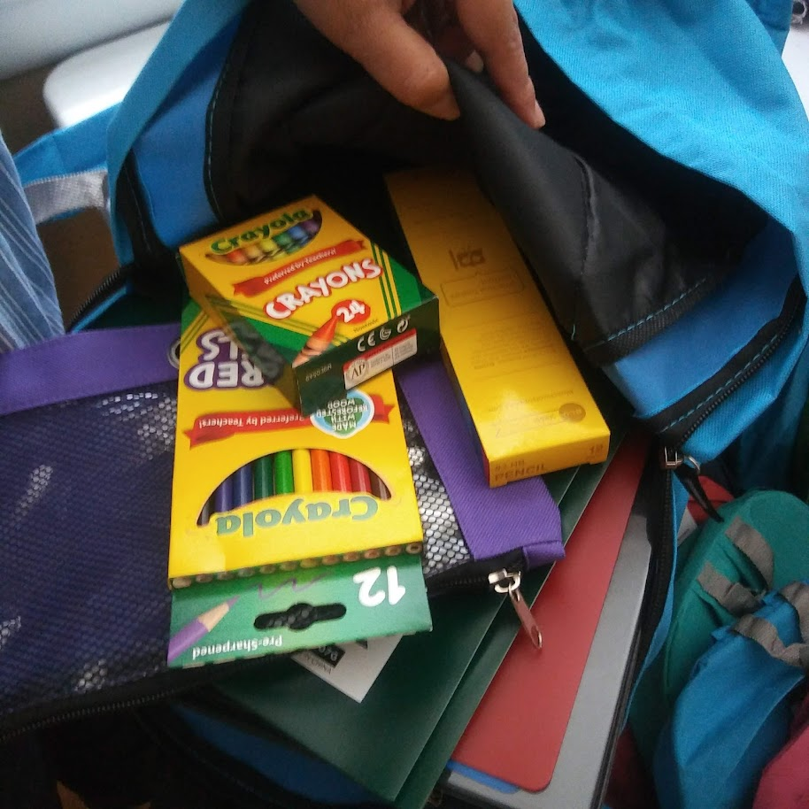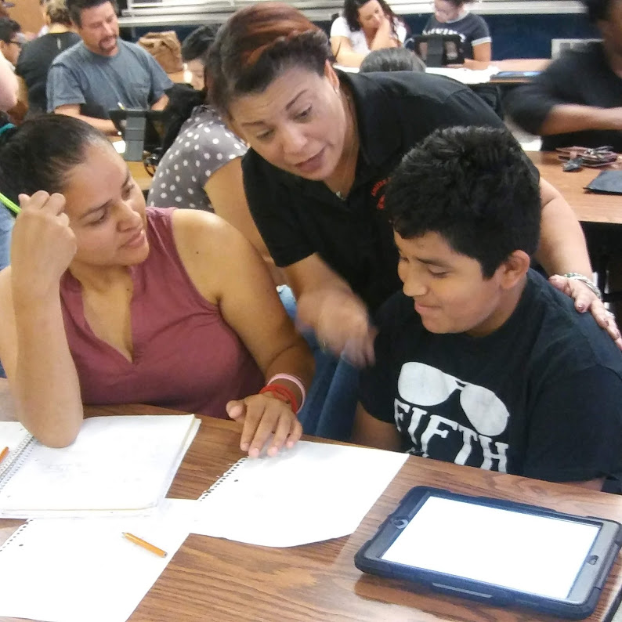

**One Team, One Goal, Student Success**

Tapp Middle School will take the following measures to promote and support parents as an important foundation of the school in order to strengthen student academic performance and reach our school goals. We will:

* Ensure that all information related to school and Family programs, meetings, and other activities is published in both English and Spanish, posted on the school website, and included in the weekly message for all Parents/Guardians.
* Provide two trainings each semester for staff during their planning periods on strategies to improve communication with families and ideas to increase family engagement.
* Partner with our feeder schools by conducting joint meetings and events for Parents/Guardians and sending school information about family engagement activities to help prepare Parents/Guardians and their child for school transitions.
* Share information in English and Spanish on the school blog and in the school newsletter for Parents/Guardians to understand the school’s academic standards and assessments as well as the ways Parents/Guardians can monitor their child’s progress and work with educators.
* Communicate with all families and the community on a regular basis regarding schoolwide events and activities, through CTLS Parent, school website, social media, campus Marquee, newsletter The Shyman Share, Principal callouts, etc.
* Work with our Parents/Guardians to develop relevant trainings and helpful presentations to educate our staff on the importance of family involvement.
* Provide necessary materials and handouts for Parents/Guardians at conferences, meetings, and activities to help Parents/Guardians work with their child to improve their child’s achievement.
* Use our Parent Facilitators and Education Partners to improve awareness of the activities and events listed in the school parental involvement policy
* Collect feedback from Parents/Guardians at all events and offer a variety of surveys throughout the school year to respond to parents’ input regarding parental involvement activities and requested meetings.

**Parental Involvement Matters**

Tapp Middle School is committed to helping our parents and families attend the family activities listed in this policy. Please call or email us if you need assistance with childcare or transportation to participate in our programs.

Laura Shyman

(770) 222-3758   
Laura.Shyman@cobbk12.org

Principal Advisory Council

The purpose of the Principal Advisory Council is to bring together parents, community members, and school staff to create a better understanding of and mutual respect for each other’s concerns and share ideas for school improvement.

The Principal Advisory Council meets three times per school year. Along with the principal, council members include:

1. Two staff members (one being the current Teacher of the Year).

2. Two parents (one being the current PTSA president).

3. Two members of the community (one being a Partner/Community representative).

If you would like to share your ideas and perspective with the **Principal** Advisory Council, please contact our Parent Facilitator Ms. Laura Shyman at Laura.Shyman@cobbk12.org

Parental Involvement Standards

Tapp Middle School and our Parents/Guardians have adopted the National PTA Standards for Family-School Partnerships as the school’s model in engaging Parents/Guardians, students, and the community. These standards are:

1. Welcoming All Families
2. Communicating Effectively
3. Supporting Student Success
4. Speaking Up for Every Child
5. Sharing Power
6. Collaborating with Community

**Share Your Thoughts**

We want to hear from you. If you have any suggestions or if there is any part of this plan that you feel is not satisfactory with the students’ and the school’s goals for academic achievement, please provide us with your comments in the space provided and leave this form in the Main Office: Or Email information to Laura.Shyman@cobbk12.org

|  |  |  |
| --- | --- | --- |
| Name (Optional): |  | |
| Phone Number (Optional): | | |
| Email Address (Optional): | |  |

Suggestions, Compliments, Concerns:

**Parent Involvement Opportunities**

I am interested in participating on the Principal Advisory Council.

☐ I am interested in the Mentoring Program

☐ I am interested in volunteering in the media center.

☐ I am interested in other volunteer opportunities, please contact me as needed

|  |  |  |  |
| --- | --- | --- | --- |
| Name: |  | | |
| Child’s Name and Grade: | | |  |
| Phone Number: | | | |
| Email Address: | |  | |

To return this form via email to Laura.Shyman@cobbk12.org

or deliver form to the school’s Main Office.