Name |  | Class

Vocabulary for Unit 1: Writing Your Story:
Memoir and Application Essays: LIST 1
Activity 1: Words In Context  Directions: Use context clues to determine the meaning of each of your new vocabulary words. Write your best guess at the definition in the right-hand column. | 

Word | In Context from the Unit Texts | Possible Definition
Benign | On the drive, I tried to calm myself with memories of benign park activities: the rainbow potato-sack slide or the Viking ship.  from “The Monster of Kings Island”
Commensurate | The train threaded into the station. We climbed out, laughing dizzily, and I felt something commensurate to love: I had survived the monster, and all I wanted was to go back and be tossed around again.  from “The Monster of Kings Island”
Dubious | And every summer I was spared the horror of the world’s longest wooden roller coaster by being too short to clear Scooby-Doo’s outstretched paw in the park’s dubious measuring system of emotional and physical maturity.  from “The Monster of Kings Island”
Embody | I remember the snacks Mom told me she ate when she was a kid and how I tried to imagine her at my age. I wanted to like all the things she did, to embody her completely.  from “Crying in H Mart”
Endear | In South Africa back then, it wasn't common to find a white person or a colored person who spoke African languages; during apartheid white people were always taught that those languages were beneath them. So the fact that I did speak African languages immediately endeared me to the black kids.  from “Chameleon”
Fusion | Last, there’s my personal favorite: Korean-Chinese fusion, which serves tangsuyuk — a glossy, sweet-and-sour orange pork — seafood noodle soup, fried rice, and jajangmyeon.  from “Crying in H Mart”
Infamy | Even before I saw the roller coaster, its infamy was scored in my mind by way of the Beast’s ubiquitous logo: two manacled claws straddling a railroad track that disappeared into a fiery hellhole.  from “The Monster of Kings Island”
Innate | But by the summer of 1984, my body had failed my innate survival instincts by growing beyond the 48-inch ride requirement.  from “The Monster of Kings Island”
Pseudo | There will usually be a pseudo-French bakery with weak coffee, bubble tea, and an array of glowing pastries that always look much better than they taste.  from “Crying in H Mart”
Ubiquitous | Even before I saw the roller coaster, its infamy was scored in my mind by way of the Beast’s ubiquitous logo: two manacled claws straddling a railroad track that disappeared into a fiery hellhole.  from “The Monster of Kings Island”

Activity 2: Use Your Resources
Directions: Use one or more dictionaries to determine the definition of each word that best matches its use in the text (as seen in Activity 1). Write the definitions in the right-hand column.

Word | Dictionary Definition
Benign
Commensurate
Dubious
Embody
Endear
Fusion
Infamy
Innate
Pseudo
Ubiquitous

Activity 3: Application of Vocabulary  Directions: With a partner, discuss each question for 1-2 minutes. | 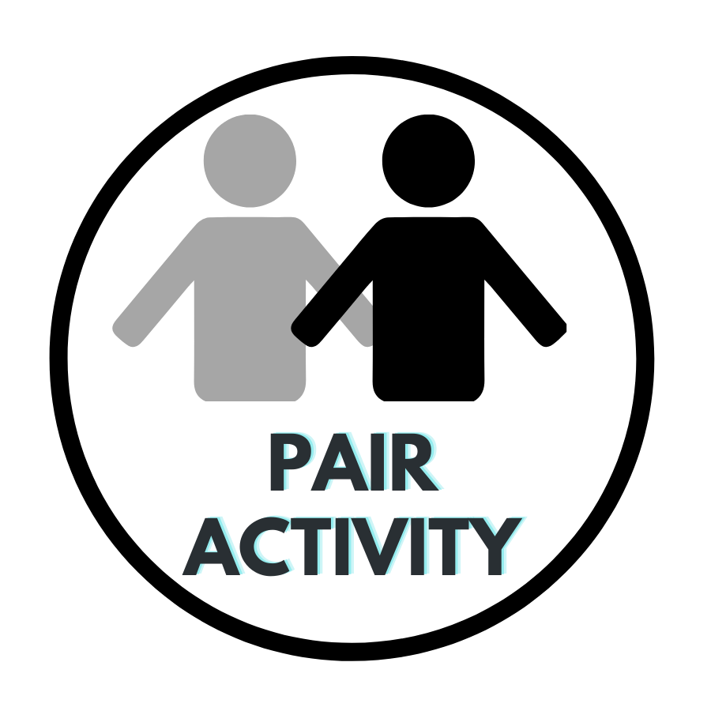
- Describe an animal that is seemingly — but not always! — benign. Explain your choice.
- Sometimes people react to an event in a way that's not commensurate with what's happening. Describe a time when someone did this in literature, film, or real life.
- How can you respond when someone tells you a dubious story?
- Name a literary character or historical figure who embodies courage. Explain your choice.
- Describe a person you find endearing. What endears them to you?
- If you could have a fusion of any two kinds of foods, what would they be and why?
- Name an infamous character in film or literature. What caused their infamy?
- Do you think a person’s talents are mostly innate? Explain.
- Astrology, the study of star signs and horoscopes, is often called a "pseudo-science." Do you think that's accurate? Why or why not?
- Name a logo or slogan that is ubiquitous in the area in which you live. Why do you think that is?

Activity 4: Writing about Literature
Directions: Use each of your vocabulary words in a sentence about one of the texts you have read. Make sure that your sentence demonstrates your understanding of both the vocabulary word’s meaning and the texts.
- Benign

- Commensurate

- Dubious

- Embody
- Endear

- Fusion

- Infamy

- Innate

- Pseudo

- Ubiquitous

Activity 5: Shades of Meaning
Directions: Each of your vocabulary words is listed below with a word that is similar — but not exactly the same! — in meaning. Determine how the meanings of the two words differ, and write your answer in the right-hand column. An example answer has been provided in the first row.

Vocabulary Word | Synonym | How the Meanings Differ
Repulsive | Unappealing | Both words describe something negative or unwanted, but repulsive is a much stronger word; it implies that something is really disgusting.
Benign | Helpful
Commensurate | Same
Dubious | False
Embody | Imitate
Endearing | Famous
Fusion | Connection
Infamous | Disliked
Innate | Habitual
Pseudo | Dishonest
Ubiquitous | Growing

Activity 6: OPTIONAL EXTENSION: Vocabulary in Conversation
Directions: Have a conversation via text message with a partner using all of the vocabulary words. Be sure your conversation provides enough context to demonstrate your understanding of each word. Follow your teacher's directions for submitting your text conversation.

