**WHEELER HIGH SCHOOL**

**Class of 2025**

**Commencement Information and Schedule of Activities**

**Saturday, May 24, 2:30 PM**

**Convocation Center**

**Kennesaw State University**

It is important that students and families review the following information carefully.

**LOCATION OF VENUE AND DIRECTIONS**

* **The Convocation Center is located on the Kennesaw campus of Kennesaw State University** at the intersection of I-75 and Chastain Road.
* From I-75, exit at Chastain Road (Exit 271) and turn west.
* Go to the first traffic light past the I-75 ramps and turn right onto Frey Road for graduate or guest parking.
* For accessible and special assistance parking, continue to the second traffic light and turn right on Kennesaw State University Road.
* Additional information and alternate routes are available on the district website at [www.cobbk12.org/graduation](http://www.cobbk12.org/graduation)

**COMMENCEMENT TICKETS**

* All guests attending commencement, including babies and small children, will need a ticket to enter the venue.
* ***Each graduate must submit their ticket request using the student portal by February 28***.
* Commencement tickets will be distributed at the May 21st commencement practice.
* Lost or damaged tickets cannot be replaced.
* **A photograph of a ticket (including but not limited to images on a cell phone) may not be substituted for a legitimate ticket.**

**SENIOR CLEARANCE**

* All fees for lost or damaged textbooks, media materials, parking, classroom instructional equipment, uniforms, or any other materials owed to the school must be cleared by Friday, May 16, 2025, to participate in commencement on May 24, 2025.

**FINAL EXAMS**

* Wednesday, May 14, 2025
  + 3rd & 4th Block Exams for A Day Only
* Thursday, May 15, 2025
  + 3rd & 4th Block Exams (All B Day Finals)
* Friday, May 16, 2025
  + 1st & 2nd Block Exams

**COMMENCEMENT PRACTICES**

* Tuesday, May 20, 2025
  + 8:30 AM – 11:30 AM – Wheeler Café
* Wednesday, May 21, 2025 – Old Gym
  + 8:30 AM – 10:00 AM
* **Attendance is mandatory** for both practices.
* Commencement tickets will be distributed at the May 21st practice.

**COMMENCEMENT DAY SCHEDULE**

Saturday, May 24, 2025, 2:30 PM, Convocation Center, Kennesaw State University (KSU).

* **1:00 PM** Seniors Report to Siegel Recreation Center.
* **1:30 PM** Elderly and Guests Needing Assistance may enter Convocation Center.
* **1:45 PM** Doors open to ALL FAMILY AND FRIENDS.
* **2:30 PM** Processional of Graduates Begin

(***No one will be allowed to enter the ceremony during the processional***).

* **Arrival Time and Location**

Graduates

* + Graduates need to arrive at KSU and report to the Siegel Recreation Center (SRC) by **1:00 PM**.
  + Graduates are to park in the Central Parking Deck. Graduates should **wear comfortable shoes for walking** from the Central Parking Deck to the Siegel Recreation Center (SRC) and then to the Convocation Center (CC).
  + In accordance with KSU requirements, all graduates must pass through metal detectors upon arriving for line-up.

Guests

* + Doors open at 1:45 PM (1:30 PM for those requiring special assistance). Early admission will be granted to the person requiring assistance and one (1) ticketed companion only.
  + All guests will enter the Convocation Center (CC) at the atrium level through the doors on the north side of the building.
* **Attire**

Dress for graduates will be as follows:

* + Gentlemen: Collared shirt, dark dress slacks, dress shoes, and socks
  + Ladies: Solid colored or black dresses (or black dress slacks), and dress shoes.
  + Flat shoes are recommended. You will be doing a lot of walking and standing.

Cap & Gown

* Herff Jones will deliver caps and gowns on March 19. If students are absent on the delivery day, the main office staff will collect their products.
* Questions concerning these items should be directed to **ATLGrad** office at **(770) 795-1626**. Each student participating in commencement must have the correct gown, matching mortar board, and tassel.
  + Caps should be worn flat on top of the head. Tassels should be on the right side of the cap.
  + To ensure the decorum of the ceremony and to provide consistency among schools, **alterations to the mortarboard and gown will not be permitted**. Graduates may only wear stoles, cords, and other insignia authorized by the school.
* **Conduct:** Behavior at the ceremony and practices must be exemplary. Please understand that misconduct in any form will not be tolerated. Any senior(s) causing a disturbance or in any way conducting themselves inappropriately during the ceremony will be removed and will not be able to participate in commencement. In addition, restitution for any damage to the venue, district property, or vendor property will be the responsibility of the graduate or guest who causes said damage.
* **Bag Check:**

**In accordance with KSU requirements, all persons entering the Convocation Center will pass through metal detection devices. Also, guests entering the facility with a bag MUST use either a CLEAR TOTE, PLASTIC ZIP TOP BAG, or SMALL CLUTCH to be approved for entry into the venue. Please do not bring any packages that cannot be opened or inspected. Also, please allow extra time for entry as there may be delays.**

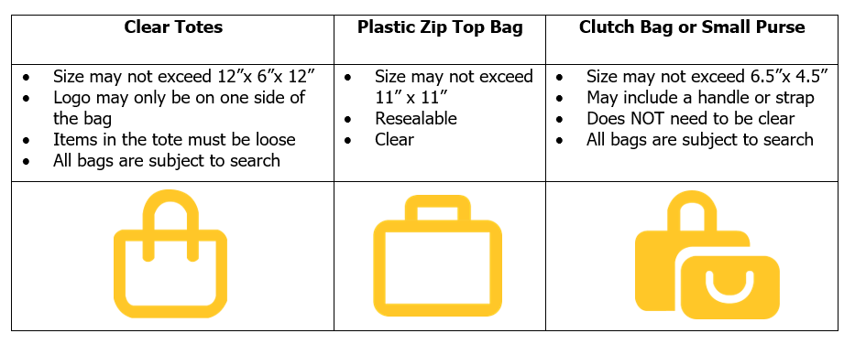Please see the descriptions provided by KSU regarding clear totes, plastic zip top bags, and small clutches.

* **Prohibited Items:** Any object which obscures the view or impacts the safety of others is not allowed in any district-managed venue. A complete list of prohibited items is available on the district graduation web page ([www.cobbk12.org/graduation](http://www.cobbk12.org/graduation)).

**PARKING**

* **KSU charges a $10.00 parking fee per car.** Be prepared to pay with credit or with debit card only.
* **Graduates** are to park in the Central Parking Deck. Graduates should be encouraged to wear comfortable shoes for walking from the Central Parking Deck to the Siegel Recreation Center (SRC) and the Convocation Center (CC).
* **Guests** will park in the East Parking Deck and the East Economy Lot (across Frey Road from the East Parking Deck). Overflow parking will be available in the Central Parking Deck.
* **Guests with disabilities and elderly guests needing individualized assistance** should park in either Lot A or Lot B (as designated on the campus map). Golf carts will run continuously to convey guests to and from the Convocation Center.

**DIPLOMA DISTRIBUTION**

* Graduates will not receive their diplomas on the day of commencement.
* Diplomas will be distributed at Wheeler High School on Tuesday, May 27th 9:00 – 12:00 and Wednesday, May 28th 1:00 PM – 3:00 PM.
* Picture ID is required to receive the diploma. Only the student or enrolling adult can pick up the diploma.

**ADDITIONAL INFORMATION**

* Participation in commencement is optional and a privilege.
* Please remember all graduation requirements must be met to participate in the commencement ceremony.
* Prior to the day of the ceremony remove your gown from the packaging and hang it up so wrinkles will fall out. Use a cool iron to press, if necessary.
* Club sponsors will give out their cords/stoles. Contact them for details. Honors cords for honor graduate students with a non-rounded 3.500 GPA or higher will be distributed at commencement practice on May 20th .
* There is no place on campus for students to store bags or any other personal items on the day of commencement.
* The ceremony will be video recorded, and a video will be offered for sale by the school district. Commencement, video, and broadcast information can be found on the district website ([www.cobbk12.org/graduation/](http://www.cobbk12.org/graduation/)).
* Flowers and graduation gifts may be purchased from district-approved vendor(s) at district-managed venues. Sales kiosks will be located in the lobby areas and/or outside the venue. <http://www.cobbk12.org/graduation/>
* Cady Studios will take photos as each graduate receives his/her diploma and will make these available for purchase.
* Parents may not be in the aisles to film or take photographs.
* The use of monopods, tripods, selfie sticks, or any other camera stabilizing device is prohibited.
* Please contact the senior sponsors with senior specific questions: Amber Brattebo, Aaron Cleveland, Jessica Gibson, or Bjorn Thornton.
* **GENERAL INFORMATION**

Contact Mrs. Munlin ([**Deanna.Munlin@Cobbk12.org**](mailto:Deanna.Munlin@Cobbk12.org))

**COMMENCEMENT TIMELINE**

|  |  |  |
| --- | --- | --- |
| Wed. May 14, 2025 | …………….…… | 3rd & 4th Block Exams for A Day |
|  |  |  |
| Thur. May 15, 2025 | …………….…… | All B Day Exams &  3rd & 4th Block Exams |
|  |  |  |
| Fri. May 16, 2025 | …………….…… | All A Day Exams &  1st & 2nd Block Exams  Senior Picnic after Exams |
|  |  |  |
| Fri. May 16, 2025 | …………….…… | Senior Clearance Deadline |
|  |  |  |
| Tues. May 20  Wed. May 21, 2025 | …………….…… | Commencement Practice, 8:30 AM – 11:30 AM  Ticket & Honor Cord Distribution, 2nd pactice 8:30 –10:00 (if needed)  Wheeler High School |
|  |  |  |
| Wed. May 21, 2025 | ………….…… | Technical Rehearsal 10:45 AM  Convocation Center, KSU  (mandatory for speakers and performers only) |
|  |  |  |
| Sat. May 24, 2025 | …………….…… | Commencement 2:30 PM  Convocation Center at KSU  Student Arrival 1:00 PM  Siegel Recreation Center |
|  |  |  |
| Tues. May 27  Wed. May 28 | …………….…… | Diploma Pick Up, 9:00 AM – 12:00 PM  Diploma Pick Up, 1:00 PM – 3:00 PM  Wheeler High School |

For additional information and updates,

please check the commencement page on the district web site: [www.cobbk12.org/graduation](http://www.cobbk12.org/graduation).