World History Summer Assignment Name: __________________________ pr: ______

Directions: Watch the video linked below and Read pp 26-79 (many pages are skipped on purpose) of the scanned pages and fill out the guided note. (Notes **MUST** be handwritten unless you have an accommodation that states otherwise.) The 1st week of school you will use these notes to take the First Unit Test.

**Part 1 – Agricultural Revolution**

Watch the video and answer the questions <https://vimeo.com/143565112>

1. Describe the theory given in this video of where, why and how agriculture began.

|  |
| --- |
| Where? |
| How? |
| Why? |

1. List the major changes created by agriculture and how agriculture led to these changes
2. What is the earliest for of writing & where was it developed?
3. Describe the importance of beer to the Egyptians and give one piece of evidence to support your argument (FRQ Practice)

Stop Video at the end of the Egyptians.

**Chapter 2 Section 1 City-States in Mesopotamia**

Define/identify

1. Tigris and Euphrates
2. Fertile Crescent
3. Mesopotamia
4. City-state
5. Dynasty
6. Cultural diffusion
7. Polytheism
8. Sargon of Akkad
9. Empire
10. Hammurabi

Label the 4 river valley Civilizations

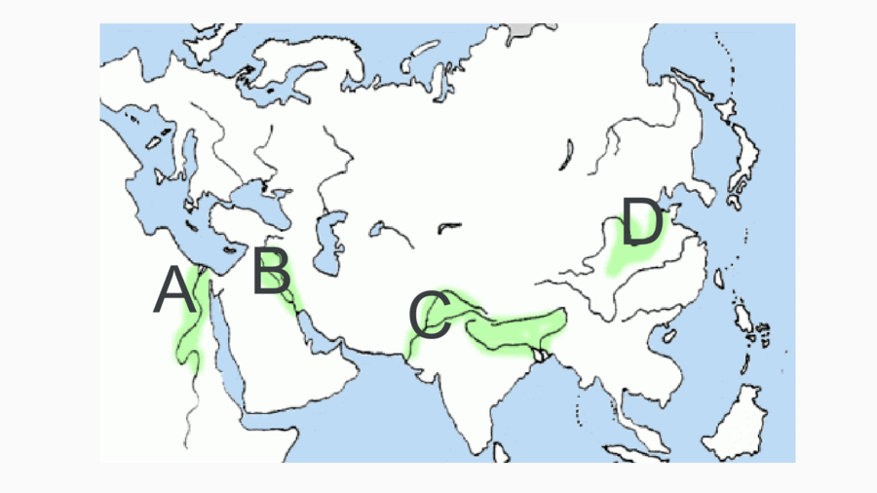

Geography of the Fertile Crescent

* 1. Mesopotamian environmental challenges?
  2. Solution to challenges?

Sumerians Create City-States

* 1. What set Sumer apart?
  2. Priests and rulers share control
  3. How did priests have power?
  4. How did ruling power change?

1. Spread of Cities
   1. What spread due to more cities and trade?

Sumerian Culture

1. What did the gods represent?
2. Characteristics of the gods and the religion as a whole?

Life in Sumerian Society

1. Describe the structure of society in Sumer

The First Empire Builders

1. As the Babylonian Empire grew what did Hammurabi put in place to keep order?

Using your reading and “Analyzing Primary Sources” on p. 33 answer the following

1. What does “tooth for a tooth” mean?
2. Give an example of “tooth for a tooth” in the code
3. Laws from the very genning of society often reflected social status. Give an example from Hammurabi’s Code that reflect social status and law inequity.

**Chapter 2 Section 2 – Pyramids on the Nile**

Define/Identify

1. Delta
2. Nile
3. Pharaoh
4. Theocracy
5. Hieroglyphics
6. Papyrus
7. Rosetta Stone

Geography of Egypt

1. For What reason is Egypt known as “The gift of the Nile”?
2. For what reasons is life on the Nile easier than for those living in Mesopotamia?
3. Scorpion King and Narmer?
4. What is the purpose of the pyramids?

Egyptian Culture vs Mesopotamian

|  |  |
| --- | --- |
| Egyptian Culture | Mesopotamian Culture |
|  |  |

1. Describe how Mesopotamian vs Egyptian life and culture differ due to their environments (give 2 pieces of evidence, FRQ Practice)

Invades Control Egypt

1. Dates of the Old Kingdom
2. Dates of Middle Kingdom
3. Who and what brought the Old Kingdom

**Chapter 2 Section 3 – Planned Cities on the Indus**

Define/Identify:

1. Subcontinent
2. Monsoons
3. Harappan civilization

Geography of the Indian Subcontinent

1. What were the environmental challenges of the Indian Subcontinent?
2. What environmental similarities did the people the Indus and Nile share?

Civilization Emerges on the Indus

1. List characteristics of the Indus Valley civilizations that make them unique/or a point of interest (pp46. & 47)

Harappan Culture

1. For what reason do we know so much less about the Harappan culture than that of Mesopotamia of Egypt?
2. What are the theories about the social structure, religion and economics of the Harappan culture?

|  |  |  |
| --- | --- | --- |
| Social Structure | Religion | Economics |
|  |  |  |

1. What are the theories for the collapse of the Indus Valley Culture?

**Chapter 2 Section 4 – River Dynasties in China**

Define/Identify:

1. Oracle Bones
2. Mandate of Heaven
3. Dynastic cycle
4. Feudalism

Geography

1. What are the 2 rivers that were cradles of civilization for China?
2. Environmental challenges?
3. How much of China is suitable for farming and what part?

Civilization Emerges in Shang Times

1. What was the first Chinese dynasty?
2. What was the first Chinese dynasty to leave written records?

Development of Chinese Culture

1. What is the view even from early on when it came to individual vs. group?
2. What was the family structure like?
3. What is tribute and how did it play a role in China during the Shang?
4. What role did ancestors play in Chinese religion?
5. Explain the structure of Chinese writing and what was its advantage?

Dynastic Cycle

Complete the Dynastic Cycle diagram



Zhou and the Dynastic Cycle

1. How did the Zhou Dynasty justify their overthrowing of the Shang Dynasty? And what is it later know as?
2. Describe the Feudal structure of government.
3. List the innovations of the Zhou and how it improved the lives of the Chinese people.
4. Describe the Warring States period?

**Chapter 3 Section 1 – Indo Europeans**

1. What is the significance of the Indo-European language family?

Hittite Empire

1. Who were the Hittites?
2. Hittites vs Egyptians?
3. What explains the military success of the Hittites?

Aryans Transform India

1. Who were the Aryans
2. Define Vedas

|  |  |
| --- | --- |
| Define the Caste System | determining factors of Caste placement |
| rules of caste system | social mobility |

**Chapter 3 section 2 – Hinduism (we will do Buddhism later)**

Define/Identify:

Reincarnation

Karma

Moksha

|  |
| --- |
| Founder/Origins |
| Key Beliefs (don’t skimp here) |
| Effects on Society |

**Chapter 2 section 4 – The Origins of Judaism**

Define/Identify

Palestine

Canaan

Torah

Abraham

Monotheism

Covenant

1. Search for the Promised Land
   1. Where do the Jewish people originate from?
   2. Where to they go? And why do the Jewish people feel this is their land even if others live there?
   3. What are the terms of the 1st Covenant?
2. Moses and the Exodus
   1. Why did the Jews migrate to Egypt?
   2. What is the exodus and who was it led by?
   3. Describe the New Covenant
3. Analyzing Primary Sources
   1. What do the 1st 4 commandment concentrate on?
      1. What does this concentration possibly indicate?